**HO CHI MINH CITY UNIVERSITY OF TECHNOLOGY AND EDUCATION**

**FACULTY FOR HIGH QUALITY TRAINING**

**

**GRADUATION PROJECT**

**RESEARCH, DESIGN AND IMPLEMENTATION OF AGV ROBOT FOR DELIVERY AND TRANSPORT ESSENTIALS IN HOSPITAL**

**TRAN TUAN HUY Student ID: 17146028**

**PHAM CAO DUY Student ID: 17146011**

**DINH ANH TUAN Student ID: 18146068**

**Major: MECHATRONICS ENGINEERING**

**Advisor: Vu Quang Huy, PhD.**

Ho Chi Minh City, July 2022

|  |  |
| --- | --- |
|  | THE SOCIALIST REPUBLIC OF VIETNAM  **Independence – Freedom– Happiness**  --------  *Ho Chi Minh City, July 4, 2022* |

**GRADUATION PROJECT ASSIGNMENT**

|  |  |  |  |  |
| --- | --- | --- | --- | --- |
| Student name: Tran Tuan Huy | | | Student ID: 17146028 | |
| Student name: Pham Cao Duy | | | Student ID: 17146011 | |
| Student name: Dinh Anh Tuan | | | Student ID: 18146068 | |
| Major: Mechatronics engineering | | | Class: 17146CLA and 18146CLA | |
| Advisor: Vu Quang Huy, PhD. | | | Phone number: 0918748924 | |
| Date of assignment: | | | Date of submission: | |
| 1. Project title: Research, design and implementation of agv robot for delivery and transport essentials in hospital | | | | |
| 2. Initial materials include: Collecting documents and books about AGV robot, ROS, LIDAR and SLAM algorithm | | | | |
| 3. Content of the project:  - Planning the idea to design a mobile robot that adapts the functional's requirement  - Choosing the appropriate electrical components, and motor  - Implementing and building mechanical system  - Implementing the Electrical system and program algorithm  - Calculating, testing the allowable strength and stress of the robot that it can carry multiple loads  - Implementing experiment and record results in order to show the advantage and disadvantage for future improvement | | | | |
| 4. Final product:  - AGV robot using LIDAR and SLAM for assist nurse and doctor to delivery essentials such as food and drink to patients in hospital  - Design mechanical blueprint | | | | |
| **CHAIR OF THE PROGRAM**  *(Sign with full name)* | | | **ADVISOR**  *(Sign with full name)* | |
|  | THE SOCIALIST REPUBLIC OF VIETNAM  **Independence – Freedom– Happiness**  --------  *Ho Chi Minh City, July 4, 2022* | |

**ADVISOR’S EVALUATION SHEET**

Student name: Tran Tuan Huy Student ID: 17146028

Student name: Pham Cao Duy Student ID: 17146011

Student name: Dinh Anh Tuan Student ID: 18146068

Major: Mechatronics Engineering

Project title: Research, design and implementation of agv robot for delivery and transport essentials in hospital

Advisor: Vu Quang Huy, PhD.

**EVALUATION**

1. Content of the project:

.................................................................................................................................................

.................................................................................................................................................

.................................................................................................................................................

1. Strengths:

.................................................................................................................................................

.................................................................................................................................................

.................................................................................................................................................

1. Weaknesses:

.................................................................................................................................................

.................................................................................................................................................

.................................................................................................................................................

1. Approval for oral defense? *(Approved or denied)*

.................................................................................................................................................

1. Overall evaluation: (Excellent, Good, Fair, Poor)

..................................................................................................................................................

6. Mark………………. (*In words*: .........................................................................................)

*Ho Chi Minh City, July, 2022*

**ADVISOR**

*(Sign with full name)*

|  |  |
| --- | --- |
|  | THE SOCIALIST REPUBLIC OF VIETNAM  **Independence – Freedom– Happiness**  --------  *Ho Chi Minh City, July 4, 2022* |

**PRE-DEFENSE EVALUATION SHEET**

Student name: Tran Tuan Huy Student ID: 17146028

Student name: Pham Cao Duy Student ID: 17146011

Student name: Dinh Anh Tuan Student ID: 18146068

Major: Mechatronics Engineering

Project title: Research, design and implementation of agv robot for delivery and transport essentials in hospital.

Advisor: Vu Quang Huy, PhD.

Name of Reviewer: .................................................................................................................

**EVALUATION**

1. Content and workload of the project

.................................................................................................................................................

.................................................................................................................................................

.................................................................................................................................................

.................................................................................................................................................

2. Strengths:

.................................................................................................................................................

.................................................................................................................................................

.................................................................................................................................................

3. Weaknesses:

.................................................................................................................................................

.................................................................................................................................................

.................................................................................................................................................

4. Approval for oral defense? *(Approved or denied)*

.................................................................................................................................................

5. Overall evaluation: *(Excellent, Good, Fair, Poor)*

.................................................................................................................................................

6. Mark………………. (*In words*: ........................................................................................)

*Ho Chi Minh City, July, 2022*

**REVIEWER**

*(Sign with full name)*

|  |  |
| --- | --- |
|  | THE SOCIALIST REPUBLIC OF VIETNAM  **Independence – Freedom– Happiness**  -------- |

**EVALUATION SHEET OF**

**DEFENSE COMMITTEE MEMBER**

Student name: Tran Tuan Huy Student ID: 17146028

Student name: Pham Cao Duy Student ID: 17146011

Student name: Dinh Anh Tuan Student ID: 18146068

Major: Mechatronics Engineering

Project title: Research, design and implementation of agv robot for delivery and transport essentials in hospital

Advisor: Vu Quang Huy, PhD.

Name of Defense Committee Member: ...................................................................................................................................................

**EVALUATION**

1. Content and workload of the project

.................................................................................................................................................

.................................................................................................................................................

.................................................................................................................................................

.................................................................................................................................................

2. Strengths:

.................................................................................................................................................

.................................................................................................................................................

.................................................................................................................................................

3. Weaknesses:

.................................................................................................................................................

.................................................................................................................................................

.................................................................................................................................................

4. Overall evaluation: *(Excellent, Good, Fair, Poor)*

.................................................................................................................................................

5. Mark………………. (*In words*: ........................................................................................)

*Ho Chi Minh City, July, 2022*

**COMMITTEE MEMBER**

*(Sign with full name)*

**TABLE OF CONTENTS**

DISCLAIMER 1

ACKNOWLEDMENT 1

LIST OF ABBREVIATIONS 2

LIST OF FIGURES 3

LIST OF TABLES 6

ABSTRACT 8

CHAPTER 1: OVERVIEW 9

1.1. General introduction 9

1.2. Research situation of domestic and abroad 10

1.3. Reason of choosing subject 15

1.4. Limitation and scope of subject 16

1.5. Research method 16

CHAPTER 2: THEORETICAL BACKGROUND 17

2.1. Overview of AMR robots 17

2.2. Introduction of ROS system. 18

2.2.1. Explanation of mobile robot platform 18

2.2.2. What is ROS (Robot operating system) ? 18

2.3.  General introduction of SLAM 18

2.3.1. Explanation of SLAM and its matters 19

2.3.2. How does SLAM operate? 20

2.3.3. Introduction of Visual SLAM 21

2.3.4. Lidar SLAM 21

2.4. Research of robot navigation 22

2.5. PID controller 23

2.5.1. Overview of PID control 23

2.5.2. Theory of algorithm 24

2.5.3. Method of PID tuning 28

2.6. Communication protocol 28

2.6.1. Summary of UART 29

2.6.2. What is Rosserial ? 31

2.7. Kinematic of mobile robot 33

CHAPTER 3: DESIGN AND IMPLEMENTATION 36

3.1. Mechanical design 36

3.1.1. Fundamental of design 36

3.1.2. Requirement of design 37

3.1.3. Calculation and selection 39

3.1.3.1. Selection of transmission 39

3.1.3.2. Motor calculation and selection 42

3.1.3.3. Belt drive calculation and selection 44

3.1.3.4. Test for Strength and fatigue of shaft 48

3.1.3.5. Wheels and Support pillow 54

3.1.4. Design of mobile robot 58

3.1.4.1. Base plate 58

3.1.4.2. Electrical components container 60

3.1.4.3. Product container 62

3.1.4.4. Frame of robot 63

3.2. Design of block diagram 66

3.2.1. Block listing 66

3.2.2. Block diagram 67

3.2.3. Operation description 67

3.3. Electrical system design 68

3.3.1 Block diagram 68

3.3.2. List of electrical components 68

3.3.3. Selection of power source 74

3.4. Controller system design 78

3.4.1. Operation process 78

3.4.2. Flow chart explanation 80

3.5. Implementation of PID controller 81

CHAPTER 4: SLAM AND NAVIGATION ALGORITHMS 84

4.1. SLAM for mapping process 84

4.1.1. Gmapping 85

4.1.1.1. Occupancy grid in ROS(grid map) 86

4.1.1.2. Robot Hardware constraints for SLAM 88

4.2. SLAM process 91

4.3. Navigation 92

4.3.1. Move_base component 94

4.3.2. Map_server component 100

4.3.3. AMCL component 101

4.3.4. Base Controller component 101

4.3.5. Odometry component 102

4.3.6. Sensor transforms component 103

4.4. ROS-Mobile for manual control 108

4.4.1. Introduction 108

CHAPTER 5: EXPERIMENTS AND ANALYSES 112

5.1. Implementation of experiment 112

5.1.1. Simulation criteria 112

5.1.2. Result of experiment 113

5.2. Establish target specifications 118

5.2.1. Qualitative Research Method 118

5.2.2. Methods of Experiment 121

5.2.3. Experiment Implementation 123

5.3. Analysis of data 131

5.3.1. Static test analysis 131

5.3.2. Dynamic test analysis 131

5.3.3. Conclusion 135

CHAPTER 6: CONCLUSION AND FUTURE IMPROVEMENT 136

6.1. Lesson learnt 136

6.2. Achievement 136

6.3. Limitation 136

6.4. Suggestion for future improvement 137

REFERENCES 138

# **DISCLAIMER**

This research project has been completetly written based on the preference of multi resources. It is much considered to be an academic journal and not held any responsibility for publishing as a student and not an offical author for all the contents in this report.

# **ACKNOWLEDMENT**

At intially, it is hornor for me to represent for all members in the group for expressing a deep gratitude to my advisor “Vu Quang Huy” for all the meaningful assistance he has given us throughout four months of carrying out thesis graduation. It was a such a huge responsibility for him to supervise and take of many groups in this semester and spent precious time for each group to comment details about the work. I and my group have learned many valuable lessons from him that considers to be a preparation of our career to become a professional engineer.

I’m also sincerely applaud to all friends in my major who were willing to give me many advises and supports to help our group accomplish this thesis graduation perfectly.

I’d like to offer my huge thanks to both of administrative staffs in the faculty of mechanical engineering as well high quality tranining and the sponsors, who walked along us and supported us in term of entertaining and marketing our project to social media.

I specially much gratefull to Mr.Duong The Phong, who is the teacher I used to ask for some advices. Thank you for taking the time to assist my group despite of not a main advisor.

I definitely not forget all my partners who went throught this most excrucitating times during the final year in the university. Thanks for being patient and supported me to overcome this thesis graduation. I couldn’t have done it without you guys.

To conclude, I’d like to save the last appreciated words to my parents. The people who always cheer me and give me unconditionally trust. Thanks for having my back, for all the sacrifications that they made that encouraged to give me a huge motivation to accomplish this thesis graduation very well.

# **LIST OF ABBREVIATIONS**

ROS: Robot Operating System

AMR: Autonomous Mobile Robot

AGV: Automated Guided Vehicle

AMCL: Adaptive Monte Carlo Localization

LiDAR: Light Detection And Ranging

UART: Universal Asynchronous Receiver / Transmitter

IMU: Inertial Measurement Unit

URDF: Unified Robot Description Format

TF: Transform

MVVM: Model–view–viewmodel

DC: Direct current

TCP/IP: Transmission Control Protocol/ Internet Protocol

PID: Proportional Integral Derivative

# **LIST OF FIGURES**

*Figure 1.1. The HelpMate robot 9*

*Figure 1.2. The AMRs in manufacturing, warehouse, and logistic applications 10*

*Figure 1.3. The AMRs in agriculture application 11*

*Figure 1.4. The AMRs in healhcare application 12*

*Figure 1.5. The AMRs in service application 13*

*Figure 1.6. The AMRs in smart city application 14*

*Figure 1.7. The AMR in healthcare application implemented in Bach Mai hospital 15*

*Figure 2.1. Some prominent components of an AMR 17*

*Figure 2.2. Demo of SLAM image 19*

*Figure 2.3. Benefits of SLAM for Cleaning Robots 19*

*Figure 2.4. SLAM Processing Flow 20*

*Figure 2.5. Visual SLAM algorithms 21*

*Figure 2.6. Lidar SLAM algorithms 22*

*Figure 2.7. Navigation of mobile robot 22*

*Figure 2.8. Block diagram of PID controller 24*

*Figure 2.9. Response of PV to SP for different Kp values respect to time 25*

*Figure 2.10. Response of PV to SP for different Ki values respect to time 26*

*Figure 2.11. Response of PV to SP for different Kd values respect to time 27*

*Figure 2.12. Different ways of communication protocol 29*

*Figure 2.13. Two UARTs directly communicate with each other. 29*

*Figure 2.14. UART with data bus 30*

*Figure 2.15. Rosserial server (for PC) and client (for embedded system) 31*

*Figure 2.16. ROS integration for Miniature of Mobile Robots 32*

*Figure 2.17. ROS integration for Miniature of Mobile Robots 32*

*Figure 2.18. The differential drive configuration 33*

*Figure 2.19. Analysis of differential drive kinematics 34*

*Figure 3.1. A Car-like mobile robot 37*

*Figure 3.2. A Hilare mobile robot 38*

*Figure 3.3. Belt drive components 39*

*Figure 3.4. Chain drive components 40*

*Figure 3.5. Gear drive components 40*

*Figure 3.6. 3D Design of belt drive mechanism 42*

*Figure 3.7. External forces acting on arobot 42*

*Figure 3.8. DC motor 43*

*Figure 3.9. Technical data DC motor 44*

*Figure 3.10. Belt GT2 47*

*Figure 3.11. Pulleys GT2 47*

*Figure 3.12. Drive mechanism and shaft distances 48*

*Figure 3.13. Bending and torque moment diagram 50*

*Figure 3.14. Support pilow dimension 54*

*Figure 3.15. Robot wheel 57*

*Figure 3.16. Universal wheel 57*

*Figure 3.17. 3D design of base plate 58*

*Figure 3.18. 3D design of full assembly base plate 59*

*Figure 3.19. Full assembly of base plate in realistic 60*

*Figure 3.20. 3D design of electrical components surface area 61*

*Figure 3.21. Distribution of electrical components in realistic 62*

*Figure 3.22. 3D design of product container 63*

*Figure 3.23. Assembly of container in realistic 63*

*Figure 3.24. Shaped aluminium 64*

*Figure 3.25. 3D design frame 65*

*Figure 3.26. Assembly of frame in realistic 65*

*Figure 3.27. Block diagram of robot 67*

*Figure 3.28. Electrical diagram of robot 68*

*Figure 3.29. Arduino mega 2560 68*

*Figure 3.30. Jetson nano 70*

*Figure 3.31. Module compass V2 with IMU integrated 72*

*Figure 3.32. Module compass V2 with IMU integrated 73*

*Figure 3.33. Driver BTS 7960 74*

*Figure 3.34. Lipo battery 4S 74*

*Figure 3.35. Lead Acid Battery Eagle EG5-12 75*

*Figure 3.36. Full specification of Lead-acid Lead Acid Battery Eagle EG5-12 76*

*Figure 3.37. Control flowchart 78*

*Figure 3.38. Arduino Mega 2560 program flowchart 79*

*Figure 4.1. Demo of SLAM running for mapping 84*

*Figure 4.2. Completed Map 84*

*Figure 4.3. Example of map 85*

*Figure 4.4. Example of Occupancy grid map 87*

*Figure 4.5. Sensors for odometry measurement 88*

*Figure 4.6. LiDAR sensor 89*

*Figure 4.7. LiDAR A1 System composition 90*

*Figure 4.8. Measurement Performance 90*

*Figure 4.9. Optical specification 91*

*Figure 4.10. Flowchart of SLAM process 91*

*Figure 4.11. Components of autonomous navigation 93*

*Figure 4.12. Relationship between messages and topics in ROS navigation package 93*

*Figure 4.13. Global path planner of mobile robot 94*

*Figure 4.14. Dijkstra’s algorithm(above) and A* algorithm(below) 95*

*Figure 4.15. Carrot_planner method for robot navigation 95*

*Figure 4.16. Local path planner of mobile robot 96*

*Figure 4.17. Demo of Dynamic Window Approach’s algorithm 97*

*Figure 4.18. The cost function used to score each trajectory 97*

*Figure 4.19. Costmap representation (gray scale) 98*

*Figure 4.20. Representation of Local and Global costmap 98*

*Figure 4.21. Relationship between distance to obstacle and costmap value 99*

*Figure 4.23. Example of image parameters 100*

*Figure 4.24. AMCL process for robot pose estimation 101*

*Figure 4.25. Diagram of base controller system 102*

*Figure 4.26. Odometry of mobile robot 102*

*Figure 4.27. The relationship between different coordinates in tf 103*

*Figure 4.28. Description of links in mobile robot 105*

*Figure 4.29. Description of joint in mobile robot 106*

*Figure 4.30. URDF file of mobile robot 107*

*Figure 4.31. Representation of different coordinate frame 107*

*Figure 4.32. The general MVVM designing concept for mobile application 109*

*Figure 4.33. Design of controller’s interface with ROS-Mobile 110*

*Figure 4.34. Mobile robotic platforms for which ROS-Mobile is currently used for evaluation and control 110*

*Figure 5.1. Final product result 112*

*Figure 5.2. Perform Slam process and map scanned result 113*

*Figure 5.3. Map in simulation environment (Rviz) 114*

*Figure 5.4. Demo of navigation 115*

*Figure 5.5. Demonstration of obstacle avoidance process 116*

*Figure 5.6. Dijkstra's algorithm 117*

*Figure 5.7. A* algorithm 118*

*Figure 5.8. Curve trajectory of mobile robot 125*

*Figure 5.9. Demonstration of noise level measuring process 126*

*Figure 5.10. Set an origin value of compass and place it on robot 127*

*Figure 5.11. Rotate the robot with 360o 127*

*Figure 5.12. Demonstration of safe distance measuring 129*

*Figure 5.13. relationship between speed and mass 131*

*Figure 5.14. A variable of fastest speed achieved over ten times tested 132*

*Figure 5.15. A variable of slowest speed achieved over ten times tested 133*

*Figure 5.16. A variable of angle’s accuracy over ten times tested 133*

*Figure 5.17. The change of safe distance over ten times test 134*

*Figure 5.18. The variable of noise level over ten times test 134*

*Figure 5.19. Power consumption with variable of loads capacity 135*

# **LIST OF TABLES**

*Table 2.1. Process of navigation 23*

*Table 2.2. Effects of increasing a parameter independently 28*

*Table 2.3. UART summary 30*

*Table 3.1. Hilary-type Robot in comparison with Like-car Robot 38*

*Table 3.2. Comparison between different types of mechanical drive 41*

*Table 3.3. Technical data of DC motor 44*

*Table 3.4. Technical data of belt GT2 46*

*Table 3.5. Summary of diameter sections 54*

*Table 3.6. Technical data of robot wheel 57*

*Table 3.7. Technical data of universal wheel 58*

*Table 3.8. Characteristic of the base plate 59*

*Table 3.9. Shaped aluminum in comparison with stainless steel 64*

*Table 3.10. List of components 66*

*Table 3.11. Technical features of Arduino mega 2560 69*

*Table 3.12. Advantages and disadvantages of Arduino mega 2560 70*

*Table 3.13. Technical Specification of jetson nano 71*

*Table 3.14. Technical Specification of LM2596 72*

*Table 3.15. Technical Specification of BTS 7960 73*

*Table 3.16. The estimated Lead-acid battery time remaining without load and with load 77*

*Table 4.1. Differences between SLAM approaches 85*

*Table 4.2. Occupancy grid map’s Algorithm 86*

*Table 4.3. Summary of Occupancy grid map 87*

*Table 4.4. Explanation of each components in SLAM process 92*

*Table 4.5. Summary of tf 104*

*Table 5.1. Simulation criteria 112*

*Table 5.2. The time value executes and distance when using Dijkstra’s and A* algorithms. 117*

*Table 5.3. List of needs 119*

*Table 5.4. List of metrics 119*

*Table 5.5. Relationship between metrics and needs 120*

*Table 5.6. Explanation of direct and indirect measure 120*

*Table 5.7. Assign marginal and ideal value for each specification 120*

*Table 5.8. Experiment methods 121*

*Table 5.9. Data collection of static test 123*

*Table 5.10. Data collection of speed variable 123*

*Table 5.11. Data collection of fastest speed 124*

*Table 5.12. Data collection of slowest speed 125*

*Table 5.13. Data collection of noise level 126*

*Table 5.14. Data collection of angle value 128*

*Table 5.15. Data collection of safe distance 130*

*Table 5.16. Data collection of power consumption 130*

*Table 5.17. Static test analysis 131*

# **ABSTRACT**

In this report our group will introduce the new upgraded type of AGV robot that utilizes in hospital for delivering essentials like meal, drug for patients in order to keep distancing between people and thus be able to lower the risk of spreading covid 19 cases in the context of complicated and serious pandemic situation. We developed the AMR robot which considers to be more flexible than its predecessor AGV. Our group used ROS in which provides the available libraries for multi-application of a mobile robot then associated with many sensors such as LiDAR and IMU for programming the tracking’s algorithm that enable robot to move around in such hospital environment with ease without colliding with obstacles and itself generate a path planning from a current to goal location. After several months of researching and implementing the robot, our group has successfully released the accomplished product. Throughout some experiments, the robot can both navigate and scan obstacles on its journey. Moreover, it is also able to not only avoid those things encounter its path but also immediately generate new path to continue reaching the goal location.

**CHAPTER 1: OVERVIEW**

**1.1. General introduction**

It is not suprising for anyone who works in a warehouse or a distribution center to come across with the wheeled robot named AMRs that have been moving around for the half of century. It is said that, William Grey Walter who works as a neurophysiologist that managed to succesfully developed the first AMR in the late 1940s and early 1950s, His two prototypes were known as Elmer and Elsie, of which used for his research purpose is neurophysiology advancement.

The next generation of these robots was integrated with a sound sensor, in which enables them to move around their environment and collects data from surroundings. Moreover, they were able to navigate to a charging station automatically after exploration.

After introducing greatest invention by William Grey Walter in human race’s history during the age of significant development of robotic field in the middle of 21st century. There were many autonomous robotics’s advanced were in testing and laboratory experiments. Not until 1990’s did a first commercially viable AMR become released and widely used in multiple hospital’s applications , which was so called the HelpMate.

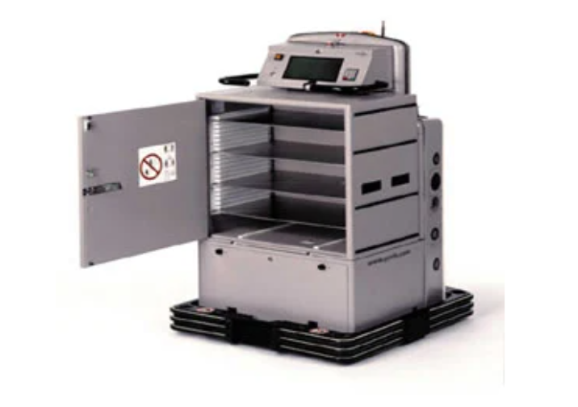

Figure 1.1. The HelpMate robot

(cited in reference **[7]**)

This robot was mainly utilized for moved many type of things from one place to another such as drugs,meals, reports,lab results or anything supposed to be essential for patient and doctor.

The abilities of HelpMate were also diversed that it was also capable of interact with its working environment based on data collected from sonar,infrared and vision systems and various of useful functions and an extreme safety system that integrated inside included estops,turn signals, and collision detect. All of these things made autonomous robots became the most reasonable and effective option of eliminating manual tasks to improve workforce productivity.

Nowadays, There have been a dramatically development of autonomous robot that has dominated in almost every day life’s aspects since the first commercial AMR robot was introduced 30 years ago. The AMR robots has gradually replaced the human being’s effort in taking over any tasks that help to release the burden of hiring more workers for factories and warehouse.

**1.2. Research situation of domestic and abroad**

* **For abroad applications**

The application of AMRs and its prominent contribution to variety of fields have been deployed by Business and government agencies to skyrocket the outcome profit and reduce the burden on employees so they could concentrate on the most valuable and most-critical tasks. There are 6 big majors that said to be most used of AMRs included:

* LIGHT INDUSTRY

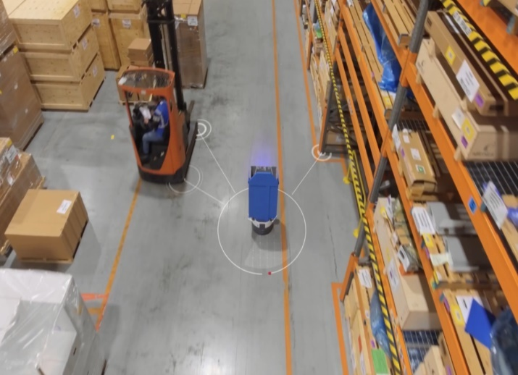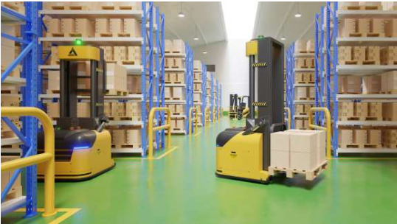

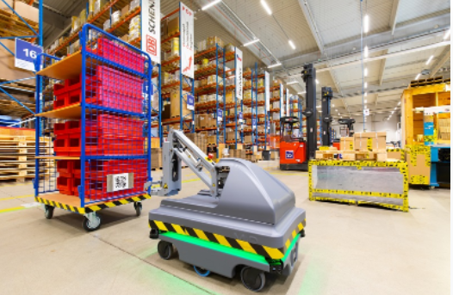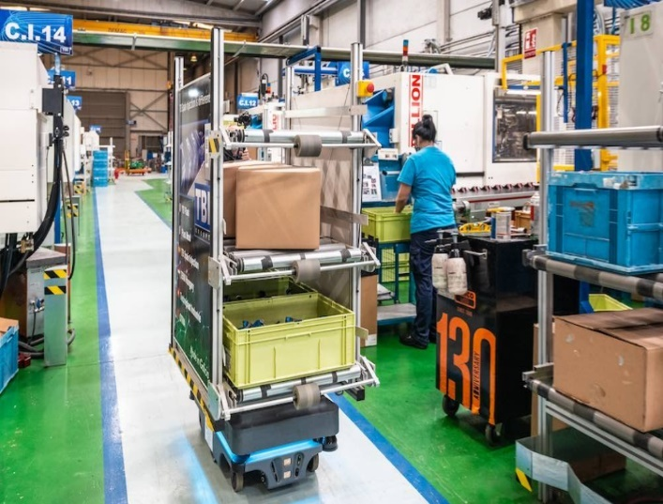

Figure 1.2. The AMRs in manufacturing, warehouse, and logistic applications

(Cited in <https://www.mobile-industrial-robots.com/fr/case-studies/mir200-tb-spain-injection-spain/>)

It is no doubt that the industry area is supposed be first and forefront of using new type of robot in carrying out difficult tasks due to the dangerous working’s environment, in which the high safety standard always prior as the critical point.

The AMRs can make best use of it to perform not only high-qualified tasks and light-duty tasks as well, deliver package safely one place to another. Furthermore, they are also in conjunction with PLC to enable them widely applied in many more specified areas require high-technique skill such as welding, assembly, materials transportation and warehouse security.

* 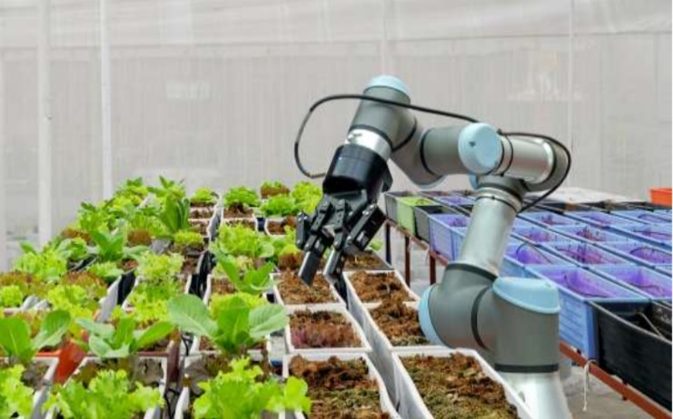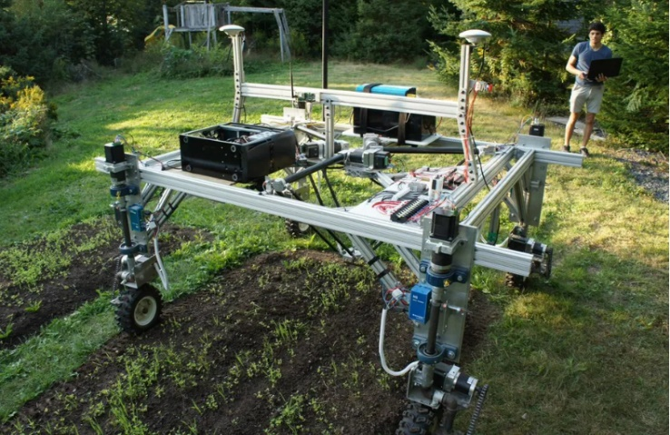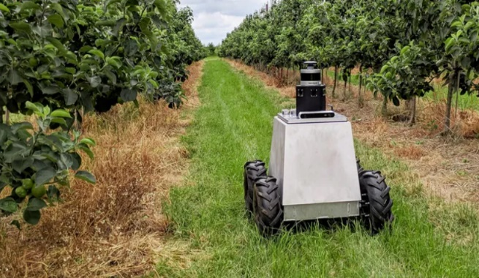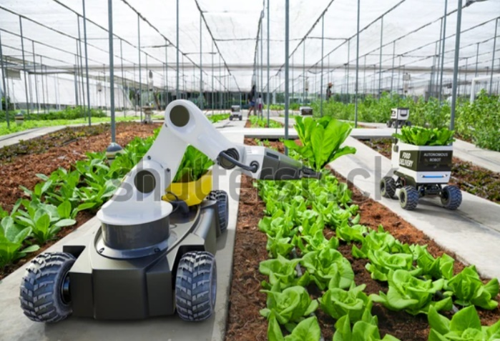FARMING AND AGRICULTURE

Figure 1.3. The AMRs in agriculture application

(Cited in:<https://www.wevolver.com/article/the-future-of-agriculture-adopting-more-advanced-robots-for-next-gen-farming>)

Thanks for the assistance of AMRs, farmers are able to harvest their crops more quickly and efficiently than before. The AMRs are integrated the intelligence capabilities that enable them to carry out some agricultural stuffs such as:

* Assess ripeness
* Move any branches or leaves out of the way
* Pick the crop precisely and delicately to avoid causing any harm to the product
* 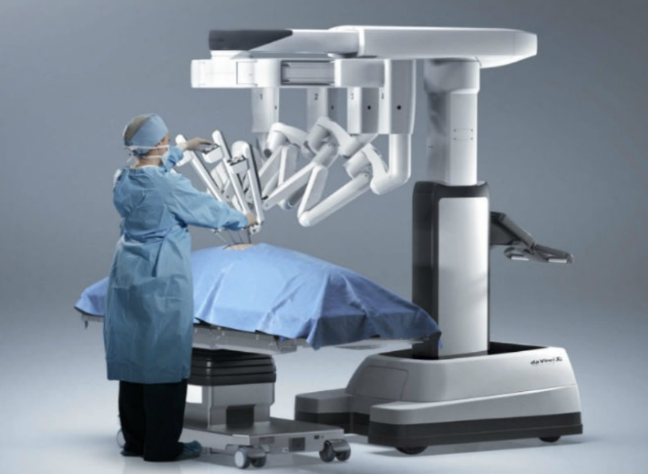HEALTH CARE

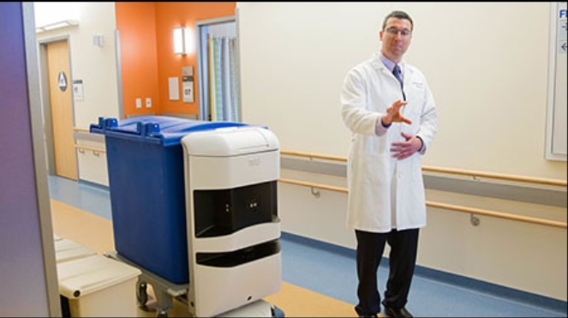

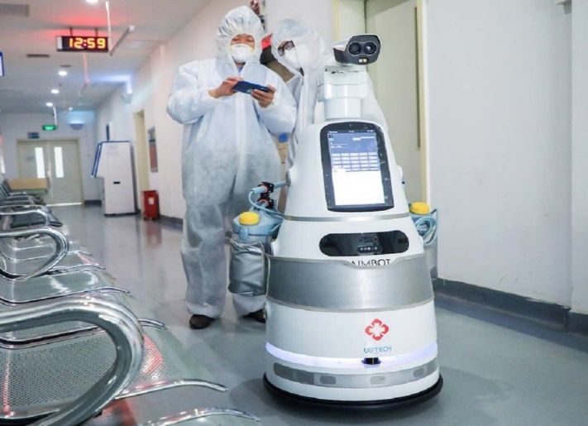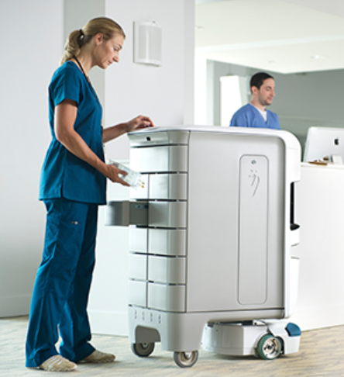

Figure 1.4. The AMRs in healhcare application

(Cited in:<https://danviet.vn/cong-nghe-khu-trung-covid-19-trong-cac-benh-vien-quan-trong-ra-sao-20210818132501167.htm> )

Healthcare organization nowadays relys substantially on AMRs due to their powerful ability to solve many problems in hospital such as disinfection,telepresence, and delivery of medication as well as medical supplies.

Moreover, AMRs was also able to assist professionals before a patient is check in.For instace, Mexico had their AMRs developed by start-up Roomie that were able to find out the infected covid 19’s patients by colecting data from their physiology included measuring temperature,blood oxygen level, and medical history when they reach at the hospital.

There are other types of AMRs that are utilized for healhcare’s application include:

* Service robot
* This kind of robot can relieve the daily burden on healthcare workers by handling routine logistical tasks.
* Furthermore, it can also help with cleaning and disinfection to help hospitals sanitize rooms and equipment aiding in the fight against COVID-19.
* Social robot
* This kind of robot can interact directly with humans by encouraging patients to comply with treatment regiment that helps to improve their ‘s emotional well-being.
* They can also be utilized for guiding direction to visitors and patients inside the hospital environment.
* RETAIL, BANKING, AND HOSPITALITY

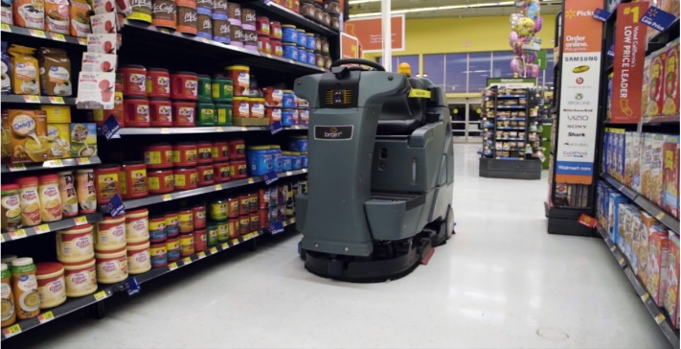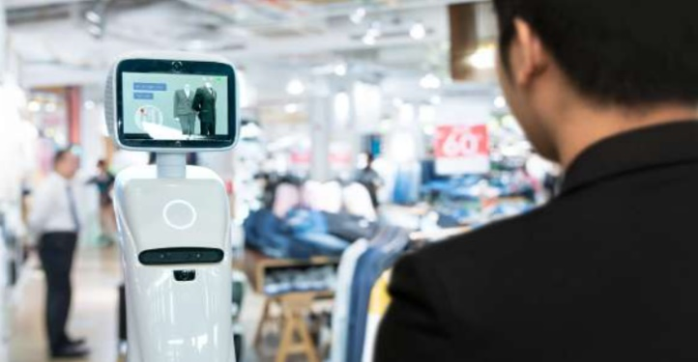

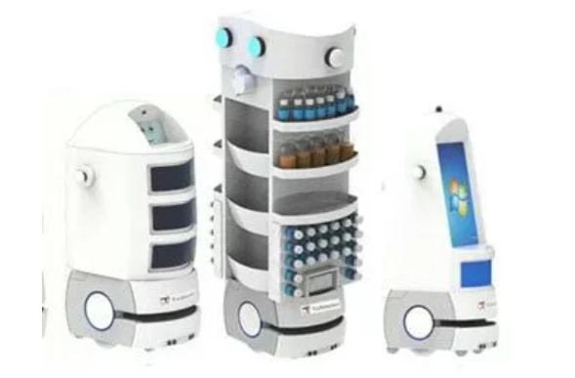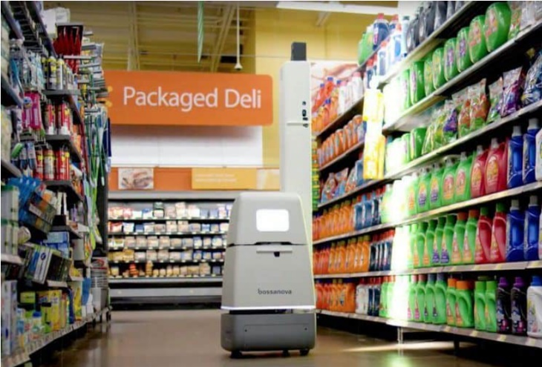

Figure 1.5. The AMRs in service application

(Cited in: [es, high-rise buildings to do all manner of deliveries, escorting and room service. Used for food, dirty linen, medicines, valuables delivery, chaperoning, security, stock taking, picking and much more.](es,%20high-rise%20buildings%20to%20do%20all%20manner%20of%20deliveries,%20escorting%20and%20room%20service.%20Used%20for%20food,%20dirty%20linen,%20medicines,%20valuables%20delivery,%20chaperoning,%20security,%20stock%20taking,%20picking%20and%20much%20more.))

There are many companies make the best use of AMRs to bring up the high-experiencing to customer or guest in diverse ways by providing some of following services such as:

* Luggage assistance
* Way-finding
* Clean various environment
* Automate inventory processes
* SMART CITIES

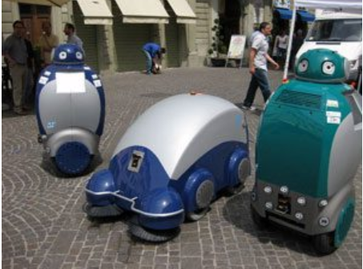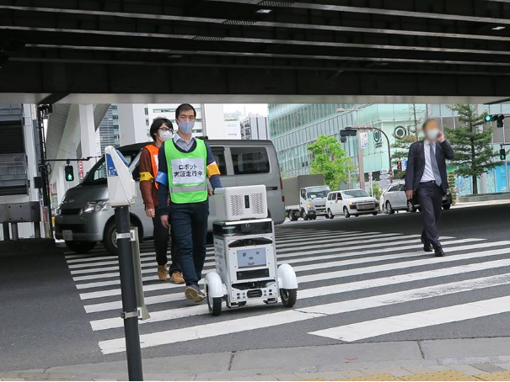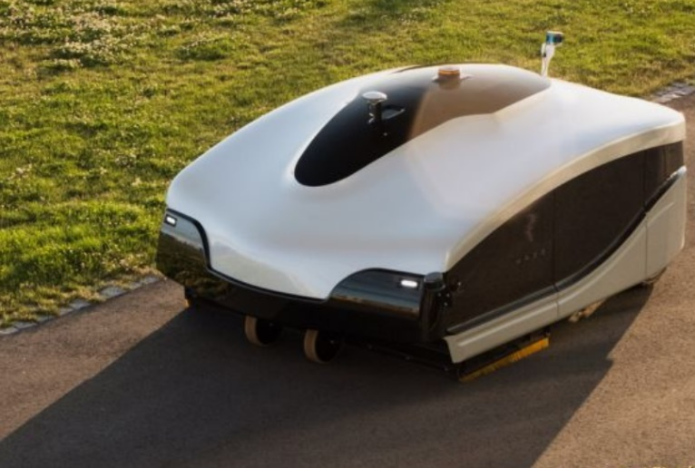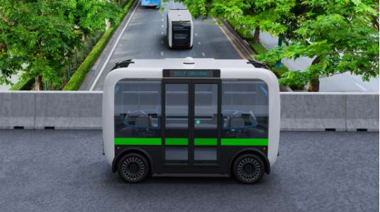

Figure 1.6. The AMRs in smart city application

(Cited in: <https://www.softbank.jp/en/sbnews/entry/20210716_01>)

Many elite countries in the world have managed to take the most advantage of AMRs in the campaign of making their cities the smart zone throughout improving residential services such as trash removal, public transportation, and public agencies with the aid of AMRs.

* **For domestic application**

In vietnam, the application of AMRs is still relatively restricted due to some limitation of technology gap as compared to other parts of the world. There are some prominent enterprises that pioneer in exposing the research of AGVs for small scale factory applications.

There are many huge companies such as Samsung, Panasonic, Foxcon, and Vinfast are using imported AGVs. While AMRs are still supposed to be unavailable in any factories in Vietnam for any applications.

However, in term of healthcare area, there are some small scale of AMRs that have been researched and implemented to deliver essential things in hospital amid the serious spread of 19 Covid pandemic as the social-distancing supposed to be a priority.

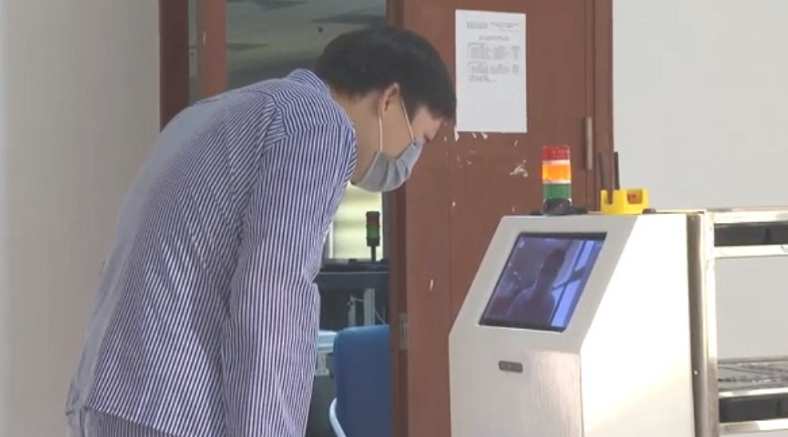Bach Mai Hospital is the first unit to pioneer in applying the advantages of AMRs to enhance the quality of caring patients and reduce the burden for doctor and nurse

Figure 1.7. The AMR in healthcare application implemented in Bach Mai hospital

(Cited in reference **[13]**)

This is a product of a science and technology project which was implemented by a Military Technical Academy as a mission to be handed by a ministry of science and technology in order to deploy in hospital at the early of 2020 when the Covid 19 has just emerged.

**1.3. Reason of choosing subject**

The world has changed dramatically since the first industrial evolution. The appearance of machinery has brought many benefits to humanity. It is anticipated that the AMRs will dominate all of categories in our life due to their efficient capabilities that can help human being tackle any problems in daily life.

Therefore, our group decided to research and implement an AMR capable of delivering food and essentials in hospital to prevent a physical-exposure between patients and doctors so as to reduce infected rates as the world is fighting against the pandemic Covid 19. The widely application of AMRs not only enhance the quality of patients’ s caring but also solve the problem of having lack of volunteers and workers in hospital.

**1.4. Limitation and scope of subject**

We decide to design and implement an AMR that meet some following requirements

* The autonomous robot has strong frame to endure the maximum weight of load up to 15 kg and can work continuously for at least 2 hour.
* The robot will be designed as a square cylinder with a dimension 430x430 mm and 730 mm height.
* Implementing SLAM and navigation algorithm for mobile robot that it can automatically create a map of working environment and go to goal location and avoids any obstacle and keep moving to finish its journey.
* Calculating the kinematic robot to proceed in PID controller that help a robot to move smoothly with suitable velocity to maintain the proper use of energy capability for not wasting too much power.
* Controls an autonomous robot via the ROS mobile app on smart phone and supervise its working status using RVIZ environment.

**1.5. Research method**

Searching the information of AMRs about their integrated component and how they work. Research of SLAM and Navigation algorithm, deploy the idea of a robot that suitable to transfer essentials in hospital.

We then started to calculate the appropriate motor and chose the material, then build a model of kinematic equation for robot. Finally, our group will design and implement a real robot.

# **CHAPTER 2: THEORETICAL BACKGROUND**

## **2.1. Overview of AMR robots**

Autonomous mobile robots have played a significant role in the development of every daily life aspect in general, and the high performance that it brings to the manufacturing industry. AMRs Have changed the way manufactures and warehouses operate, they are a high-class version of AGVs, which have surprisingly more capabilities than their predecessors. Both of them are able of moving material from origin to goal location and carry very high-load capacity up to 1500kg. However, when AGVs appear to be no different like a railroad train, which only operates effectively on predefined train tracks. An AMR, on the other hand, like a taxi that able to freely move between any two points and self-replan its route when encounter obstacles.

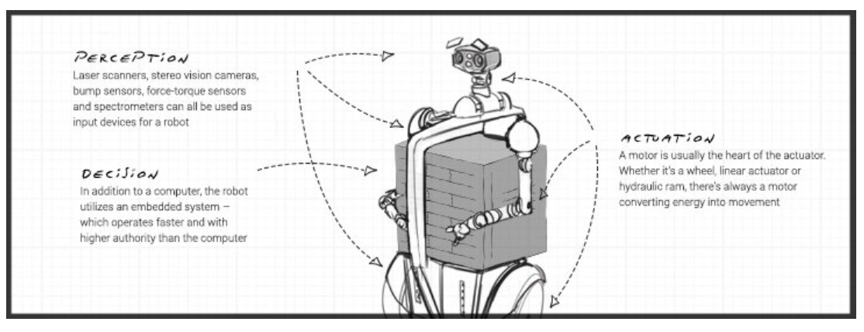Therefore, AMRs are capable of free-movement and real-time path planning that enables them to collaborate in material handling tasks with humans and thus makes them outraced AGVs. Apart from those fundamental differences, what stands out when it comes to AMRs is obstacle avoidance. They can automatically detect an obstacle and move around it to complete their designated task by localizing in a map created by themselves in working environment. This high-tech capability is thanks to a group of components equipped inside AMRs included 3D depth camera, and Lidar sensor to ensure the safety of people around them. These sensors work together to facilitate vision and smart identification of both static and dynamic objects within the robot’s field of view.

Figure 2.. Some prominent components of an AMR

(cited in reference **[12]** )

Furthermore, AMRs are supposed to be safer than AGVs, when they are trained to avoid humans and smart enough to identify obstacles of just everything in the working range of sensors.

The cost of maintaining an AMR is considered to be cheaper than AGVs. An AGV require a magnetic wires or tapes that stick on the ground to predefine the guide direction of it, therefore these wires need to spend a lot of time and effort to on maintenance after a period of time working that need to be replaced to ensure the proper working of AGVs. While an AMR require no infrastructure on the ground for maintaining.

## **2.2. Introduction of ROS system.**

### **2.2.1. Explanation of mobile robot platform**

* **What is robot software platform**

Whenever someone starts to deeply research about robot field, it is necessary to come across with the term robot platform. It is classified into software and hardware platform. A robot software platform consists of tools that are used to develop robot application programs such as hardware abstraction, low-level device control, sensing, recognition, SLAM, navigation, manipulation, and package management, libraries and so on.

Both of the platforms combine with each other to make it possible to develop application programs using software platform without having expertise in hardware. For instance, we can develop mobile apps without acquiring any knowledge about hardware composition or specifications of the latest smartphone.

* **Need for robot software platform**

The main reason why we should consider this core thing before starting working with robot field is that it can reduce development time which means to provide us all available and powerful tools that support us to program and create a complete robot without spending too much time on learning a new concept or avoid changing the already build system. We only need to insert a few standardized codes to turn a non-ROS system to a a ROS- system.

### **2.2.2. What is ROS (Robot operating system) ?**

In general, ROS is an open-source, or a meta-operating system for your robot. It provides the services you expect from an operating system. Thus, all of them help simply build a complex robot system by combining those robot platforms together. Moreover, ROS has been created to enable the people around the world to collaborate with each other and develop robot software globally. Using the already researched API helps to reduce the process of programing a real robot, which considers to be an ultimate goal of ROS.

In a nutshell, ROS is focused on maximizing code reuse in the robotics research and development.

## **2.3.  General introduction of SLAM**

SLAM or (Simultaneous Localization And Mapping) can be defined as an approach to enable the autonomous vehicles to explore and build the map based on the unknown environment while localizing itself in that map simultaneously. The term of Localization is also known as pose estimation of which collected by attached sensor on top of robot.

The information after being gained by mapping will be used for launching tasks including obstacle avoidance and path planning.

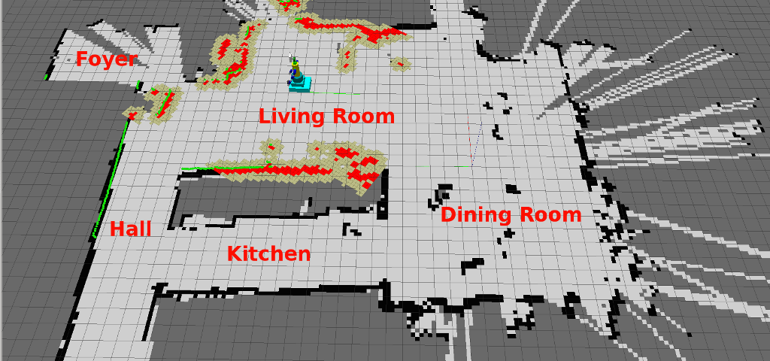

Figure 2.. Demo of SLAM image

(cited in <https://www.allaboutcircuits.com/news/wi-fi-sensors-help-robots-map-their-indoor-environment/>)

### **2.3.1. Explanation of SLAM and its matters**

SLAM has always been an interesting subject among technical community who take an interest in AMR. It was not until the significant improvement of computer speed and price’s deduction of sensors such as cameras and laser range finders that SLAM become practical to use for real life applications in various of fields. Let’s take a a deeper insight into some advantages and examples to know why SLAM is so important for autonomous robot.

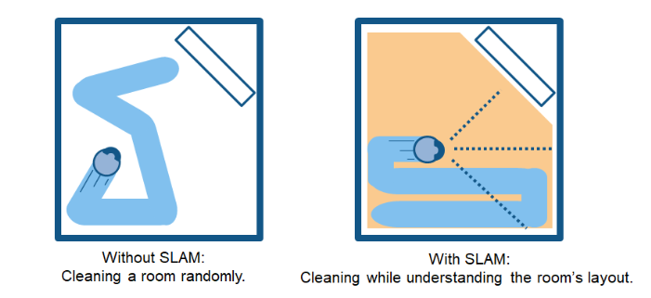

Figure 2.. Benefits of SLAM for Cleaning Robots

(cited in reference **[14]** )

One of the most transparent examples to show SLAM’s benefits is an indoor robot for vacuum application.

As we can see on the above picture, the robot without SLAM will just more randomly within a room and result in cleaning unfinished the entire floor surface. Moreover, this normal way may consume excessive energy and soon run out of the battery.

On the contrary, the robot with SLAM algorithm uses information calculated via number of wheel rotations and data from cameras and other imaging sensors to determine the amount of movement requires by which able to consume the amount of power in allowable range without burning out too much energy. This is so called Localization.

The process of simultaneously creating a map of the obstacles in its environment by using camera and other sensors while avoid cleaning the same area more than one time. This is so called mapping.

### **2.3.2. How does SLAM operate?**

In general, SLAM is a combination of 2 types of technology components including

* **Sensor signal processing**

Which is also known as the front-end processing, and depend largely on the sensors used

* **Pose-graph optimization**

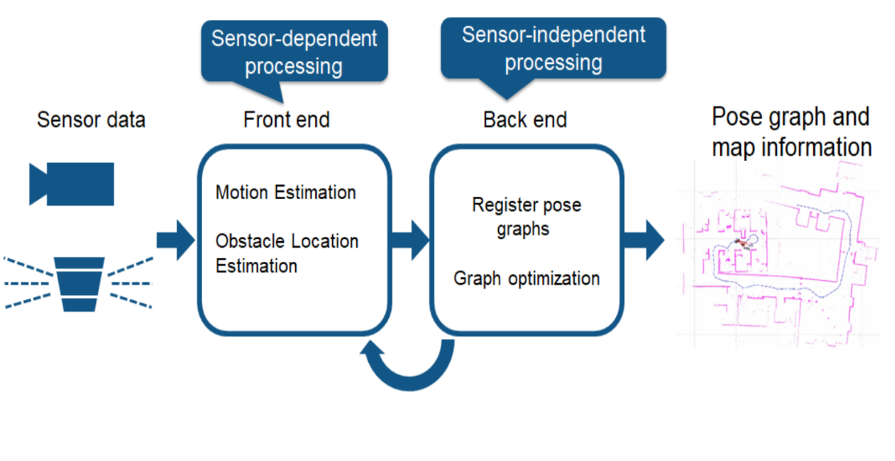Which is also known as the back-end processing, or sensor-agnostic

Figure 2.. SLAM Processing Flow

(cited in reference **[14]** )

### **2.3.3. Introduction of Visual SLAM**

This method mainly uses images collected from cameras and others image sensor. Furthermore, this way supposed to be implemented at low-cost with very cheap cameras. We also know that camera provide a large volume of information which used for detecting landmarks (previously measured position).

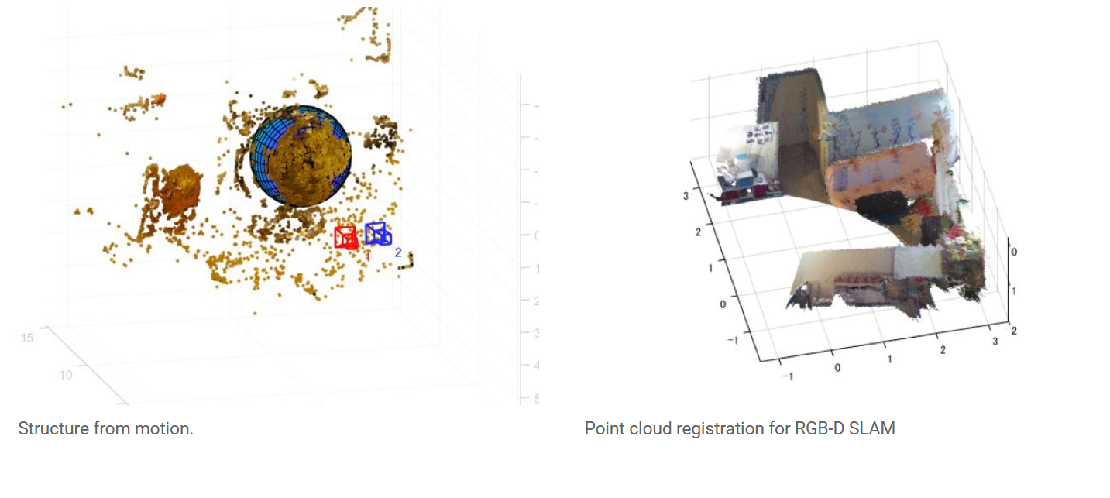There is another variant of Visual SLAM called Monocular SLAM, of which uses a camera as a single sensor to make it difficult to define depth. This problem can be solved by either either detecting AR markers, or fusing camera information with sensor such as IMUs that can estimate physical quantities are velocity and orientation. This Visual SLAM uses some techonologies includes structure from motion, visual odometry, and bundle adjustment.

Figure 2.. Visual SLAM algorithms

(cited in reference **[14]** )

### **2.3.4. Lidar SLAM**

This method is supposed to be widely used for automous robot on account of it flexibility, of which uses a lidar as a laser sensor (or distance sensor).

What make this method is effectively outraced the Vslam is the dependence on sensors instead of cameras that are more precise and feasible to use in some applications require high-speed moving vehicles likes self-driving cars and drones.

The output values from sensors can be either 2D (x,y) or 3D (x,y,z) which is point cloud data. The 3D data offers high-precision distance measurement and very effectively for map bulding with SLAM. The estimated movement or traveled distance is used for localizing the robot. 2D or 3D point cloud maps can be represented as a grid map.

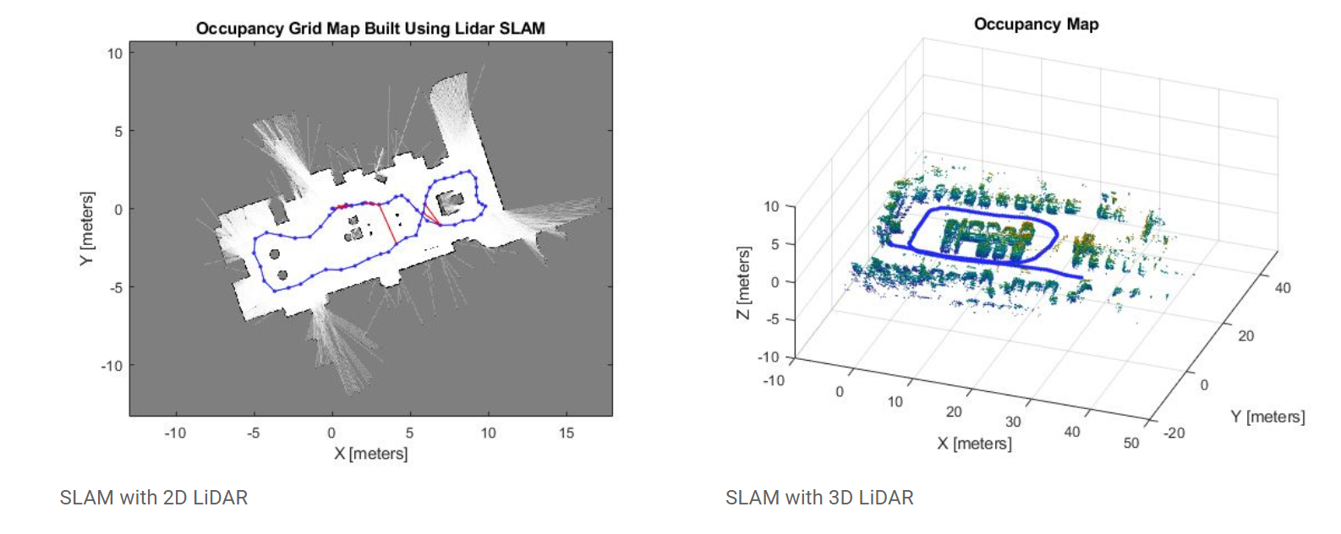

Figure 2.. Lidar SLAM algorithms

(cited in reference **[14]** )

## **2.4. Research of robot navigation**

The navigation of robot is to move it from one place to another in a given environment while localizing itself and to acquire a map of its moving environment. It does not sound an easy task. Moreover, the core things that enable robot to move safely in any environment is to figure out the optimized route among various of given options calculated, and to avoid obstacles such as walls or any object includes human on its journey. These tasks require a lot of efforts for an engineer to accomplish a smooth navigation system for mobile robot.

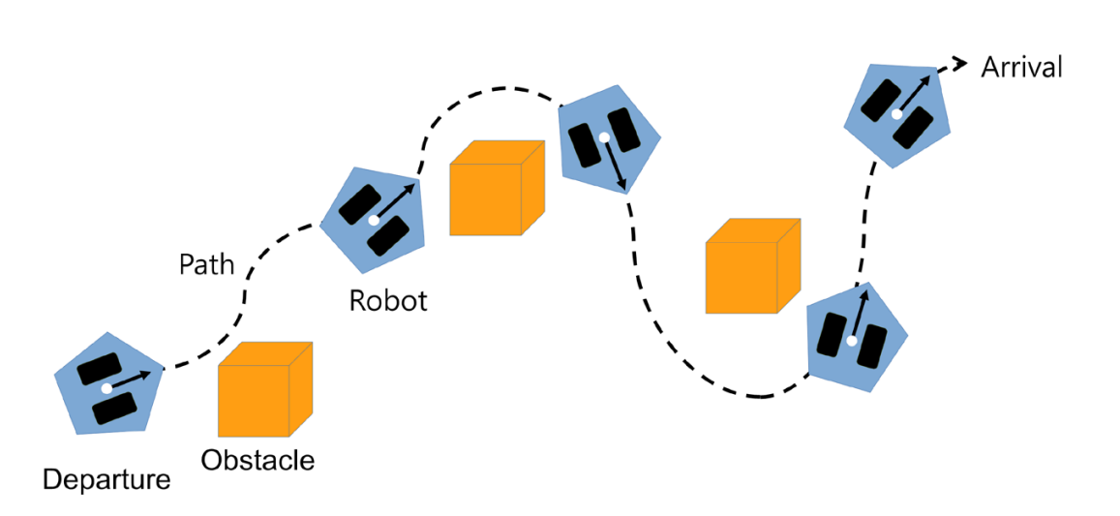

Figure 2.. Navigation of mobile robot

(cited in reference **[4]**)

The ability to move from the current position to final goal substantially based on a map that uses some components such as robot’s encoder, inertial sensor, and distance sensor. In its simplest term, we can obtain a navigation by the following process that summaries under a table below.

Table 2.1. Process of navigation

|  |  |  |
| --- | --- | --- |
| Procedure | Components require | Function |
| Sensing | * Encoder * Inertial sensor (IMU) | Measures distance from the pose of the sensor to the obstacle |
| Localization/Pose estimation | * Wheel rotation (from encoder) * Inertial information (from IMU) * Distance information (from sensor to obstacle) | Estimates the current position on the previously created map |
| Motion planning | * Global path planning (in the whole map) * Local path planning (smaller areas around robot) | Create a trajectory or a shortest path from the current to the target position on the map |

## **2.5. PID controller**

### **2.5.1. Overview of PID control**

This considers to be a famous algorithm that commonly used in Electrical area or any major that requires high precision motion control especially in robotic field. The PID controller can help to optimal the output value of a system in order to make it as close to input value as possible by which eliminates all the noise error caused by Exterior elements.

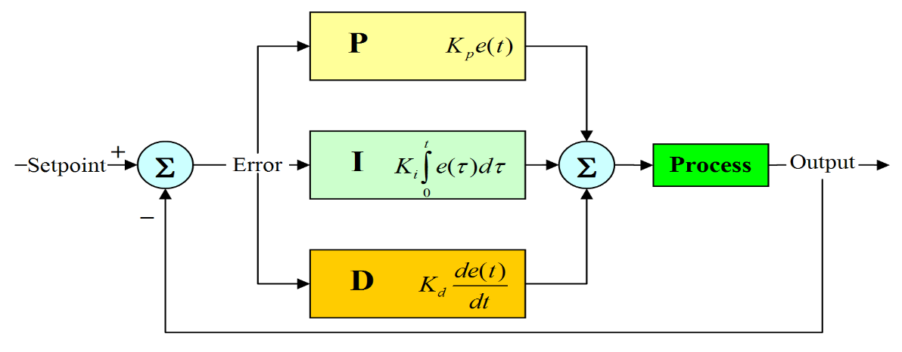

Figure 2.. Block diagram of PID controller

(cited in reference **[15]**)

### **2.5.2. Theory of algorithm**

An automatic car that uses some components includes board Arduino, an ultrasonic sensor, and a motor driver. The question is how to control a car to move in straight line without curving caused by the speed’s error between two wheels.

Let’s assume we want a motor to rotate with a speed of 100 rpm. However, the observable output value is only 50 rpm due to a high friction force as a noise factor. In this time being, we have an error of which presented as e = 100 – 50 = 50. Then we can conclude the error = 50 rpm

The way of how to control motor’s speed will largely depend on the error that we have just already found. It is clear that the motor still rotates relatively slow with the error = 50 rpm, we need to speed up the velocity of motor by increasing the pulse width (PWM).

As a result, PWM = 50 + 50 (assume: 100rpm ~ 50 PWM)

In case, the motor runs too fast respect to the set point value (e < 0), we need to decrease the pulse width.

The final result of algorithm is a speed’s error in a specific time being, this value will be adjusted and calculated properly to extract the most accurate output value.

The return output value calculated by algorithms is a composition of 3 elements includes P, I, D which can be explained as an error at the moment, error based on the whole process, and the deprivative of error at that moment.

* **Proportional (P)**

An error value at the time being, this value can be calculated via ideal speed value that we want motor to run.

As we can see, the pulse width is almost propotional to the error, then we can write out an equation

$X = Kp.e\left(t\right)$**[15]**

While: X is a Pulse width

Kp is a proportional gain (tuning parameter)

e is an error = SP – PV(t) (SP: setpoint, PV: process variable)

t is an instantaneous time

Kp should be chosen according to the realtime running of motor. This is the most time consuming stuff.

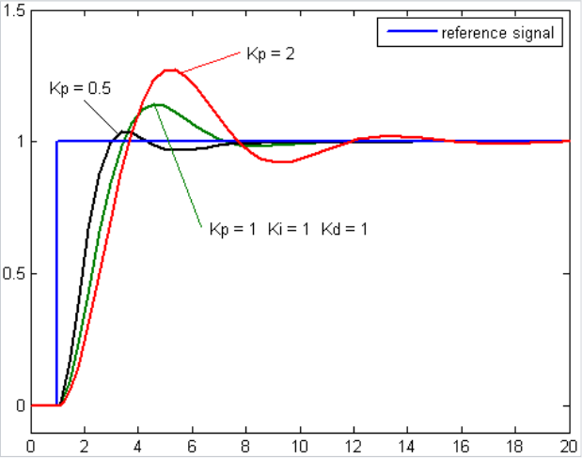

Figure 2.. Response of PV to SP for different Kp values respect to time

(cited in reference **[15]** )

* **Integral (I)**

The term I presents for past error value and integrates them over time to produce it. More detailed, the integral in a PID controller is the sum of the instantaneous error over time and gives the accumulated offset that should have been corrected previously.

Theoritically, the ouput value can be adjusted accurately via the equation X = Kp*e. However, it does not work as expected in practical due to the return error value is too small that affects the X value so it is unable to change the speed of motor. As a result, motor always run in a certain value as close to real value and never reach it. For instance, the expect value is 100 rpm, but the real value is just 99 rpm, as a consequence of small X that is impossible to speed up the motor.

In this case, we need to accumulate the sum of error respect to time. After a specific interval of time we will add more error value until the value is large enough to change the speed of motor. The pulse width equation is now presented as

$X= Kp.e\left(t\right)+ Ki.\int_{0}^{t}{e(τ)dτ}$**[15]**

While: Ki is a intergral gain (tuning parameter)

e(t) is an error = SP – PV(t) (SP: setpoint , PV: process variable )

t is an instantaneous time

$τ$ is a variable of integration

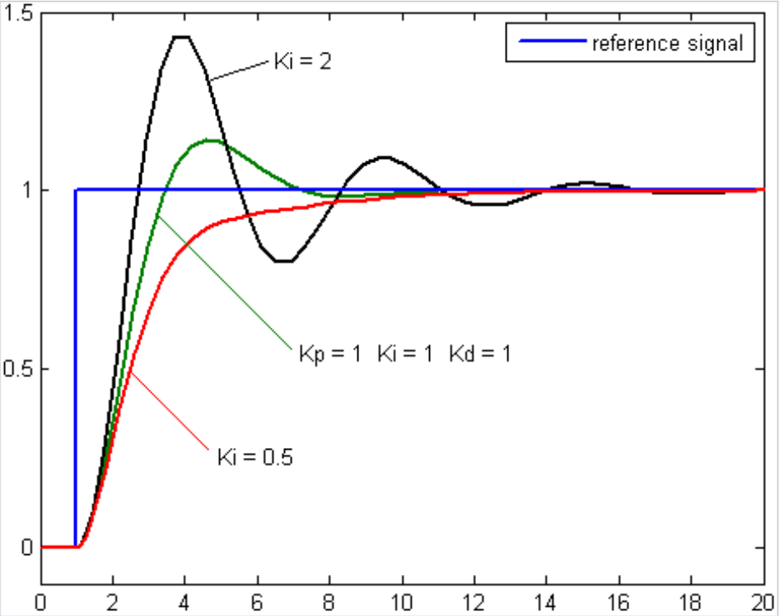

Figure 2.0. Response of PV to SP for different Ki values respect to time

(cited in reference **[15]**)

* **Derivative (D)**

This derivative method can be used to anticipate the future state of motor’s speed based on its current rate of change, The more rapid of change, the greater the controlling or damp effect.

Let’s assume the motor is speeding up and reaches approximately to the set point value (e = 0), we stops adjusting PWM as soon as X = 0, the velocity will be likely to remain constant or decrease. However, velocity keeps increasing due to the inertial force caused by motor shaft and other components inside it. Therefore, we need to adjust the X value to make it smaller to decrease the motor speed. At the moment e = 0, X = 0. Then, we stop adjusting pulse width. As a matter of fact, the velocity does not maintain at a constant value but decreases a little bit. The behaviour of speed to surpass requirement value a little more than the actual value which we call fluctuation respone behaviour.

The way of keeping this fluctuation at bay is to slow down or decelerate speed of motor as the it is getting close to the set point. This rate of change can be calculate via

$∆t= e- e(t)$**[15]**

While: e is an error value at a preset moment

e(t) is an error value at previous moment

The pulse width equation is now presented as

$X= Kp.e\left(t\right)+Ki.\int_{0}^{t}{e\left(τ\right)dτ+Kd.(e-e(t))}$**[15]**

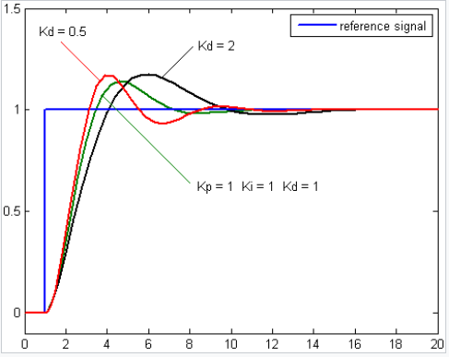While: Kd is the derivative gain

Figure 2.11. Response of PV to SP for different Kd values respect to time

(cited in reference **[15]** )

### **2.5.3. Method of PID tuning**

Tuning a loop control is the process of adjusting its parameter to optimum values for the best desired control response. The most important criteria to consider is stability of a system. As a matter of fact, different systems have different behaviour. Despite of having only three parameter to adjust, But PID tuning is a difficult task because it must satify complex criteria within the limitations of PID control. Furthermore, There are various methods for tuning loop control. However, in our project we decided to use the manual tuning method as it does not require any complex calculation or mathematics model but depends largely on experienced personel.

* **Brief summary of manual tuning**

At initial, we have to set Ki and Kd values is zero, increase Kp untill the output of the loop appear oscillation, then set Kp to approximately half that value for a “quarter amplitude decay”-type response. Then increase Ki until any offset is corrected in sufficient time for the process, but not untill the a value become to large to cause instability. At last, increase Kd to expedite the response process to quickly reach the set point.

Table 2.2. Effects of increasing a parameter independently

|  |  |  |  |  |  |
| --- | --- | --- | --- | --- | --- |
| Parameter | Rise time | Overshoot | Settling time | Steady-state error | Stability |
| Kp | Decrease | Increase | Small change | Decrease | Degrade |
| Ki | Decrease | Increase | Increase | Eliminate | Degrade |
| Kd | Minor change | Decrease | Decrease | No effect in theory | Improve if Kd small |

## **2.6. Communication protocol**

This is a very important definition that nearly almost any communication between 2 or many devices are largely depend on. The various system requirements will be a decisive factor on how it is designed in different ways. There is a specific rule between these protocols and devices to guarantee the succesful communication.

Embedded system, microcontrollers, and computers mostly use UART as a form of device-to-device hardware communication protocol. UART is said to be a simplest way of wiring connection among the other protocols since it require only two wires for its transmitting and receiving ends tasks.

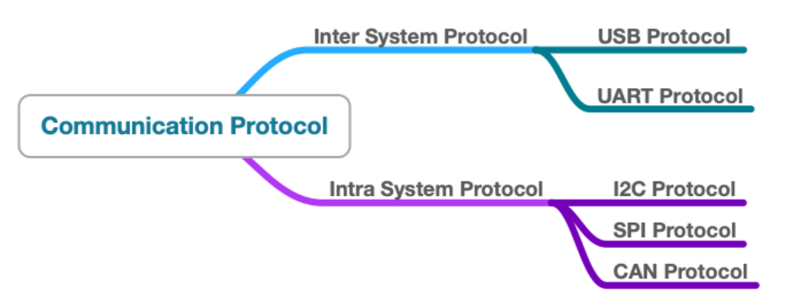

Figure 2.12. Different ways of communication protocol

(cited in reference **[16]**)

### **2.6.1. Summary of UART**

UART, which is a reduction of universal asynchronous receiver-transmitter. In other ways, it is also known as a hardware communication protocol that uses asynchronous serial communication with speed can be configured. The term “asynchronous” means the synchronization of output bits without clock signal between the transmitting device going to the receive end.

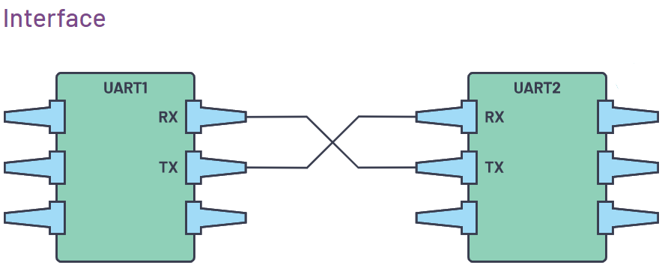UART is one of the most used device-to-device communication protocol

Figure 2.13. Two UARTs directly communicate with each other.

(cited in reference **[16]**)

The communication among UART devices can be represented as 2 types of signals includes Transmitter(Tx) and Receiver(Rx).

A transmitter and receiver line among each device responsible for transmitting and receiving serial data intended for serial communication.

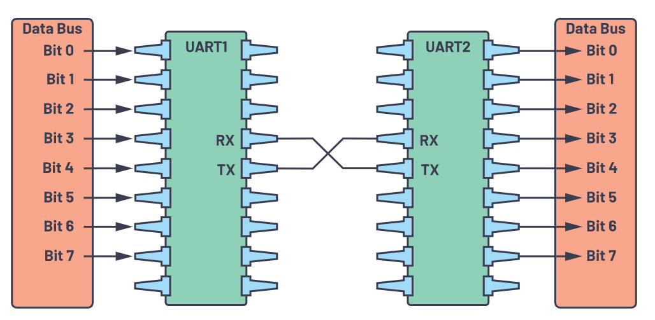

Figure 2.14. UART with data bus

(cited in reference **[16]**)

The UART transmitter sends data in a parallel form via a controlling data bus. After that, transmission line will transmiss the data serially, bit by bit, to the UART receiver. Finally, the serial data will be converted into parallel for the receiving device.

In additional, the UART lines can be uses as the communication medium to transmit and receive one data to another. Furthermore, the baud rate is highly recommended to adjust the same on both the transmitting and receiving device. The baud rate is the speed of transferring information to the communication channel. Moreover, the baud rate represents for the maximum number of bits per second to be transferred.

Table 2.3. UART summary

|  |  |
| --- | --- |
| Wires | 2 |
| Speed | 9600, 19200, 38400, 57600, 115200, 230400, 460800, 921600, 1000000, 1500000 |
| Methods of transmission | Asynchronous |
| Maximum Number of Masters | 1 |
| Maximum Number of Slaves | 1 |

As we already knew, a clock signal in UART interface does not mainly take on for the synchronization between the transmitter and receiver devices is impossible. The replacing method is to generate a bitstream based on transmitter’s clock signal during the incoming data is sampled by the receiver using its internal clock signal.

The main point of synchronization method is to have the same baud rate on both devices. Once this continuous process fails that can lead to the discrepancies during data handling as a consequence of timing affect between sending and receiving data.

### **2.6.2. What is Rosserial ?**

The rosserial is a package in which contains ROS messages, topics, and services to be converted into form of data that can be used in a serial communication. In its simplest term, rosserial is a bridge to allow new electronic hardware to directly communicate to ROS system.

The need of message conversion is due to the normal use of serial communication by microcontroller via UART instead of TCP/IP which is a default communication in ROS. Therefore, rosserial must take responsible for interpreting every data sent from microcontroller (rosserial-client) to computer(rosserial-server) using ROS in order to make them understand each other.

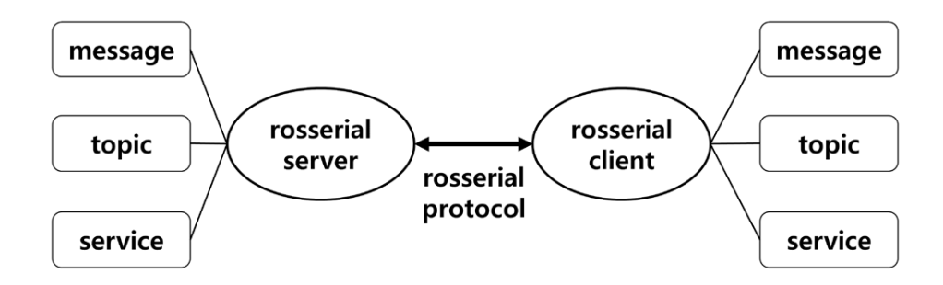

Figure 2.15. Rosserial server (for PC) and client (for embedded system)

(cited in reference **[17]** )

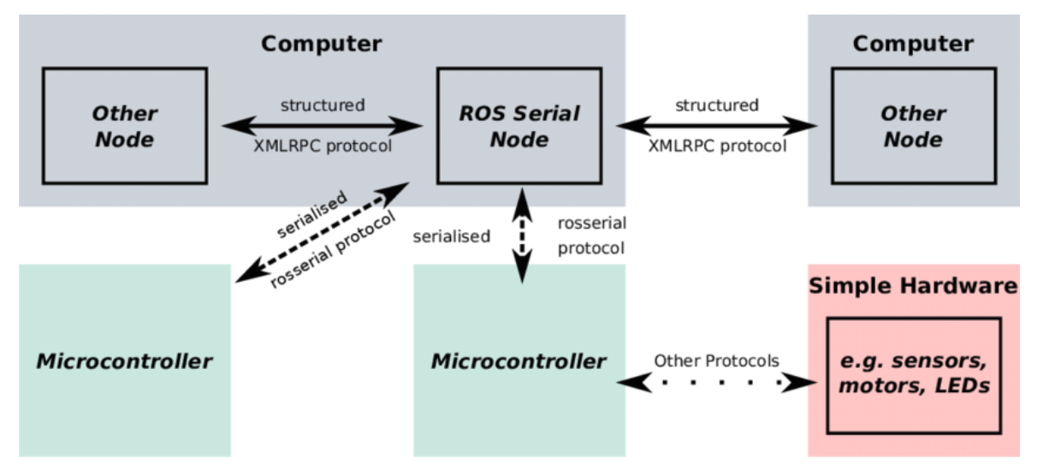

Figure 2.16. ROS integration for Miniature of Mobile Robots

(cited in reference **[17]** )

A complete ROS system is a combination of two components includes

* **Rosserial-client package**

It is a list of available microprocessor types compatible for ROS communication such as Arduino, STM32, embeddedlinux, and so on

* **Rosserial-server package**

It plays an important role as an interpreter which is a group of programming language such as C++ and Python

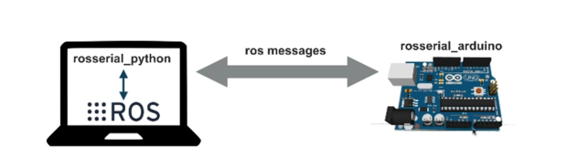

Figure 2.17. ROS integration for Miniature of Mobile Robots

(cited in reference **[17]** )

## **2.7. Kinematic of mobile robot**

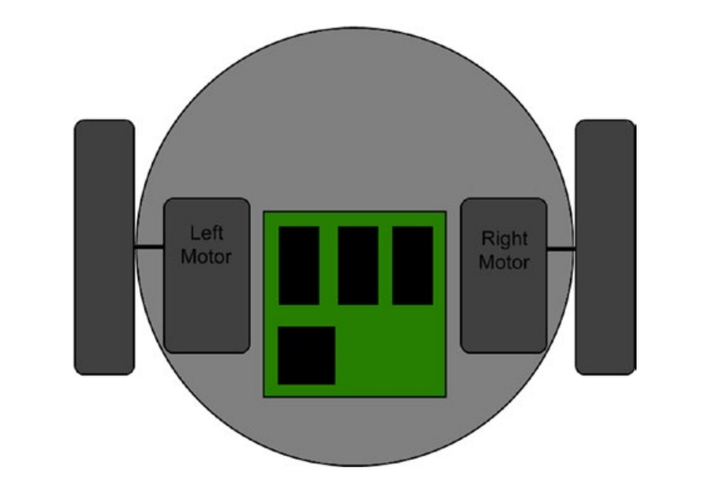Nowadays, Many mobile robots have been designed based on differential drive kinematic as a main drive mechanism, of which consists of two wheels placed on opposite direction. Both of them are attached to motors to rorate, the direction or pose of robot can be control by changing speed of the motor.

Figure 2.18. The differential drive configuration

(cited in reference **[3]** )

The movement of robot from point A to point B requires an accurate computation of differential drive kinematic. Therefore, all we have to know is the exact position as well as orientation of the robot that obtain from speed of the robot’s wheels by counting each revolution of the wheel via encoder, which is a sensor that integrated in motor. After calculation we can collect the velocity and thereby the displacement and orientation of the robot.

In order to predict the current position and orientation while the robot is moving, we have to solve the robot’s kinematic equation. It is the study of a robot’s motion without considering the cause of it. The kinematic equations can be classified into two types are inverse and forward. However, in differential drive robot, we will focus on forward kinematics.

When robot perform rolling motion, it must rotate about a point that lies along their common left and right wheel axis, which is also known as the ICC-Instantaneous Center of Curvature.

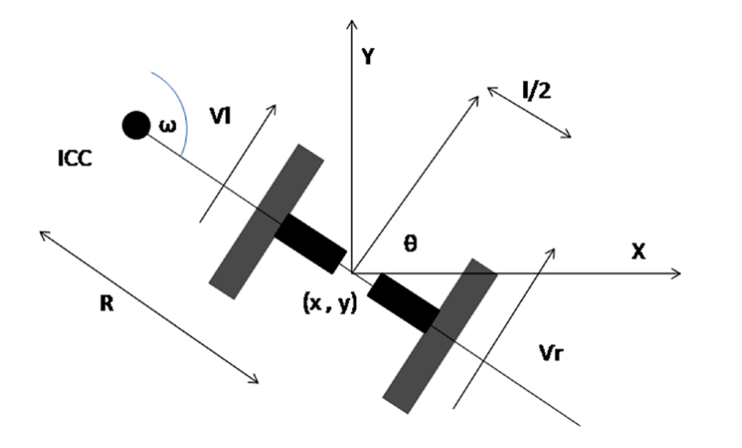

Figure 2.9. Analysis of differential drive kinematics

(cited in reference **[3]**)

The trajectories of robot can be changed via varying the velocities of both wheels. Since the rate of rotation $ω$ around the ICC must be identical for both wheels. The following equations can be written as:

$\left\{\begin{aligned}V_{r}=ω(R+\frac{l}{2}) \\ V_{l}=ω(R-\frac{l}{2})\end{aligned} \right.$**[23]**

Where: $l$ is the distance between two wheels’s center

$V_{r}$ and $V_{l}$ are the right and left wheel velocities respectively

R is the distance from ICC to the center of the robot

$ω$ is the angular velocity $(2π/180)$ (rad/s)

At any instance in time we can solve for R and $ω$:

$\left\{\begin{aligned}R=\frac{l}{2}({V_{l}+V_{r}}/{V_{r}-V_{l}}) \\ ω=\frac{V_{r}-V_{l}}{l}\end{aligned}\right.$**[23]**

We assume the robot is centered at a point midway along the wheel axle. We can control the robot to move to different positions and orientations by manipulating $V_{r}$ and $V_{l}$. Then using equation above, we can find the ICC location:

$ICC=\left[x-Rsin\left(θ\right),y+Rcos\left(θ\right)\right]$**[23]**

And at time $t+δt$ the robot’s pose will be:

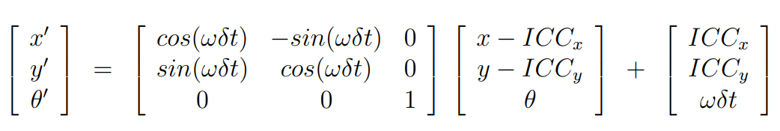

(cited in reference **[23]**)

This equation describes the motion of a robot rotating a distance R about its ICC with an angular velocity of $ω$.

# **CHAPTER 3: DESIGN AND IMPLEMENTATION**

## **3.1. Mechanical design**

### **3.1.1. Fundamental of design**

Our group decided to design and implement a mobile robot that adapts some following criteria:

* In term of a scale, the robot will be approximately 680 mm on height and weight about 19 kg that easily to contact with almost majority of patients and doctors in hospital.
* In term of task carrying out, our robot is expected to carry essential products are food and drink 3 times annually, for 20 patients in their own sick beds at nearly 20 minutes.
* The maximum amount of weight robot can carry is about 15 kg.
* The operating interval of time will last at least 2 hours.
* The possible range of the robot’s operation depends on size of the map scaned and stable wifi connection.

The robot will be designed to have some basic operating systems as:

* The centre system: which is a combination of MCU and motor driver that help to control the movement of robot stable and precisely.
* The interact,control and supervise system will be operated via Rviz environment on computer and Rosmobile.
* The obstacle avoidance and path planning system helps the robot to move effectively like a real human being.

The principles of operation will go through some following step below:

* Before running robot in a real application, we first need to control a robot to move around the surrounded area to scan a map.
* After having a map we then proceed to distribute products on robot’s container.
* Running Rviz environment on computer and click to destination’s point on the map, by which commands it to move to that goal.
* When the robot reachs at patient’s bed, doctor can observe all things happening via camera as patient pick up their products, the doctor then continue to click to another patient’s postion.

### **3.1.2. Requirement of design**

Mobile robot that operates in hospital is required to meet some basic requirements such as light weight structure, fit scale, and non-restricted moving in any direction. There are two types of mobile robots are car-like and Hilare-type that we will study and choose the most appropriate one.

* **Car-Like Mobile Robot**

This kind of robot is no different as compared to a real car in term of drive mechanism. It has a single motor to powers a differential,which in turn distributes the motor’s torque to the rear wheels. The front wheel(s) will be attached to a steering mechanism, and driven by a motor to generate steering angles to steer the robot.

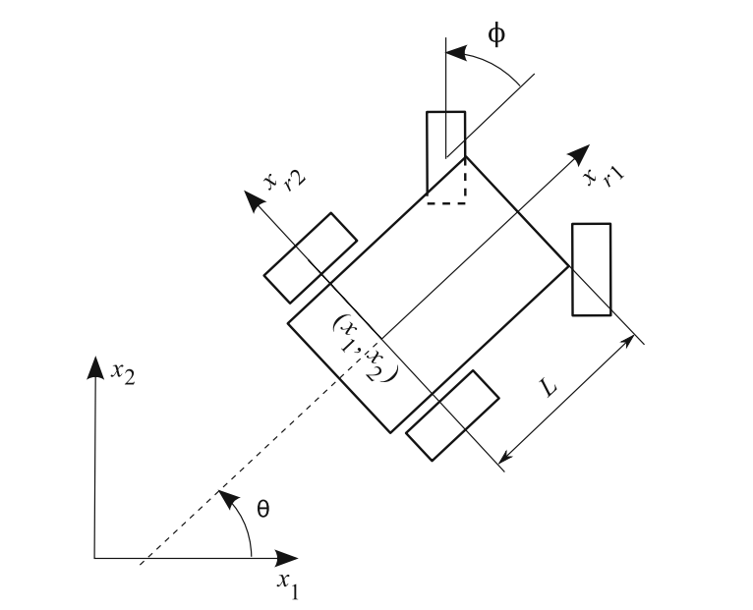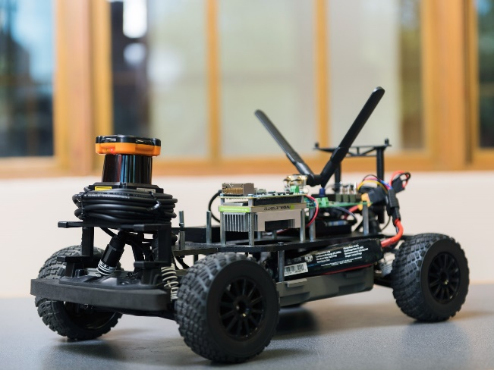

Figure 3.1. A Car-like mobile robot

(cited in reference **[6]**)

* **Hilare-type Mobile Robot**

This robot is widely recommended to be used in an indoor application. Their drive mechanism composes of two independent driven wheels. Thus, there are two separated motors control for each wheel. In additional, the Hilare-type robots also have one or many passive casters wheel that support for the balance of it. Moreover, their maneuvering abilities are supposed to be good performance. They can be controlled at ease and save a lot of time for assembly process due to their simple drive mechanism.

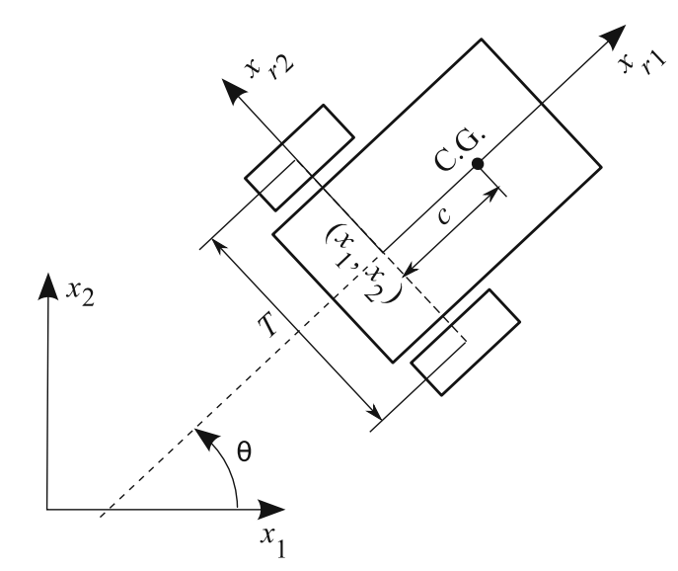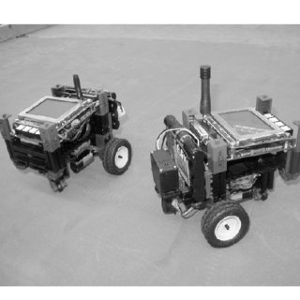

Figure 3.2. A Hilare mobile robot

(cited in reference **[6]**)

* **Comparison between 2 types of robots**

Table 3.1. Hilary-type Robot in comparison with Like-car Robot

|  |  |  |
| --- | --- | --- |
| **Characteristics** | **Type of robots** | |
| **Hilare-type Robot** | **Like-car Robot** |
| Flexible moving in small environment | High-performance | Low performance |
| Programming control | Complicated | Simple |
| Assembly and manufacturing | Very quick due to its simple structure | Waste a lot of time due to its complex structure |
| Drive mechanism | Simple (not many components) | Complicated (many components) |
| Curve angle | Wide | narrow |
| Maneuvering abilities | Good due to minimum turn radius | Bad due to nonzero minimum turn radius |

After a relative comparison between two types of robots, we can conclude that Hilare Robots are more effective compared to Like-car robots when used in service applications in a limited area or environment. Thus, the Hilare robot is expected to adapt more flexible and well-performance than its opponent in the hospital application.

### **3.1.3. Calculation and selection**

#### **3.1.3.1. Selection of transmission**

There are three types of transmission that mostly used in many devices,machinery and manufacturing processes nowadays,such as:

* Mechanical transmission
* Electrical transmission
* Hydraulic and pneumatic transmission

Mechanical transmission is the most widely used among the other types in such many industrial areas.They transmiss the movement between the engine by converting the potential energy into the mechanical energy that that drive the whole mechanical system.We also have 2 types of mechanical transmission based on working principle:

* **Friction transmission:** Belt chain and internal-contact friction
* **Gearing transmission:** Gear drive, worm gear

The mobile robot serves in hospital must be flexible in order to avoid people and move smoothly in such narrow area without causing much noise. Thus, choosing the most suitable one must be considered out of given three forms transmission below:

* **Belt drive**

This transmission is carried out by link or more rotating shafts or pulleys mechanically using a belt, which is a source of motion that transmit power effectively or to track relative movement. The transmission ratio can be varied flexible via changing the belt radius.

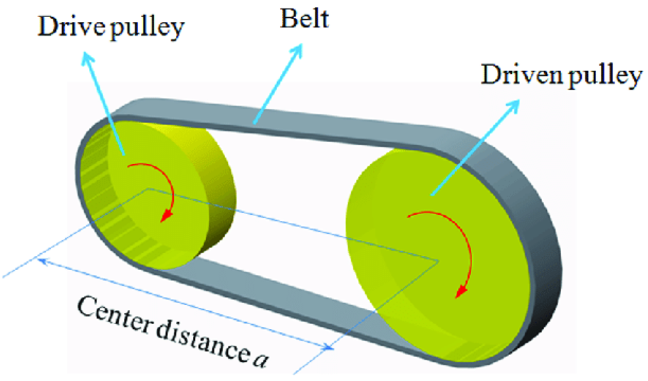

Figure 3.3. Belt drive components

(cited in: <https://www.researchgate.net/figure/Schematic-structure-of-belt-drive_fig9_312339125>)

* **Chain drive**

in this transmission type, the mechanical power is transsmited from one plate to another via different chains. It is often used to convey power to the wheels of a vehicle, such as motorbikes and bicyles.

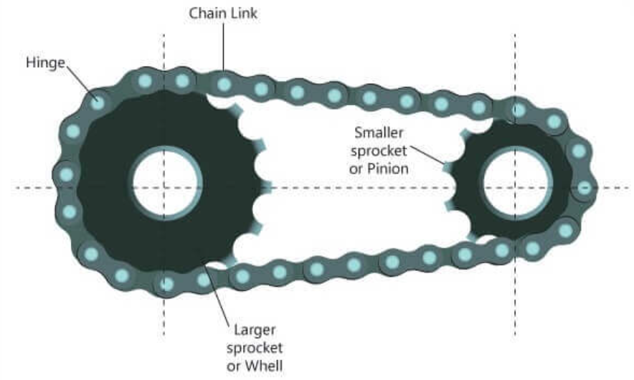

Figure 3.4. Chain drive components

(Cited in: <https://www.pinterest.com/pin/687573068096159241/>)

* **Gear drive**

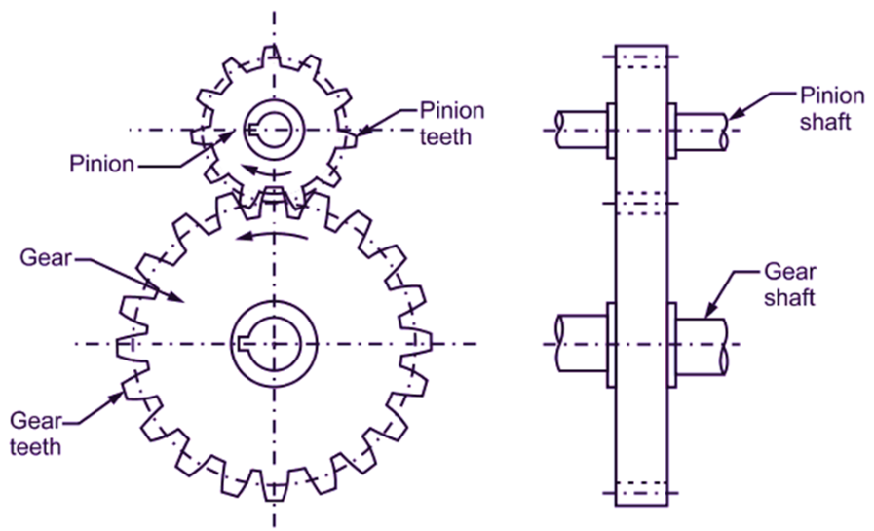This kind of transmission has a gear as a rotating part which has cut teeth and mesh with another toothed part so as to transmit torque and power. In addtional, the rotational speed of the output shaft can be increased or decreased just by gear drives. The most common use of gear drives is for reducing speeds of motors and engines that run at thousands of revolution, which are speed reducers.

Figure 3.5. Gear drive components

* **Comparison among three types of mechanical drive**

Table 3.2. Comparison between different types of mechanical drive

|  |  |  |  |
| --- | --- | --- | --- |
| **Criteria** | **Belt drive** | **Chain drive** | **Gear drive** |
| Space occupied | Large space requires | Moderate space requires | Less Space requires |
| Structure design | Simple | Simple | Complicated |
| Life expectancy | Less life | Moderate life | Long life |
| Maintanance | Not required,can be replaced with low cost | Required proper lubrication and tension chain | Requires proper lubrication,high cost maintanance |
| Installation cost | Cheap | Expensive | More expensive |
| Ratio of transmission | Used for Low-velocity application (ratio can vary flexible) | Used for moderate-velocity (fixed ratio) | Used for high-velocity application (requires precise ratio) |
| Effects on machine when failure | Does not cause the further damage | May not cause seriously damage | May cause serious break down |
| Loads acting on shaft | Safe due to high-tension capability | Low | Low |
| Shaft length | Large | Large | Small |
| Noise during operating | Low | High | Low |

After having evaluate different types of drive mechanism based on some criteria, our group decided to choose belt drive as a main mechanism drive for the mobile robot due to its low cost and easy to replaced. Furthermore, it is also suitable for transmit smoothly movement cause less noise when operating in such hospital environment.

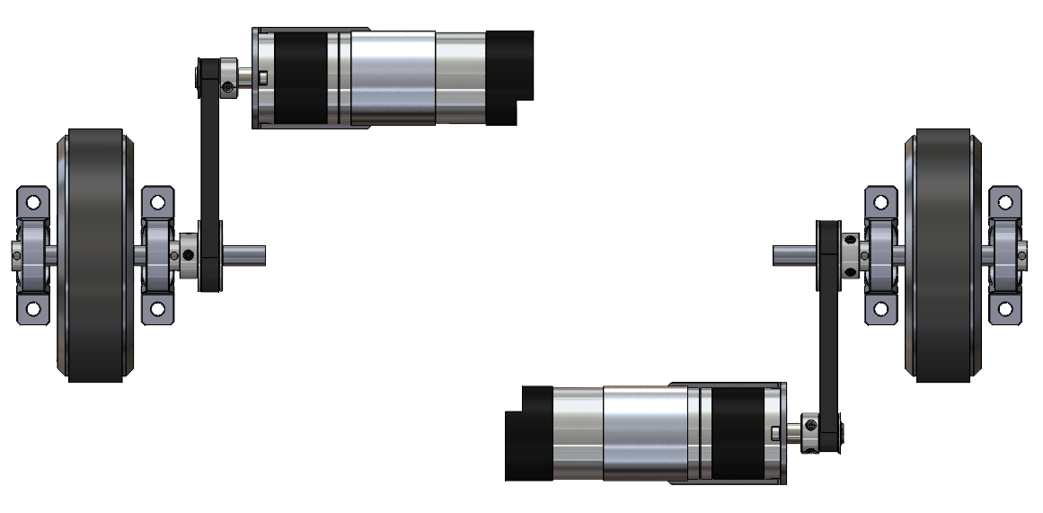

Figure 3.6. 3D Design of belt drive mechanism

#### **3.1.3.2. Motor calculation and selection**

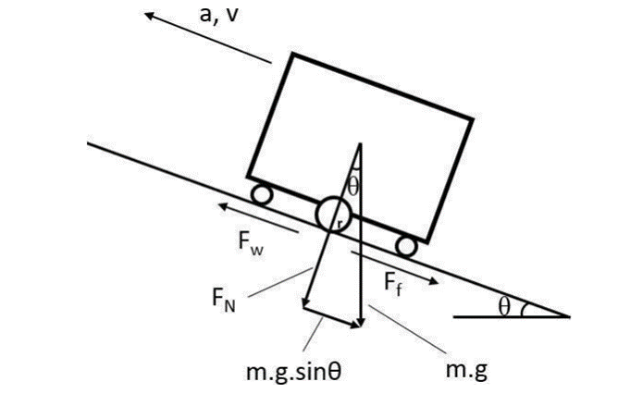

Figure 3.7. External forces acting on arobot

The robot's weight is 20 kg + 10 kg load, the maximum speed is 75 rpm with a wheel size of 100mm (0.1m) equivalent to 0.3925 m/s when running in manual mode and 40 rpm is equivalent to 0.21 m/s to ensure high accuracy. Suppose: the robot moves on a homogenous plane; wheel radius is r = 50 mm; coefficient of friction is 0.3; g = 9.8 m/s2

The sum of the forces acting on the car while moving is:

$$F_{w}=F_{f}+ma=mg+ma=70,8 N$$

Transmitter performance: ${olan}^{2}.dai={0,99}^{2}.0,95=0,93$

Engine torque: $T=F_{w}×r=$ 3,54 (N.m)

In there :

* T: is torque (N.m)
* $F_{w}$: Traction force generated by the engine (N)
* $r$: wheel radius (m)

Engine speed:

$$N=\frac{60×1000×v}{π×D} [1]$$

Where:

* N: motor shaft revolutions (rpm)
* v: velocity (m/s)
* D: diameter (mm)

$$N=\frac{60×1000×0,5}{π×145}=63,61323 (rpm)$$

Angular velocity: $ω=2πf=2π.\frac{N}{60}=6,6581 (rad)$

$$P_{ct}=T.ω=23,56697 (W)$$

In there:

* $P_{ct}:$ Required power (W)
* $ω:$ Angular velocity (rad)

Engine power: $P=\frac{P_{ct}}{η}=29 (W)$

With requirement moment 𝑇 = 3,54 𝑁. 𝑚, 𝑃 = 29𝑊, 𝑁 = 64rpm.

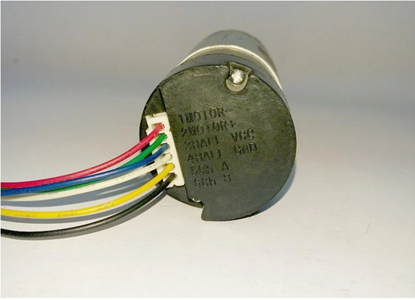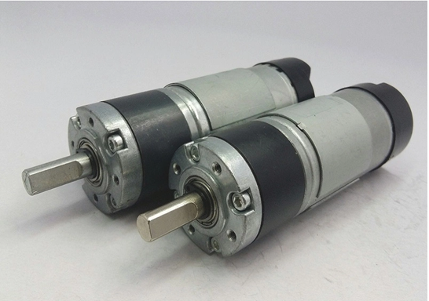We choose: Planet 12V 30w 600rpm encoder 12ppr

Figure 3.8. DC motor

(Cited in: <https://robotstore.vn/dong-co-planet-320rpm-12v-30w-encoder-12xung>)

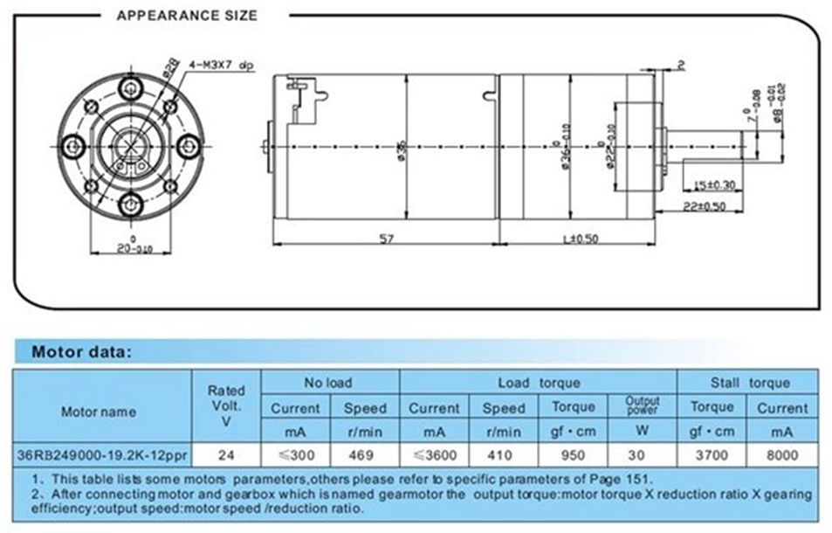

Figure 3.9. Technical data DC motor

(Cited in: <https://robotstore.vn/dong-co-planet-320rpm-12v-30w-encoder-12xung>)

Table 3.3. Technical data of DC motor

|  |  |  |
| --- | --- | --- |
| **No.** | **Characteristics** | **Value** |
| 1 | Engine type | DC Planet motor with gearbox |
| 2 | Power | 30W |
| 3 | Speed | 320rpm |
| 4 | Transmission ratio | 19.2:1 |
| 5 | Encoder | 12r, 2 channel A,B |
| 6 | Sources | 5VDC |

#### **3.1.3.3. Belt drive calculation and selection**

In the scope of this project, the transmission method by toothed belt is selected with many advantages such as no slip of the belt, high efficiency, small force acting on the shaft and the bearing. Simultaneously, toothed belt drives are widely available in the market with predefined standards for quick reassembly and easy maintenance and replacement.

Module of toothed belt:

$$m=k\sqrt[3]{\frac{P.Cr}{N}}=1,5276\left(mm\right) [1]$$

In there:

- P: power (Kw).

- N: number of drive wheel, rpm; 𝑘 = 35 – trapezoidal belt

- Cr: dynamic load factor, value 1.3…2,4 (large value for equipment working with frequent local shocks or overloads)

- Tooth pitch of belt:

$$p=m.π=4,71 mm$$

Based on table 4.27 page 68 reference **[1]** With 𝑚 = 2, choose belt width 𝑏 = 16 (mm) From modulus parameters 𝑚 = 2; tooth pitch 𝑝 = 5.08; belt width 𝑏 = 16. It is very difficult to choose a belt with the correct parameters as above, so the suitable belt type is selected as follows: GT2 belt type, belt pitch 𝑝 = 2 mm

Based on table 4.29 page 70 reference **[1]**

In order to ensure the life of the belt, the number of teeth of the active gear $Z_{1}$ > 12. Choose $Z_{1}$ = 20 teeth. Choose the gear ratio U = 2.Number of teeth of the passive gear:

$$Z_{2}=U×Z_{1}=40 (teeth)$$

The shaft distance is selected according to the condition:

$$a_{min}{≤a≤a}_{max} [1]$$

In there :

$$a_{min}=0,5m\left(Z_{1}+Z_{2}\right)+2m=48,88571 (mm)$$

$$a_{max}=2m\left(Z_{1}+Z_{2}\right)=183,3214 (mm)$$

Select preliminary shaft distance 𝑎 = 100 𝑚𝑚

Number of belt teeth: $Z_{đ}=\frac{2a}{p}+\frac{Z_{1}+Z_{2}}{2}+\frac{{(Z_{2}-Z_{1})}^{2}}{40a}=60 teeth$

Belt test for specific ring force

$$q=\frac{F_{t}.K_{đ}}{b}+q_{m}.v^{2}=3,51$$

In there :

* $F_{t}$ is the ring force: $F_{t}=1000.\frac{P}{v}=17 (N)$
* $K_{đ}$ is the load factor according to the table 4.7 document [1] choose $K_{đ}$ = 1,
* $q_{m}$ is the mass of 1 meter belt with a width of 1mm, see table 4.31 reference **[1]** we choose $q_{m}$ = 0.0032.
* b is the belt width 𝑏 = 16𝑚𝑚, v is velocity 𝑣 = 0.4𝑚/𝑠, (check table 4.31 page 71 reference **[1]**)

Our group decided to choose belt GT2 which has some following details information below.

Table 3.4. Technical data of belt GT2

|  |  |  |
| --- | --- | --- |
| **Parameter** | **Symbol** | **Value** |
| Belt Type | GT2 |  |
| Belt step | $$p$$ | 2 mm |
| Belt width | $$b$$ | 10 mm |
| Belt length | $$L$$ | 150 mm |
| Number of active gears | $$Z_{1}$$ | 20 tooth |
| Number of passive gears | $$Z_{2}$$ | 40 tooth |
| Diameter of the driving belt | $$d_{1}$$ | 30,55357 mm |
| Diameter of the pass ring of the passive pulley | $$d_{2}$$ | 61,10714 mm |
| Outer diameter of drive pulley | $$d_{a_{1}}$$ | 29,75357 mm |
| Outer diameter of passive pulley | $$d_{a_{2}}$$ | 60,30714 mm |
| Active pulley top ring diameter | $$D_{1}$$ | 32,59047 mm |
| Passive pulley top ring diameter | $$D_{2}$$ | 65,18095 mm |

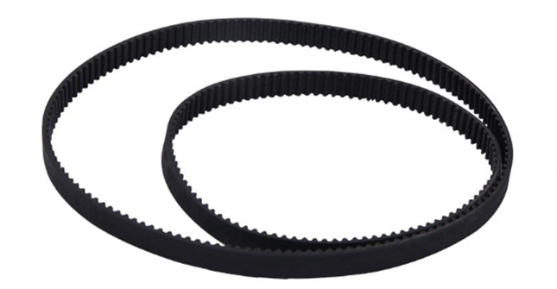

Figure 3.10. Belt GT2

Diameter of the rings of the pulleys:

$$d_{1}=m.Z_{1}=30,5535 (mm)$$

$d_{2}=m.Z_{2}=$ 61,1071 (mm)

Outer diameter of pulley:

$$d_{a_{1}}=mZ_{1}-2δ=29,7535 (mm)$$

$$d_{a_{2}}=mZ_{2}-2δ=60,3071 (mm)$$

Active pulley top ring diameter:

$$D_{1}=32,5904 (mm)$$

$$D_{2}=65,1809 (mm)$$

Our group decided to choose a couple of pulleys which have a given dimension as shown below.

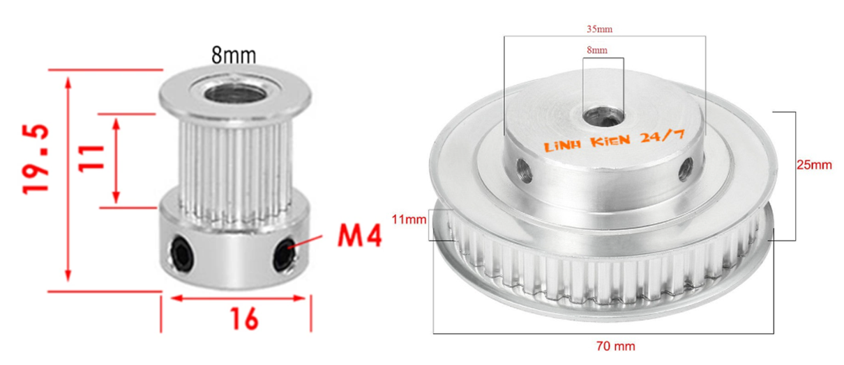

Figure 3.11. Pulleys GT2

#### **3.1.3.4. Test for Strength and fatigue of shaft**

Select materials for manufacturing the lookup shaft (Table 6.1/page 92):

- Choose C45 steel 𝜎𝑏 = 750 𝑀𝑃𝑎.

- Allowable bending stress: [𝜏] = 12. . .20𝑀𝑃𝑎 => Choose [𝜏] = 18𝑀𝑃𝑎

Preliminary determination of shaft diameter:

* The shaft diameter is determined by the formula (10.9):

+ T: Torque Nmm.

+[𝜏]: Allowable torsional stress MPa.

Chosse d= 8mm

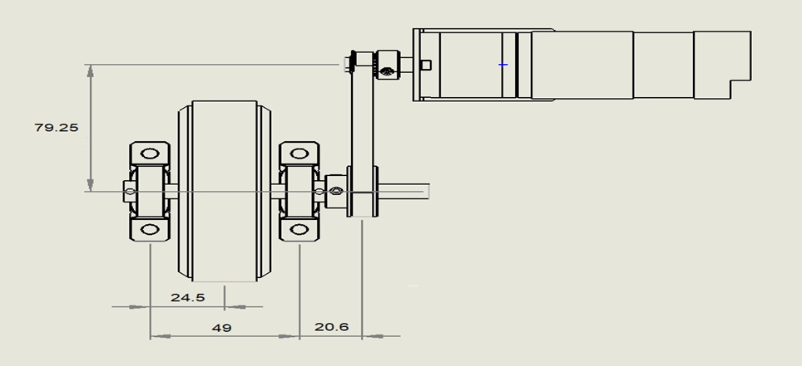

Figure 3.12. Drive mechanism and shaft distances

Axis parameters:

+ Shaft length: 𝑙 = 79,25𝑚𝑚

+ Distance from wheel to bearing: 𝑙1 = 24.5𝑚𝑚

+ Distance from bearing to gear: 𝑙2 = 20.6𝑚𝑚

+ Distance from gear to bearing remaining: 𝑙3 = 69.6𝑚𝑚

+ Torque: T = 3540 Nm

+ dw1 = 40 mm

+ αtw = 0

+ β = 0

- Follow 10.1/page 184:

+ Ring force: Ft =177N

+ Radial force: F = Fr=88.5N

+ Axial force: Fa = Ft.tagβ = 0

Due to the vehicle's weight 20kg

=> The reaction force acting on the car is 200𝑁

=> The reaction force on each rear wheel is 𝐹𝑁 = 66.667 𝑁

Plane Oyz:

∑𝑀(𝐷) = −𝐹𝑦1. (𝑙 − 𝑙1) + 𝐹𝑟. (𝑙 − 𝑙1 − 𝑙2) + 𝐹𝑁 . 𝑙 ⇔ 0

⇔ 𝐹𝑦1 = 151,7006 (𝑁)

−𝐹𝑦1 + 𝐹𝑟 − 𝐹𝑦2 + 𝐹𝑁 = 0

⇒ 𝐹𝑦2 = 3,466 (𝑁)

Plane Oxz:

∑ 𝑀(𝐷) = 0 ⇒ 𝐹𝑥1. (𝑙 − 𝑙1) − 𝐹𝑡(𝑙 − 𝑙1 − 𝑙2) = 0

𝐹𝑥1 + 𝐹𝑥2 − 𝐹𝑡 = 0 ⇒ 𝐹𝑥1 = = 110,4027 (𝑁)

* **Internal force diagram:**

(Mx)

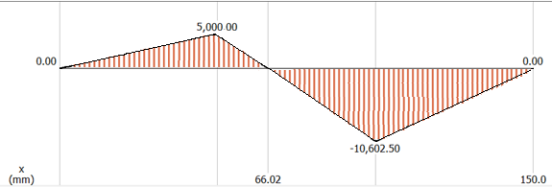

(My)

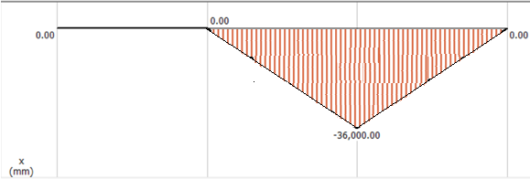

(Torque )

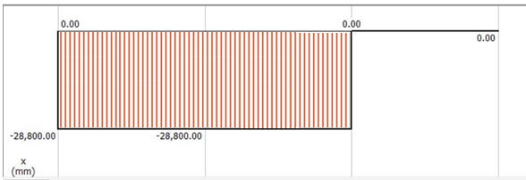

Figure 3.13. Bending and torque moment diagram

**At point A:**

+ Follow method 10.15/page 194

+ Shaft diameter at cross-section A:

Follow method 10.17/page 194

+ In there :

[𝜎]=50 (MPa) follows C45, 𝜎𝑏 ≥ 600(𝑀𝑃𝑎) shaft diameter d > 30(mm)

$${ d}_{1A} =\sqrt[3]{\frac{M_{tđA}}{0.1 ×[σ]}}=7.994 (mm)$$

=> Choose d1A = 8 (mm)

**At point B:**

${ M}_{B}=\sqrt{M_{yB}^{2}+M_{xB}^{2}+{0.75T}_{B}^{2}}=3067.59 (mm$)

$${ d}_{1B} =\sqrt[3]{\frac{M_{tđB}}{0.1 ×[σ]}}=7.994 (mm)$$

=> Choose d1B = 8 (mm)

**At point C:**

$M_{B}=\sqrt{M_{yB}^{2}+M_{xB}^{2}+{0.75T}_{B}^{2}}=$ 3950 (N.mm)

$${ d}_{1C} =\sqrt[3]{\frac{M_{tđC}}{0.1 ×[σ]}}=8.699 mm$$

=> Choose d1C = 8 (mm)

**At point D:**

+ Shaft diameter at cross-section D:

=> Choose d1D = d1B = 8 (mm) follow 10.2/page 189

* **Shaft test calculation for fatigue strength:**

Fatigue test at sections with dangerous cross-sections – At point C

$$M_{xC}=10602.5 \left(N.mm\right)$$

$$M_{yC}=36000\left(N.mm\right)$$

$$d_{C}=8 mm$$

The factor of safety must satisfy the condition:

$s=\frac{s_{σ}×s_{τ}}{\sqrt{s_{σ}^{2}+s_{τ}^{2}}}≥[s]$ (Formula 10.19/page 195).

In there: $s_{σ}$ factor of safety considering only normal stress at C

Follow method (10.20): $s_{σ}=\frac{σ_{-1}}{K_{σd}×σ_{a}+ψ_{σ}×σ_{m}}$ (3.29)

Where:

+ σ-1: fatigue limit for symmetry period.

+ Steel Carbon 45 $σ_{b}$ = 750 (MPa)

+ = 0,436. $σ_{b}$ = 0,436.750 = 327 (MPa)

+ : Effect coefficient of mean stress value, Follow table 10.7 :

+ For the axis of rotation

+ According to the formula:

+ According to the formula (10.15):

+ Follow table (10.6) with keyway shaft:

+ Follow table (10.16) can check then: b.h = 6*6 (mm)

+ Keyway depth on shaft: $t_{1}$ = 3,5 (mm)

$W_{c}$ bending moment at C: $W_{c}=\frac{{πd}_{C}^{3}}{32}-\frac{{b.t}_{1}{\left(d_{C}-t_{1}\right)}^{2}}{d_{C}}=499.5 (N.mm)$

*+* Put in the formula (10.12):

+ coefficient determined by the formula (10.25)

$$K_{σ_{d}}= \frac{{K_{σ}}/{ε_{σ}}+K_{x}-1}{K_{y}}$$

Where:

+ stress concentration coefficient due to surface state

+ shaft surface increase factor

Put in the formula (10.25): $K_{σ_{d}}$ = (2,44 + 1,1 − 1)/1,6 = 1,588

Put in the formula (10.20):

$S_{σ}=\frac{S_{-1}}{K_{δd}.δ_{a}C+ψ_{δ}×δ_{m}}=\frac{327}{1,588×50,23+0,1}=4,1$

Where:

+ : The factor of safety is considered only for the reaction at C:

According to the formula (10.21/page 195):

$$s_{τ}=\frac{τ_{-1}}{K_{τd}×τ_{a}+ψ_{τ}×τ_{m}}$$

Where:

+ torsional fatigue limit for symmetry period

$$τ_{-1}≈0,58×σ_{-1}=0,58×327=189,66 (MPa)$$

Substitute the values in (10.20):

$$S_{τ}=\frac{τ_{-1}}{K_{td}×τ_{m}+ψ_{τ}×τ_{a}}=10.05$$

$S=\frac{S_{δ}×S_{τ}}{\sqrt{S_{δ}^{2} +S_{δ}^{2}}}$ = 2.98

- We have: 𝑆 = 2,98 < [𝑆] = 1,5 ÷ 2,5

- We also have : $S_{c}$ = 3,91 > = 2,5…3

=> Thus, the test conditions for the stiffness of the shaft are satisfied.

* **Static strength test shaft:**

Follow(10.27/page 200), The test formula has the form:

$$σ_{tđ}=\sqrt{σ^{2}+3τ^{2}}≤[σ]$$

* Considering the dangerous cross-section C:
$$M_{max}=M_{x}=11227,5 \left(N.mm\right)$$

$$T_{max}=32318 (N.mm)$$

* From (10.28/page 200): $δ=\frac{M_{max}}{0,1×d_{C}^{3}}=\frac{10602,5}{0,1×{20}^{3}}=13,25$
* From (10.29/page200): $τ=\frac{T_{max}}{0,2×d_{C}^{3}}=\frac{28800}{0,2×{20}^{3}}=18$
* So $δ_{td}=\sqrt{{13,25}^{2}+{3,18}^{2}}=33,88$
* Meanwhile, Steel 45: $σ_{b}$ = 750 (Mpa); $σ_{ch}$ = 450 (MPa)
* Follow method (10.30): [𝜎] = 0,8 × $σ_{ch}$ = 0,8 × 450 = 360 (𝑀𝑃𝑎)
* So $δ_{tđ}$ = 33,88 < [𝛿] = 360 (Mpa)

=> Conclusion: the shaft meets the requirements for static strength.

Table 3.5. Summary of diameter sections

|  |  |  |
| --- | --- | --- |
| **Parameter** | **Symbol** | **Value** |
| Shaft length | d | 70 mm |
| Cross-sectional diameter at A | $$d_{1A}$$ | 8 mm |
| Diameter of cross-section at B | $$d_{1B}$$ | 8 mm |
| Section diameter at C | $$d_{1C}$$ | 8 mm |
| Distance from wheel to bearing | $$l_{1}$$ | 24.5 mm |
| Distance from bearing to gear | $$l_{2}$$ | 20.6 mm |
| Distance from gear to ball bearing remaining | $$l_{3}$$ | 69.6 mm |

#### **3.1.3.5. Wheels and Support pillow**

* 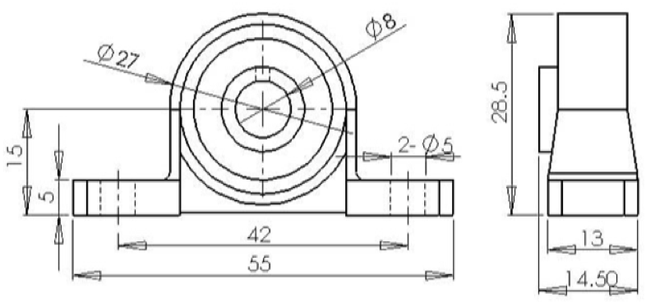**Selection of support pillow**

Figure 3.14. Support pilow dimension

Depending on the working conditions, at the bearing positions only the ring force Ft and the radial force Fr. So at the supports, choose a block bearing

Select drive size:

- Provided that all rolling bearings are oil-lubricated.

- On the shaft, bearings are located at B and D. Preliminary selection: ball diameter 7.94

C0 = 6,3 kN- static load capacity.

C = 10 kN- dynamic load capacity.

- Forces acting on the bearing:

- Thus, the total reaction on each drive is

$$F_{l1}=\sqrt{F_{x1}^{2}+F_{y1}^{2}}=75,6 (N)$$

$$F_{l2}=\sqrt{F_{x2}^{2}+F_{y2}^{2}}=82,6 (N)$$

We test at the drive with a higher load $F_{l1}$ = 829,6 N

Select drive according to dynamic load capacity:

Dynamic load capacity Cd is calculated according to the formula (11.1/page 213)

$$C_{d}=Q ×\sqrt[m]{L}$$

In there:

+ Q: conventional dynamic load.

+ For thrust ball bearings, in formula (1.3): Q = (X.V. $F_{r}$ +Y.)

- We have:

X = 1 radial load factor (table 11.4).

V = 1 factor to account for the rotation in the rotation. Fa = 0 axial force.

Y = 0 axial load factor (table 11.4).

$k_{t}$ =1 factor taking into account the effect of heat when working θ = ${150}^{o}$ C.

$k_{d}$ = (1÷1,2 factor taking into account the load characteristics. Look up table 113/page 215

Choose kđ = 1.

Q = (1x1x829,6 + 0)1x1 = 829,6 N = 0,8296 kN.

L: life in million revolutions

- From (11.2/page 213)

- With: $L_{h}$ lifespan in hours.

$$L_{h}=5×2×300×8=24000h$$

⇒ $L=\frac{24000.60.106}{{10}^{6}}=152,64$

m = 3 degree of fatigue curve in rolling bearing test (for ball bearings).

⇒ $C_{d}=Q ×\sqrt[m]{L}$ = 2,05

We have : Cd = 2,05 ≤ C = 10 KN

- So: According to table P2.7, choosing ball bearings as above is reasonable

Select drive according to static load capacity:

To prevent residual deformation, ball bearings need to satisfy the following conditions:

- Formula (11.18/page 221): Qt ≤ Co

In there :

Qt conventional static load (kN)

Follow method (11.19/page 221): Qt = Xo. Fr + Yo.Fa

With:

+ Xo = 0,6 radial load factor (table 11.6/page 221)

+ Yo = 0,5 axial load factor (table 11.6/page 221).

+ Qt = 0,6x0,8296+ 0,5x0 = 0,49776 (kN)

We have: Qt = 0,49776 ≤ Co = 6,3 KN

So: According to table P2.7/page 254, it is reasonable to choose ball bearings as above.

* **Selection of wheels**

Wheels: Wheels are an extremely important part, helping the entire machine structure to move smoothly. At the same time, it is also the part that supports the machine structure. Because self-propelled vehicles running in hospitals have relatively light loads, move mainly in wards and corridors with flat terrain, the following types of wheels should be selected: Active wheels: Aluminum wheels with roads 100mm glass, wheels are very good quality, affordable, easy to assemble and apply in design. 100mm wheels are often used with motor shafts so that they can be attached to the engine.

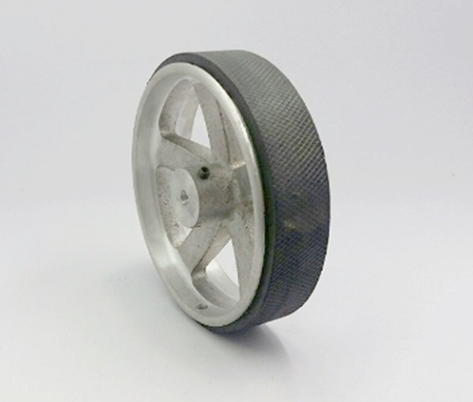

Figure 3.15. Robot wheel

(cited in:<https://robotstore.vn/banh-xe-nhom-duong-kinh-145mm>)

Table 3.6. Technical data of robot wheel

|  |  |  |
| --- | --- | --- |
| **No.** | **Characteristics** | **Value** |
| 1 | Mass | 210g |
| 2 | Weight | 50kg |
| 3 | Outer Diameter | 100mm |
| 4 | Width | 40mm |

The passive part is used by a small multi-directional wheel, bearing scattered forces: Multi-directional wheel specifications:

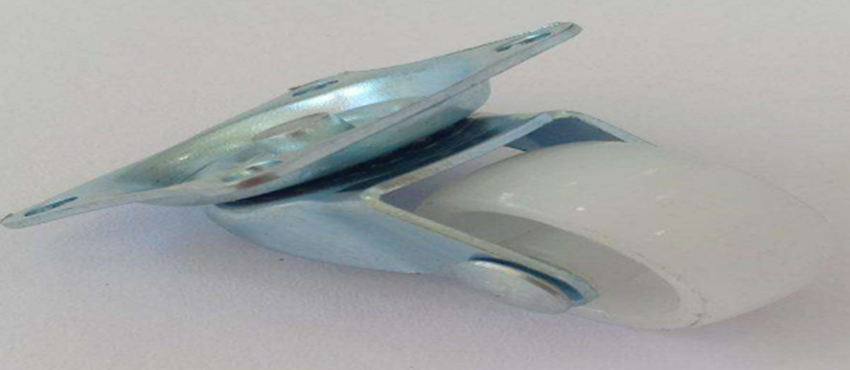

Figure 3.16. Universal wheel

(Cited in: <https://nshopvn.com/product/banh-xe-da-huong/>)

Table 3.7. Technical data of universal wheel

|  |  |  |
| --- | --- | --- |
| **No.** | **Characteristics** | **Value** |
| 1 | Multi-directional wheel height | 33mm |
| 2 | Steel plate size | 38x32mm |
| 3 | Roller material | plastic |
| 4 | Roller diameter | 21mm |
| 5 | Roller thickness | 14mm |

### **3.1.4. Design of mobile robot**

The robot will be divided into three floors respect to their own functionalities:

* The 1st floor contains drive mechanism, motors and power source.
* The 2nd floor contains electrical components.
* The 3rd floor contains products such as foods and drinks

#### **3.1.4.1. Base plate**

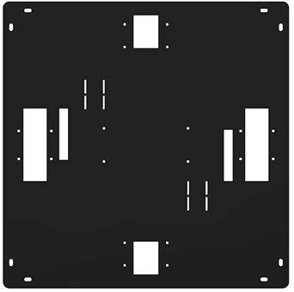

Figure 3.17. 3D design of base plate

This is the most crucial part of the whole robot that it responsible for enduring the total mass of the robot as well as the acting load. Therefore, the base plate is forced to meet some requirements in term of strenth,hardness and small size so it can fit in an indoor application.

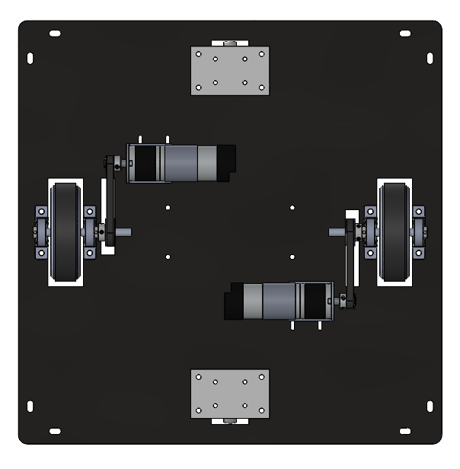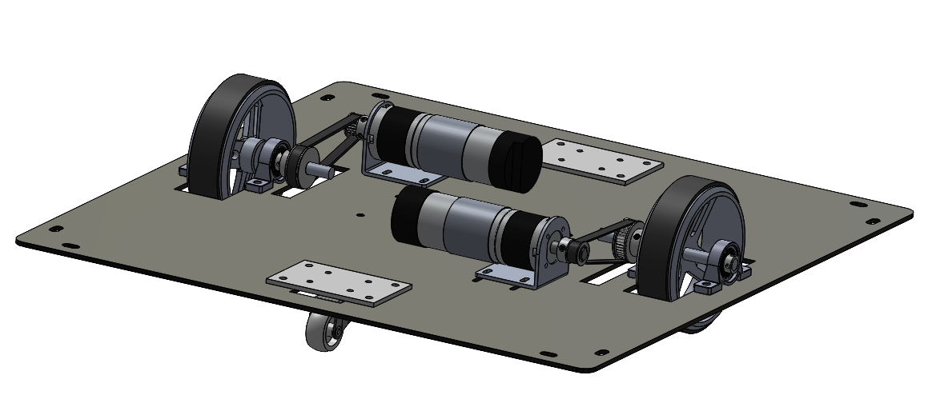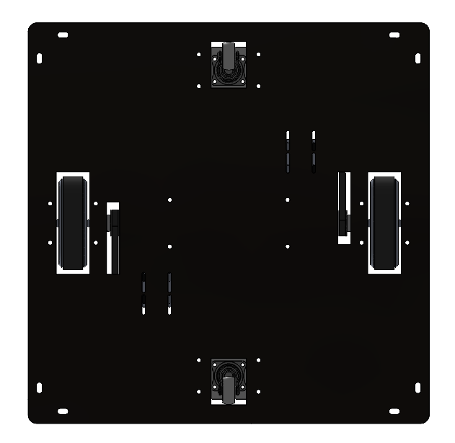Table 3.8. Characteristic of the base plate

|  |  |
| --- | --- |
| **Material** | **Steel SS400** |
| Mass | 3.912 kg |
| Density | 0.01 g/mm3 |
| Volume | 508129.46 mm3 |
| Surface area | 350612.68 mm3 |
| Thickness | 3 mm |

Figure 3.18. 3D design of full assembly base plate

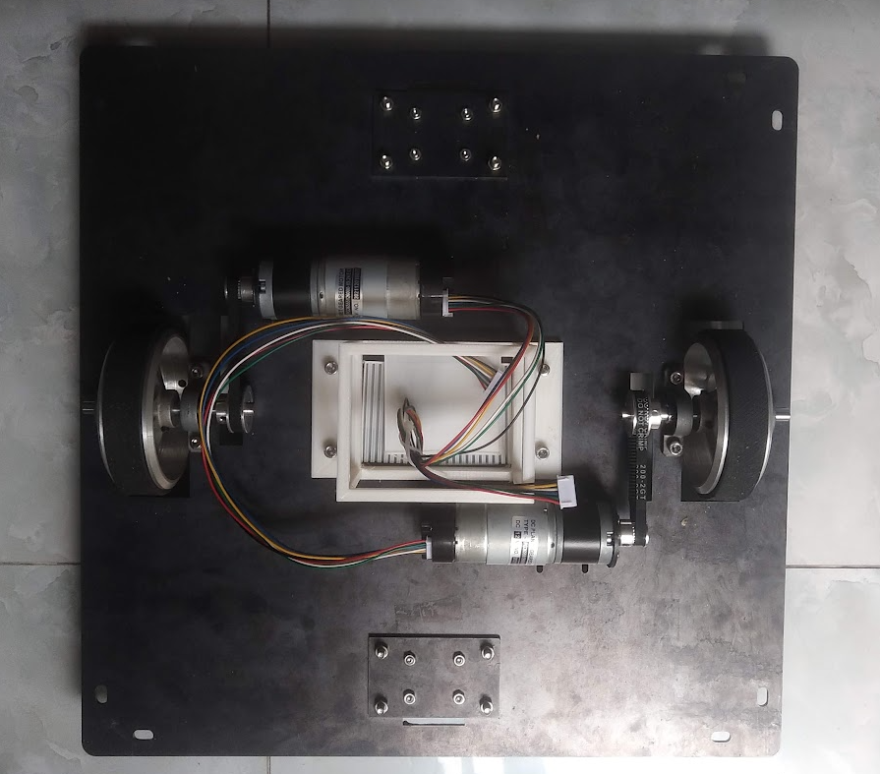

Figure 3.19. Full assembly of base plate in realistic

#### **3.1.4.2. Electrical components container**

The plate in which we place electrical components is relative light but still strong enough to endure many components that are equally distributed. The thickness of plate is about 3 and made from acrylic.

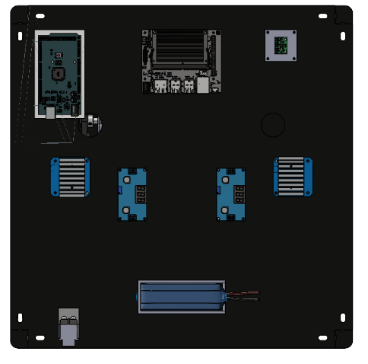

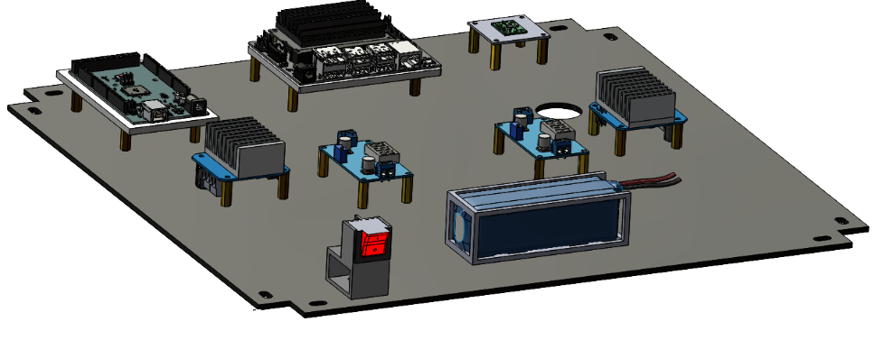

Figure 3.20. 3D design of electrical components surface area

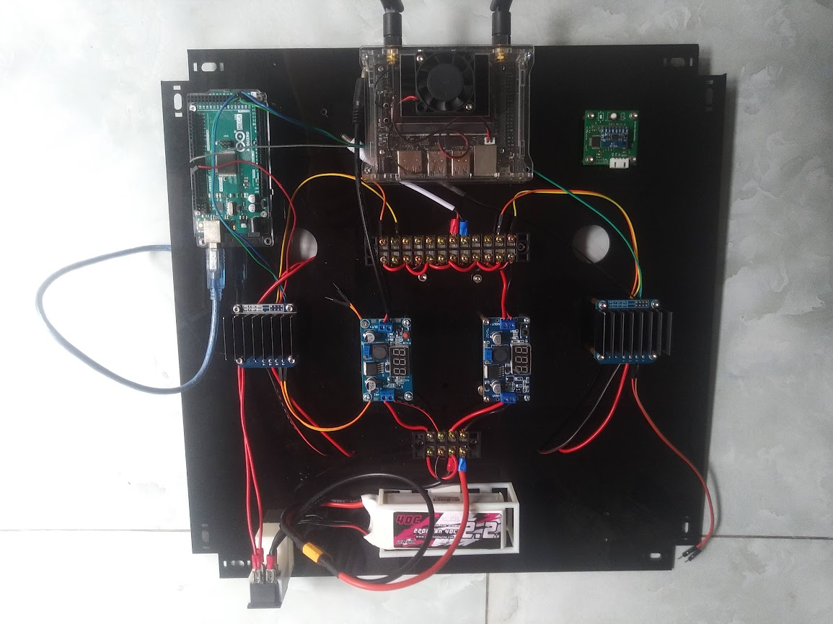

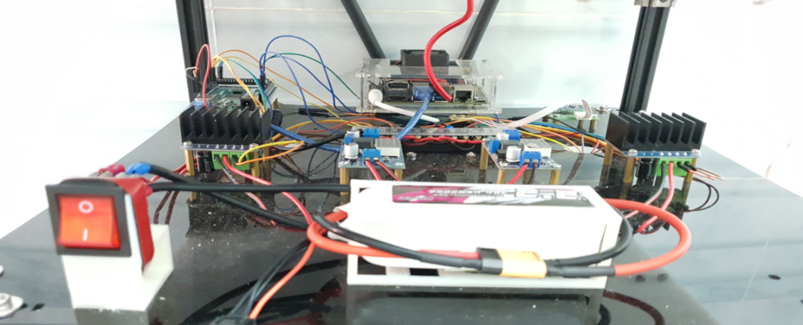

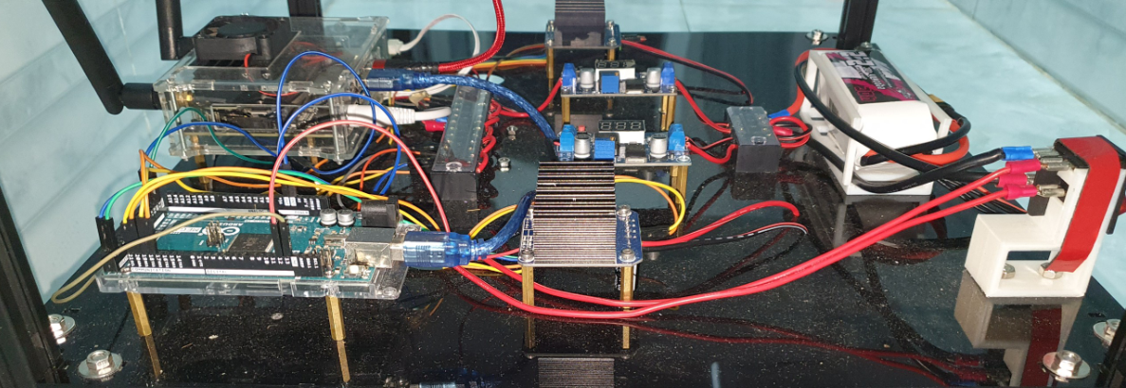

Figure 3.21. Distribution of electrical components in realistic

#### **3.1.4.3. Product container**

This container will be devided into 2 parts, the left side is split into 3 cases that contain foods, whereas the right side will be used for placing water bottles or vice versa.

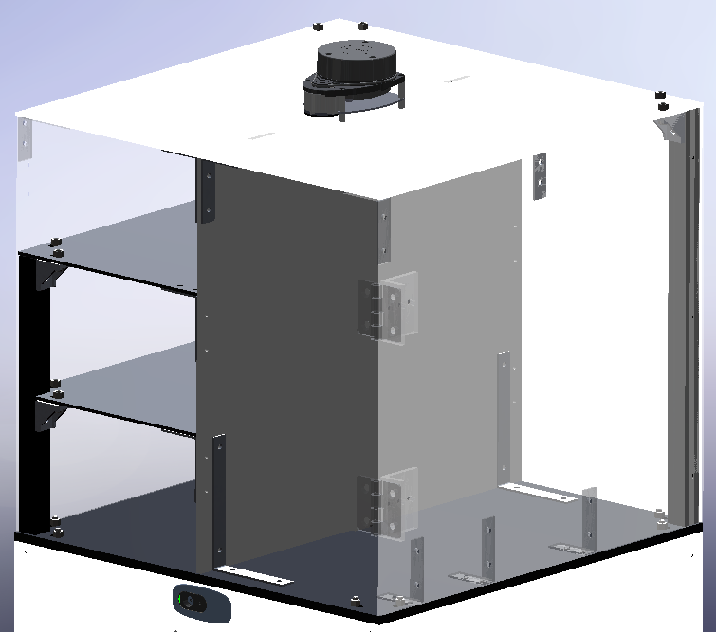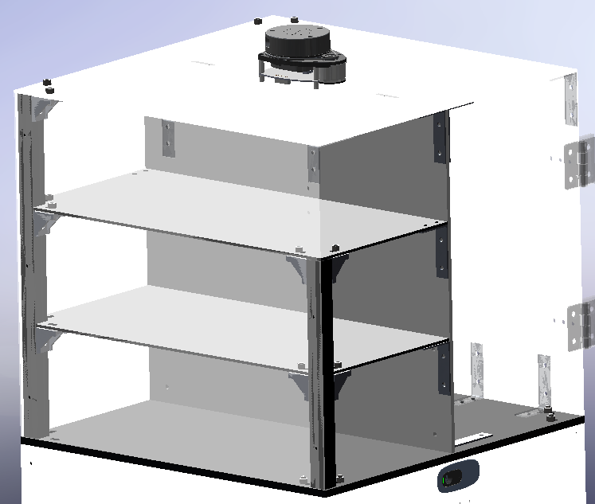

Figure 3.22. 3D design of product container

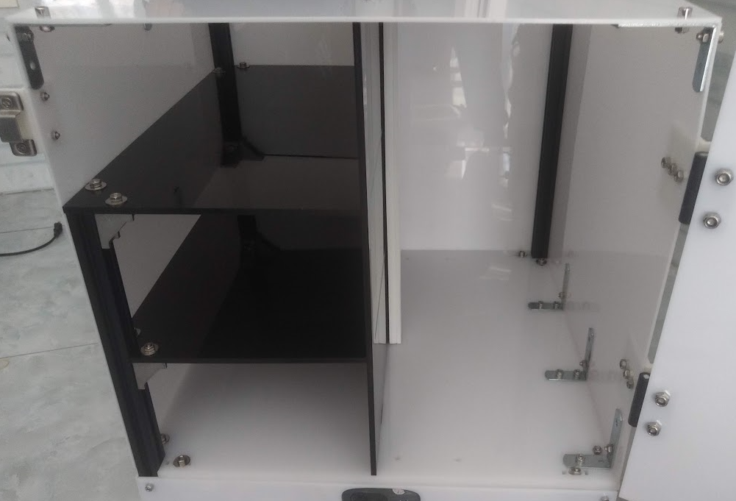

Figure 3.23. Assembly of container in realistic

#### **3.1.4.4. Frame of robot**

Frame is also highly considered to be the one of the most important parts that support to endure strength and load act on robot. The appearance or shape of robot largely depends on the way we design the frame. Therefore, the frame should have a light weight but still ensures the toughness. There are many types of material in the market, however our group put more concentrate on two categories that supposed to be very strong and tough are shaped aluminum and stainless steel.

Table 3.9. Shaped aluminum in comparison with stainless steel

|  |  |  |
| --- | --- | --- |
| **Characteristics** | **Shaped aluminum** | **Stainless steel** |
| Cost | Cheaper than steel | More Expensive than aluminum |
| Strength to weight ratio | Not as strong as steel | Tougher than aluminum |
| Corrosion |  | High oxidation and corrosion resistance |
| Thermal Conductivity | Better than steel | Lower than aluminum |
| Workability | Soft and easier to cut and form | Harder to form than aluminum due to its wear and abrasion resistances |
| Thermal properties | Can be damaged above 400 degrees | Much endures higher temperature than aluminum |
| Electrical conductivity | Higher than steel | Poorer than aluminum |
| Strength | Weaker than aluminum | Stronger than aluminum |

Our robot is relative not too big and fit in an indoor environment so we decided to make the frame out of shaped aluminum due to its cheap price and easy to assemble when compared to stainless steel.

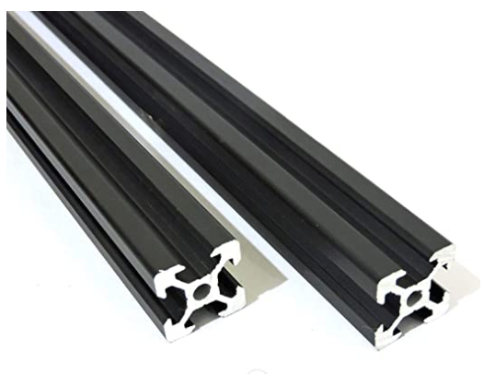

Figure 3.24. Shaped aluminium

(Cited in: <https://www.amazon.in/2020-Aluminum-Extrusion-Profile-Black/dp/B076NMW3VX> )

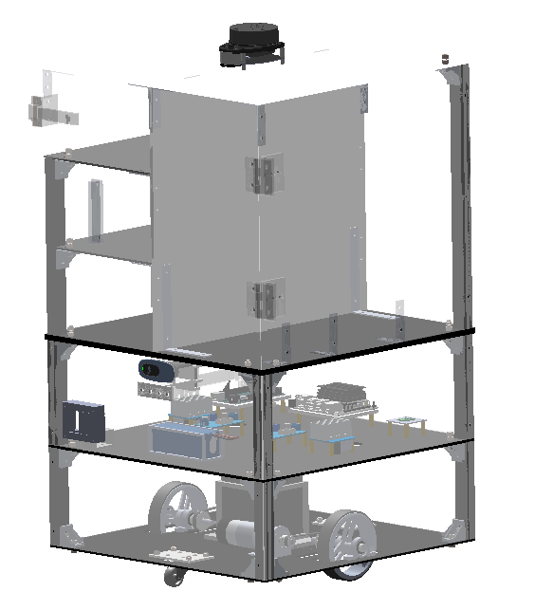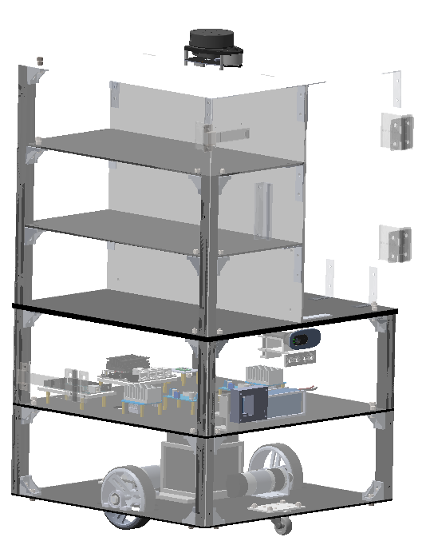

Figure 3.25. 3D design frame

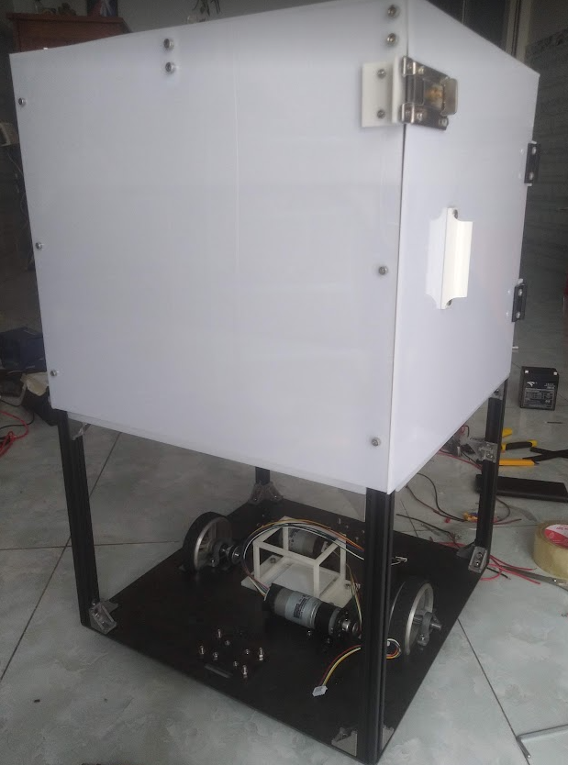

Figure 3.26. Assembly of frame in realistic

## **3.2. Design of block diagram**

Now we will come to find out the relationship between components used for our mobile robot and how they connect to each other via summary of the block diagram

### **3.2.1. Block listing**

Table 3.10. List of components

|  |  |
| --- | --- |
| **List of blocks** | **Function** |
| Power source 1 | Provides energy to power the motors |
| Power source 2 | Provides energy to power electrical components |
| MCU | Controls motors and sensors |
| IMU | Estimates the pose of robot by getting yaw angle |
| Jetson nano | Processes the main algorithm |
| Lidar A1 | Scan the 2D map for navigation and obstacle avoidance |
| Camera | Streaming the journey of robot |
| Left motor | Controls left wheel |
| Right motor | Control right wheel |
| Encoder | Gets the pulse signal to control velocity |
| Wireless controller (Ros mobile) | Manual control mode |

### **3.2.2. Block diagram**

Figure 3.27. Block diagram of robot

### **3.2.3. Operation description**

Our robot uses two sources of power supply, the first source provides 5v for some main electrical components such as MCU and jetson nano, whereas the other provides 12v for both of motors. The motors will be controlled by MCU, in which the encoder ticks will be collected and subscribe to the same topic of which the jetson nano also publishes to. At this moment, the connection between MCU and jetson nano will be created throughout the aid of rosserial that interpret all data from MCU which use UART communication so the jetson nano can understand. This is a so called TCP/IP protocol.

First of all, the robot will be controlled by wireless device using Ros-mobile app to move around the indicated environment to scan the 2D map using sensor Lidar A1. After gathering the information about the surrounded area, we need to locate the initial or starting position of robot on map. Then we have got to choose the goal location for robot to reach. When the robot is moving it will plan a line that track around in order to navigate as well as avoid obstacle. The bad or good performance of this stuff depends on the different type of algorithms we program for the robot. The location of robot on map and velocity can be accurately estimated via odometry and encoder sensor respectively. The IMU also provides information about the rotation value of robot by estimating the yaw angle. Last but not least, the robot is also equipped a camera to supervise the journey of it while moving.

## **3.3. Electrical system design**

### **3.3.1 Block diagram**

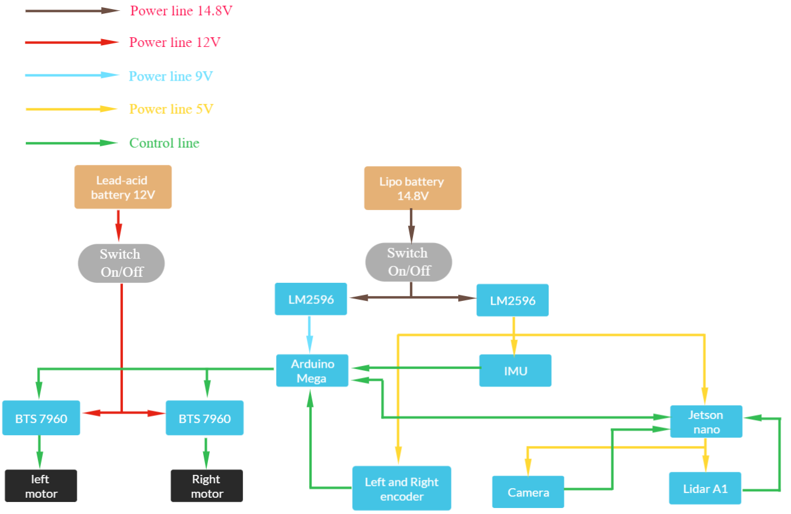

Figure 3.28. Electrical diagram of robot

### **3.3.2. List of electrical components**

* 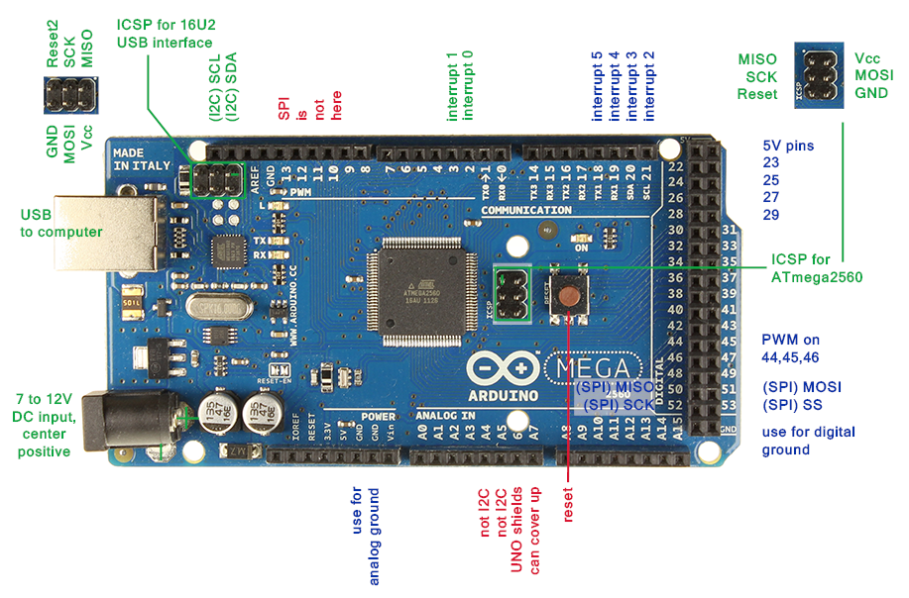**Mega Arduino 2560**

Figure 3.29. Arduino mega 2560

(Cited in: <https://www.elprocus.com/arduino-mega-2560-board/> )

This is an upgrade version of its predecessor which is Arduino Uno. In additional, this is an open source development board based on Atmega2560 AVR microcontroller or 8-bit microcontroller and runs under ATmega16U2 Microchip Technology. This board can be programmed using wiring/processing language.

Table 3.11. Technical features of Arduino mega 2560

|  |  |  |
| --- | --- | --- |
| **Technical Features** | | |
| Operating voltage | | 5V |
| Input Voltage | Recommended | 7-12V |
| Limit | 6-20V |
| Analog Input Pins | | 16 |
| Digital I/O Pins | | 54 |
| DC current for 3.3V Pin | | 50mA |
| DC current per I/O Pin | | 20mA |
| Flash Memory | | 256 kB |
| SRAM | | 8 kB |
| EEPROM | | 4 kB |
| Clock Speed | | 16 MHz |
| LED_BUILTIN | | 13 |

Table 3.11. Advantages and disadvantages of Arduino mega 2560

|  |  |  |
| --- | --- | --- |
| **Advantages** | | **Disadvantages** |
| More memory space, I/O Pins bigger size than Arduino Uno | | Available only for 8-bits but 32 bits |
| 4 hardware serial port and reset pin speed up communication | |
| Three ways to power the board | USB cable |
| Vin pin |
| Power jack |
| Overheating of USB port when high current flows through the board can be prevented by resettable polyfuse | | Clock speed is limited to 20 MHz |
| Two voltage regulator 5V and 3.3V that provides the flexibility to regulate the voltage as per requirements | |

* **Jetson nano**

This is a small, powerful computer for embedded applications and AI, IoT. Moreover, it has the performance and capabilities that enable the users to run multiple neural networks in parallel for applications like image classification,object detection,segmentation,and speech processing.

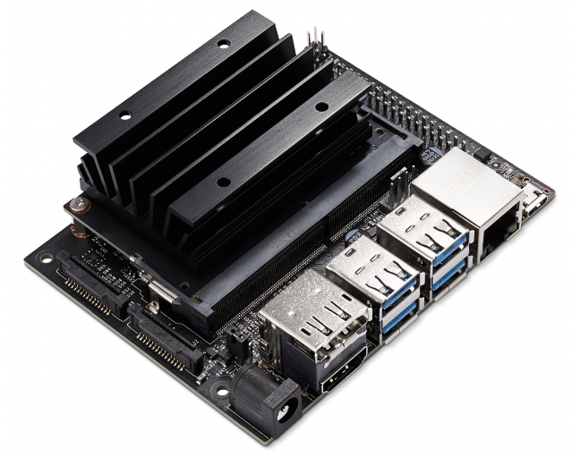

Figure 3.30. Jetson nano

(Cited in: <https://developer.nvidia.com/embedded/jetson-nano-developer-kit> )

Table 3.13. Technical Specification of jetson nano

|  |  |
| --- | --- |
| **Technical Specification** | |
| GPU | Quad-core ARM® Cortex®-A57 MPCore processor |
| Memory | 4 GB 64-bit LPDDR4 |
| Storage | 16 GB eMMC 5.1 Flash |
| Video Encode | 4K @ 30 (H.264/H.265) |
| Video Decode | 4K @ 60 (H.264/H.265) |
| Camera | 12 lanes (3x4 or 4x2) MIPI CSI-2 DPHY 1.1 (1.5 Gbps) |
| Connectivity | Gigabit Ethernet |
| Display | HDMI 2.0 or DP1.2 | eDP 1.4 | DSI (1 x2) 2 simultaneous |
| UPHY | 1 x1/2/4 PCIE, 1x USB 3.0, 3x USB 2.0 |
| I/O | 1x SDIO / 2x SPI / 6x I2C / 2x I2S / GPIOs |
| Size | 69.6 mm x 45 mm |
| Mechanical | 260-pin edge connector |

* **IMU**

This is a module compass V2 which integrates the IMU as a high performance sensor in measuring the rotation angle precisely and stably with a resolution up to 0.1 degree. Furthermore, there is a button on the module to recalibrate the module in case of missed or error value. This module is quite appropriate to some projects relate to localization or tracking applications.

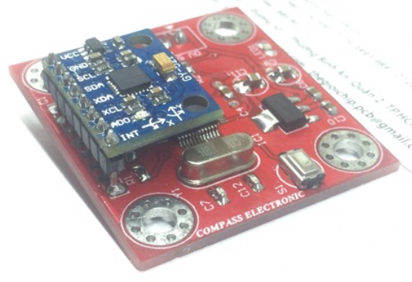

Figure 3.31. Module compass V2 with IMU integrated

(Cited in: <https://thegioichip.com.vn/products/la-ban-v2> )

* **LM2596**

This is known as a DC-DC buck converter, which used to step down input voltage and results in lower level voltage in an output. The amount of energy after or before a conversion is also visible by observing the 7 segments led that mounted on it.

Table 3.14. Technical Specification of LM2596

|  |  |
| --- | --- |
| **Technical Specification** | |
| Conversion efficiency | 92%(highest) |
| Switching frequency | 150KHz |
| Output ripple | 30mA9 (maximum) |
| Load Regulation | ± 0.5% |
| Voltage Regulation | ± 0.5% |
| Dynamic Response speed | 5% 200uS. |
| Input voltage | 4.75-35V |
| Output voltage | 1.25-26V |

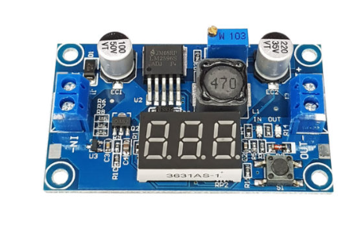

Figure 3.32. Module compass V2 with IMU integrated

(Cited in: <https://nshopvn.com/product/mach-giam-ap-dc-lm2596-co-hien-thi/> )

* **Driver motor BTS7960**

This driver is also known as a fully integrated high current half bridge for motor applications with thermal over-current protection. This driver brings a strong drive and braking. Moreover, it also provides a cost optimized solution for protected high current PWM motor drives with very low board space consumption.

Table 3.15. Technical Specification of BTS 7960

|  |  |
| --- | --- |
| **Technical Specifications** | |
| Input Voltage | 6 ~ 27Vdc |
| Driver current | 43-Amp |
| PWM capability | Up to 25 kHz |
| Control Input Level | 3.3~5V |
| Control Mode | PWM or level |
| Working Duty Cycle | 0~100% |
| Board Size (LxWxH) | 50mmx50mmx43mm |
| Weight | ~66g |

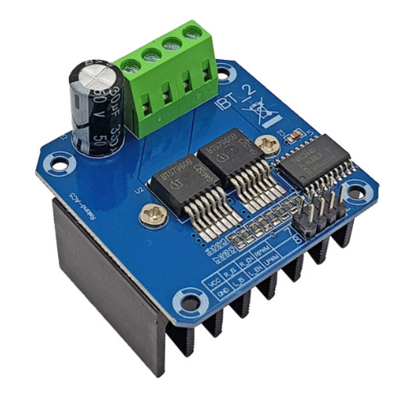

Figure 3.33. Driver BTS 7960

( Cited in: <https://nshopvn.com/product/mach-dieu-khien-dong-co-dc-bts7960-43a-1-dong-co/> )

### **3.3.3. Selection of power source**

Our mobile robot uses two kind of power sources to provide the energy for couple of motors separately to other electrical components such as MCU, sensors, camera.

* **CNHL 2200mAh 14.8V 4S 40C Lipo Battery XT60 Plug**

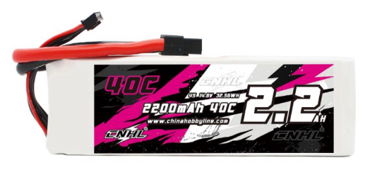

Figure 3.34. Lipo battery 4S

(cited in: <https://chinahobbyline.com/products/cnhl-2200mah-14-8v-4s-40c-lipo-battery-with-xt60-plug-us-warehouse?_pos=3&_sid=8aca06e27&_ss=r>)

- Specification for CNHL 2200mAh 14.8V 4S 40C Lipo Battery XT60 Plug:

* Capacity: 2200mAh .
* Voltage: 14.8V max voltage 16.8V.
* Charge rate: Max 5A.
* Dimension: 32.4x35x108mm.
* Weight: 264g.
* Discharge rate: 40C Continual / 80C Burst.
* Jack: XT60.

This Lipo battery our group uses to provide the 5V power supply for the hardware system components for Jetson Nano and 9V for the Arduino Mega 2560 (Use module Step Down Adjustable Dc reduces the voltage from 14.8-16.8V to 5V and 9V respectively) and 5V power supply (Use module Step Down Adjustable Dc reduces the voltage from 14.8-16.8V to 5V) for electric components such as two encoders response from two motors, RPLIDAR A1, Logitech c270 webcam, IMU sensor, and also provide the power for the logic two motor driver modules so we get the measurement current consumes from VOM device the total approximately about 650mAh for total 9 electric components that means:

The estimated battery time remaining:

t = $\frac{Capacity of Lipo battery}{The current consume of 9 electric componets }$ = $\frac{2200 mAh}{650 mah}$ = 3.38 (hrs)

$≈$ 202.8 (mins)

So that mean after 3.38hours or 202.8 minutest is out of lipo battery.

* **Rechargeable Sealed** **Lead Acid Battery EG5-12**

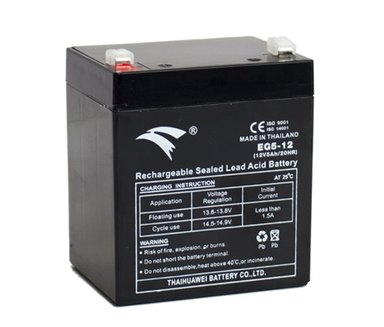

Figure 3.35. Lead Acid Battery Eagle EG5-12

(cited in: <https://matnau.vn/san-pham/ac-quy-12v-5ah-eagle-eg5-12-1700>)

- Primary specification for rechargeable Sealed Lead Acid Battery EG5-12:

* Capacity: 5Ah.
* Voltage: 12V.
* Charge rate: Less than 1.5A for floating use (13.6 – 13.8V) and cycle use (14.5-14.9V).
* Dimension: 90x70x106mm.
* Weight: 1.68 kg.
* Design Life : 6 years.

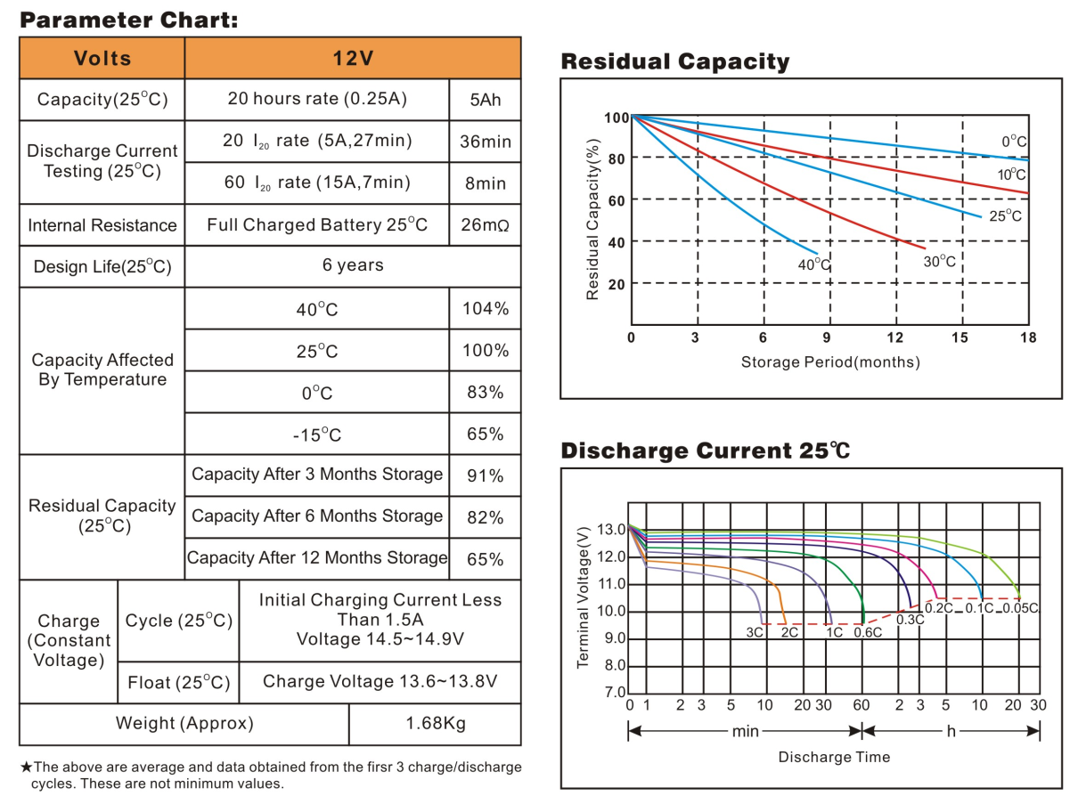

*Figure 3.36. Full specification of Lead-acid Lead Acid Battery Eagle EG5-12*

* **Calculating battery time remaining when operating the system**.

|  |  |  |  |  |  |  |
| --- | --- | --- | --- | --- | --- | --- |
| Without load | | | With load capacity | | | Mass(kg) |
| Current (A) | Power(watt)-  Current multiplies by 12 | t (hrs) - Battery  Time  Remaning | Current (A) | Power(watt)-  Current multiplies by 12 | t (hrs) - Battery  Time  Remaning |
| 1.7 | 20.4 | 2.05 | 1.86 | 22.32 | 1.88 | 1.5 |
| 1.92 | 23.04 | 1.82 | 3 |
| 2 | 24 | 1.75 | 4.5 |
| 2.3 | 27.6 | 1.52 | 6 |
| 2.3 | 27.6 | 1.52 | 7.5 |
| 2.6 | 31.2 | 1.34 | 9 |
| 2.8 | 33.6 | 1.25 | 10.5 |
| 2.7 | 32.4 | 1.29 | 12 |
| 2.9 | 34.8 | 1.2 | 13.5 |
| 3 | 36 | 1.16 | 15 |

Table 3.16. The estimated **Lead-acid battery time remaining without load and with load**

For the Lead-acid battery, we use to provide power for the two motors driver module to control the motors, we have the equation for calculating the time estimatedLead-acid battery time remaining as follow:

t = $\frac{A.V.η}{P}$ (Cited in reference **[24]** )

Note:

t: The time using the Lead-acid battery (hours)

A: Capacity of the Lead-acid battery (Ah)

V: Voltage of the Lead-acid battery (volt)

P: Power consumption of load (watt)

$η$: The coefficient of the Lead-acid battery. Normal $η$ = 0.7

## **3.4. Controller system design**

### **3.4.1. Operation process**

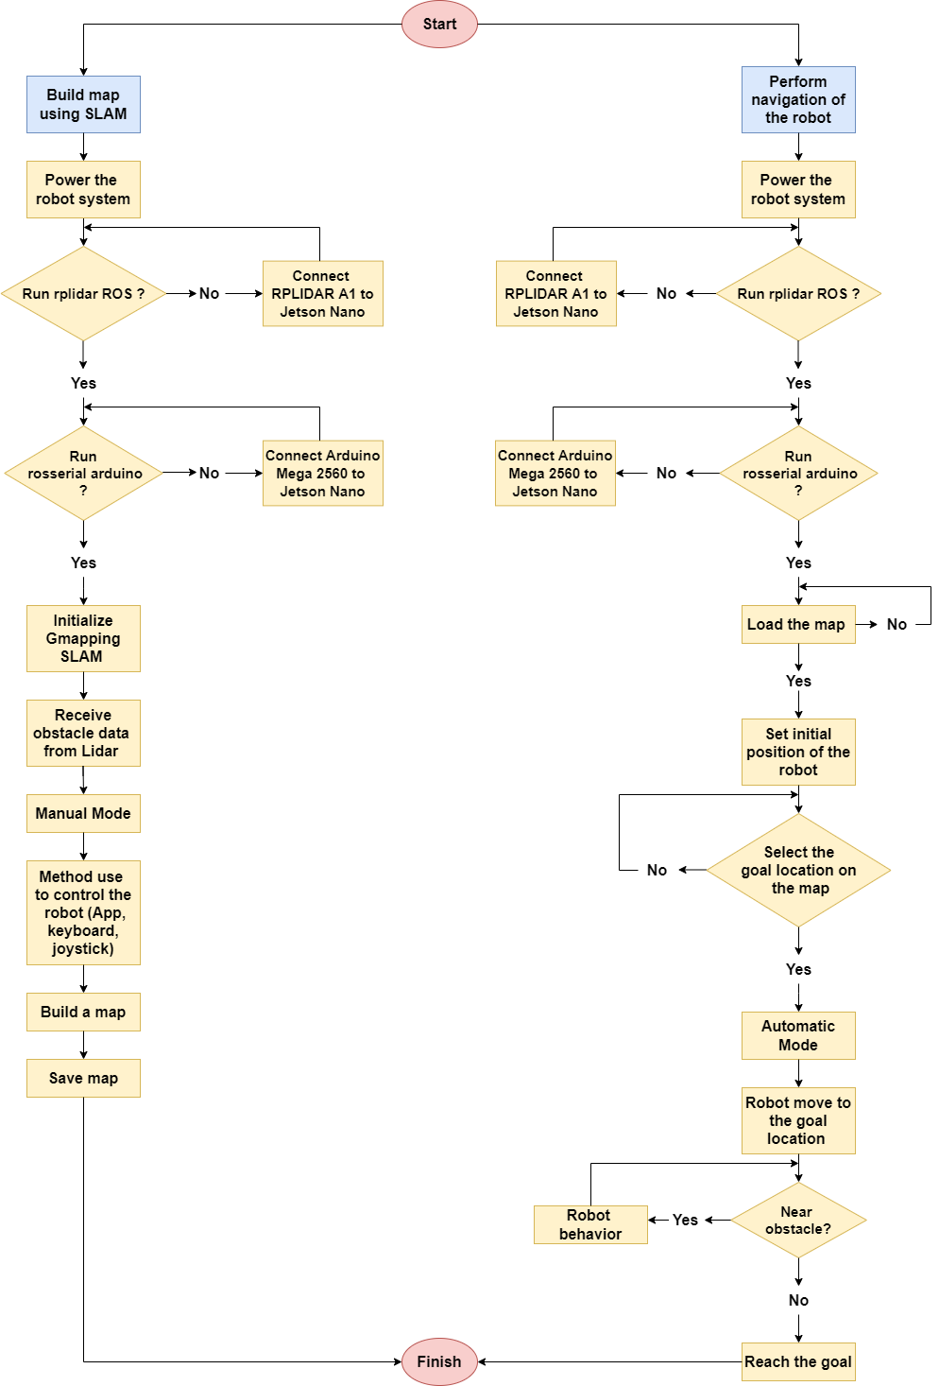

Figure 3.37. Control flowchart

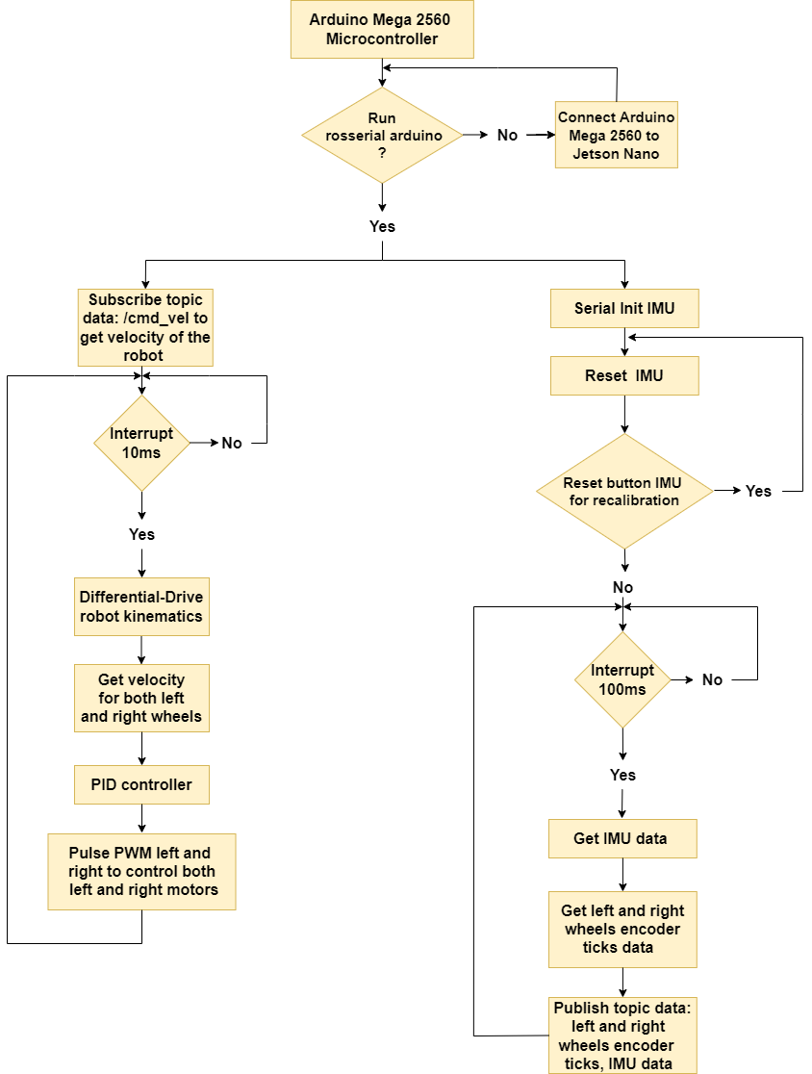

Figure 3.38. Arduino Mega 2560 program flowchart

### **3.4.2. Flow chart explanation**

* **Control flowchart:**
* **Build Map using SLAM:**

- Power the robot system (12 volts for the Motors driver module and 5 and 10 volts power supply for the jetson nano and Arduino mega respectively).

- Run rplidar ROS let for the Jetson Nano get the data ROS LaserScan message on the RPLIDAR A1.

- Run rosserial arduino let for the Jetson Nano and Arduino mega exchange the data using UART protocol communication have baud rate at 57600 bit/s.

-Initialize Gmapping SLAM algorithm to create a map.

- Receive obstacle data from Lidar. RPLIDAR A1 detects the obstacle and send the data for the Jetson Nano to build a map and save pixel at that position have or not have an obstacle.

- Method using control of the robot (App, keyboard, joystick) to move straight or rotate over the PID algorithm.

- Continue to build a map while going to the new location.

- Save the final map data if not go to another location, later the robot gets this saved map to perform the navigation purpose. Process build map using SLAM done.

* **Perform navigation of the robot:**

- Power the robot system (12 volts for the Motors driver module and 5 and 10 volts power supply for the Jetson Nano and Arduino Mega respectively).

- Run rplidar ROS let for the Jetson Nano get the data ROS LaserScan message on the RPLIDAR A1.

- Run rosserial arduino let for the Jetson Nano and Arduino mega exchange the data using UART protocol communication have baud rate at 57600 bit/s.

- Load the saved map using SLAM ready to perform navigation of the robot if not there is no map loading in Rviz simulation.

- Set the initial position of the robot, the robot needs to know the position in the map simulation with respect to the position in reality so it can perform navigation correctly.

- Select the goal location on the map.

- Robot will move to the goal location automatically with the PID algorithm.

- If the robot detects a nearby obstacle, it will perform robot behavior and find a new path to go to the goal location.

- If the robot reaches the goal, the process of performing the navigation robot is finished.

* **Arduino Mega 2560 program flowchart:**

Arduino Mega 2560 microcontroller: the Kp, Ki, and Kd parameters are defined for the left and right motor, and also the rosserial arduino must be run before going to the interrupt period.

Interrupt 10ms: Before going to the interrupt 10 ms period the Arduino Mega 2560 will subscribe to the /cmd_vel topic from the publisher Jetson Nano to get the velocity value (Linear and angular data). In interrupting period, this value later will use for the Differential-Drive kinematic function to calculate separately the left and right wheels velocity (range 0.18 to 0.26 m/s). The PID controller gets the sample encoder ticks in 10ms with the set point left and right wheels velocity value to specify the real required speed then it will export the PWM values to the motor driver module to control the left and right motors.

Interrupt 100ms: Before going to the interrupt 100 ms period establishes the serial communication between the Arduino Mega 2560 and IMU sensor and reset the value IMU, a button is pressed on the sensor to recalibration if the value is drifting or wrong. In interrupting period, for every 100 ms, Arduino Mega 2560 gets the IMU, left and right encoder ticks data (topic: /float_imu, /lwheel_ticks_16bit, /rwheel_ticks_16bit) to publish all these values for the Jetson Nano for the differential drive package to calculate the odometry value, this value is used for Rviz simulation.

## **3.5. Implementation of PID controller**

The PID algorithm can be implemented as the following steps below.

* **Step 1: Import library and declares necessary variables**

Declares the PID library so as to enable its capability.

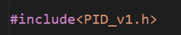

For each motor wheel, we declare the 3 basic values of PID controller are Ki, Kp, and Kd.



Creates the the PID function for each motor wheel in which contains all necessary variables.

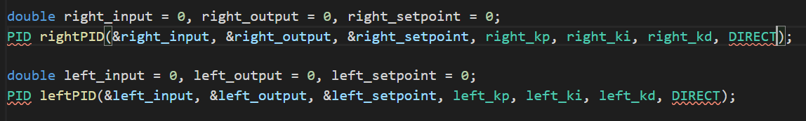

Declares kinematic and encoder variables for both wheel motors that can be used for processing PID algorithm

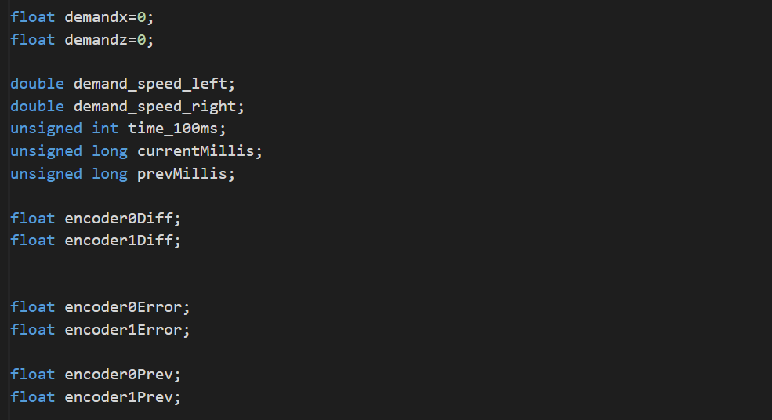

* **Step 2: Processing PID algorithm**

Discretes data and interrupt the system for every 10ms to obtain sample value

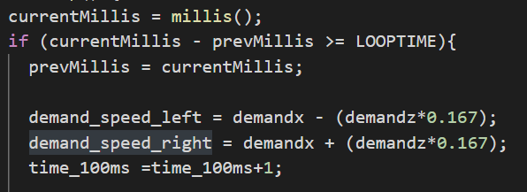

Taking the new sample value for every 10 ms

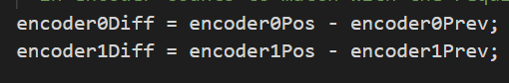

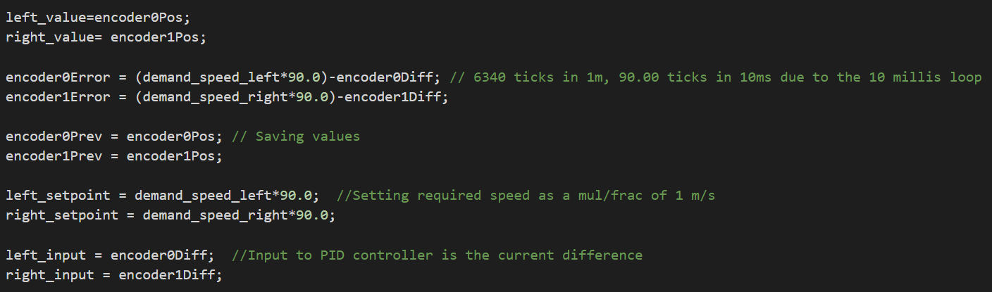Establish formula for calculating PID value

* **Step 3: Output final PID value**

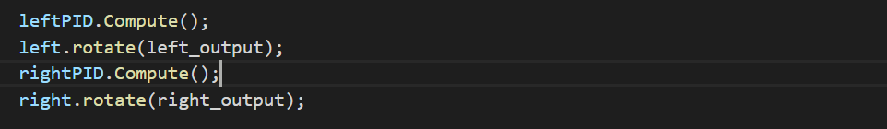

# **CHAPTER 4: SLAM AND NAVIGATION ALGORITHMS**

## **4.1. SLAM for mapping process**

We are going to take a look at how the SLAM processes for scanning the map before researching about the deep method in the below image.

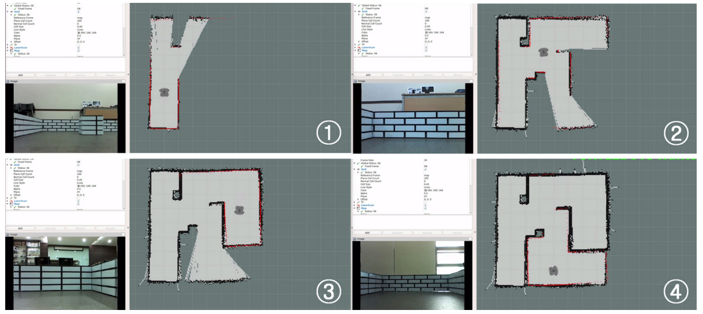

Figure 4.1. Demo of SLAM running for mapping

(Cited in reference **[4]** )

Figure 4.2. Completed Map

(Cited in reference **[4]** )

* **How to create map in ROS**

First of all, we need to know that a certain environment can not be understood by a robot if we just simply input a paper map to it. Because, robot do not have consciousness like the human-being to it self explore the unknow environment. Therefore, the robot would need encode and understand the information.

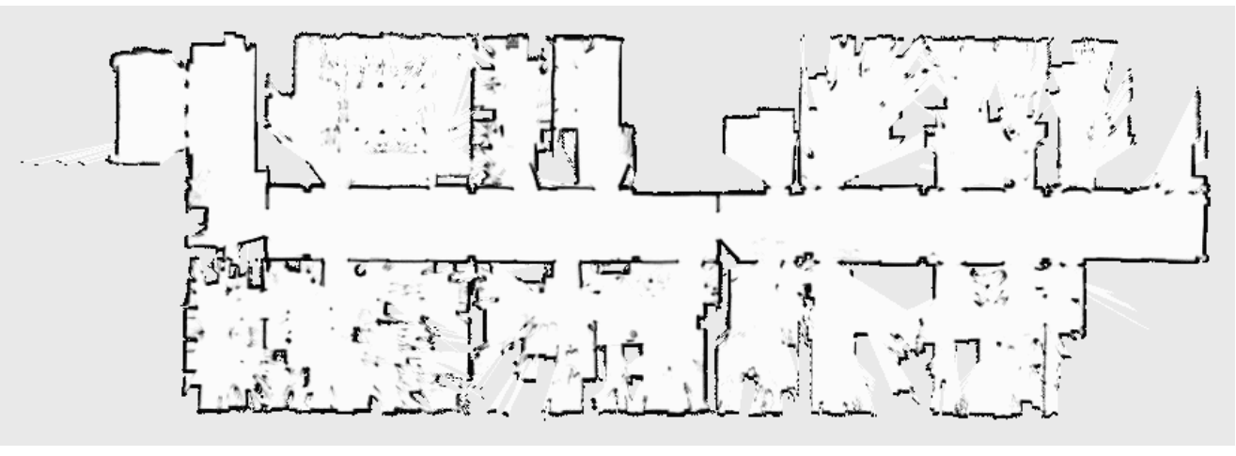

Figure 4.3. Example of map

(Cited in reference **[4]** )

SLAM provides some packages or approaches allow robot to move around and create a map by itself.

Table 4.1. Differences between SLAM approaches

|  |  |
| --- | --- |
| **SLAM approaches** | **Characteristics** |
| A particle filter-based mapping | Involves a ROS wrapper for OpenSlam’s Gmapping |
| Cartographer | System developed by Google that provides real-time SLAM in 2D and 3D across multiple flatforms and sensor configurations |
| Hector_slam | Can be implemented without the aid of odometry |

To built a map using ROS, we can apply the common used package Gmapping which contains A particle filter-based mapping approach that can create an occupancy grid map.

### **4.1.1. Gmapping**

This package is a localization system, it operates on an unexplored environment, peforming SLAM. It creates a 2D occupancy grid map using the pose which is a combination of orientation and position as well as the laser data(or converted data, kinect data).

#### **4.1.1.1. Occupancy grid in ROS(grid map)**

* **Introduction of occupancy grid map**

This term is some kind of computer algorithms in probabilistic robotics for mobile robot that deal with the problem of generating maps from noisy and uncertain sensor measurement data only the pose of robot is known. This algorithms were first proposed by H.Moravec and A.Elfes in 1985.

The way this algorithms works out is to present a map of the environment as an evently spaced field of binary random variables each representing the presence of an obstacle at that location in the environment.After that, the algorithms calculate approximate posterior for these random variables.

* **Explanation of algorithms**

The ultimate duty of this alogorithm is to get the posterior probability over maps with the data givens as:

$$p\left(m\right|z_{1:t},x_{1:t})$$

Where $m$: the map

$z_{1:t}$: set of measurements from time 1 to t

$x_{1:t}$: set of robot poses from time 1 to t

This algorithm do not need the controls and odometry since the path is assumed known.

It also represents the map as a fine-grained grid over the continous space of locations in the environment. The 2D maps are the most common type which occupancy grid map uses as a slice of the 3d world.

Table 4.2. Occupancy grid map’s Algorithm

|  |  |
| --- | --- |
| Assumption | Result |
| $m_{i}$: grid cell with index $p\left(m_{i}\right):$ probability of occupied cell | estimating the posterior is the dimensionality of the problem. |
| The map contains 10000 grid cells, then Number of possible maps is $2^{10000}$ | estimating the posterior is infeasible for all maps. |

The standard approach is solved by breaking the problem into smaller problems of estimating.

$$p\left(m_{i}\right|z_{1:t},x_{1:t})$$

Each of these estimation problems is a binary problem for all grid cell $m_{i}$, this process is convenient but does lose some of the structure of the problem. Since it does not enable modelling dependencies between neighboring cells. Instead, the posterior of a map is approximated by factoring it into.

$$p\left(m\right|z_{1:t},x_{1:t})=\prod_{i}{p\left(m_{i}\right|z_{1:t},x_{1:t})}$$

The occupancy probability for each grid cell is occupied can be represented by using a log-odds and estimated by using a binary Bayes filter.

* **Summary of Occupancy grid map**

Table 4.3. Summary of Occupancy grid map

|  |  |  |  |  |
| --- | --- | --- | --- | --- |
|  | **Occupancy Grid** | | | |
| **Map** | **In ROS** | | |
| **Characteristics** | Grid (matrix) of cell | Map is built with SLAM | | |
| A cell can be empty or occupied | Cell has three possible states | | |
| Cell size can be 5 – 50 cm, depends on resolution | Unknown | Empty | Occupied |
| Each cell hold a probability of occupancy 0%-100% |
| Unknown areas are marked as -1 |

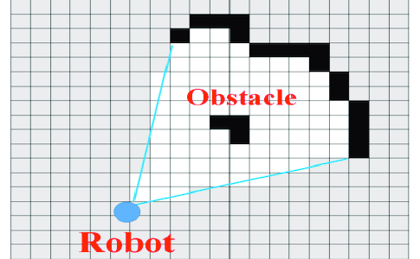

Figure 4.4. Example of Occupancy grid map

(Cited in: <https://www.researchgate.net/figure/Occupancy-grid-map_fig1_321326800>)

Where: Unknown (gray scale) is an unexplored area.

Occupied(black scale) is the area robot can not move.

Empty(white scale) is the free area robot cant’t move

Ray-tracing(blue scale) is used to find a empty cell.

#### **4.1.1.2. Robot Hardware constraints for SLAM**

The Gmapping package that we used for SLAM contains some hardware constraints that we should understand.

* **Movement**

There are three parameters in robot platform in order to make it move includes X,Y axis linear and theta angular velocity command. For example, the robot composed of two motors is a differential drive or an omni-wheel robot which has more than three drive shaft.

* **Odometry**

This is a process of getting variety of current robot’s pose respect to time by estimating the traveled distance via compensate pose with inertial data or calculate translation and angular speed with IMU sensor. Furthermore, the odometry can also be estimated via rotary encoder.

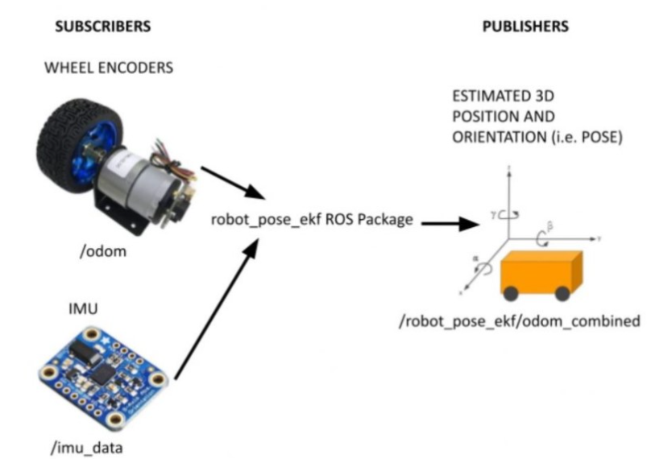

Figure 4.. Sensors for odometry measurement

(Cited in:<https://automaticaddison.com/sensor-fusion-using-the-ros-robot-pose-ekf-package/> )

* **Distance measuring sensor**

For SLAM and navigation, the robot should have sensors such as LDS , LRF or LiDAR so as to measure the distance to the obstacle on the XY plane. It is quite important to choose the postion of mounting the sensor in the non-obstacle area on robot to achieve the best scanning range quality.

Our group decided to choose the LiDAR sensor due to its powerfull functionality in comparison with others type.

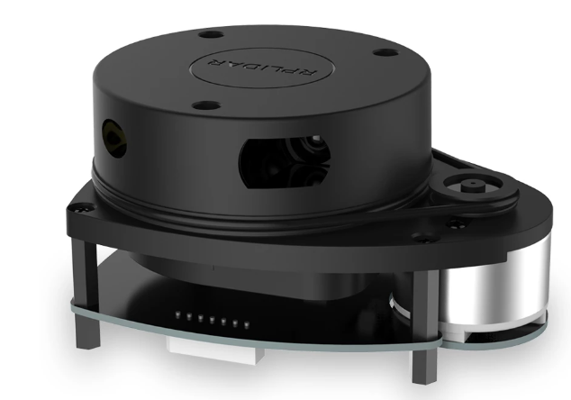

Figure 4.6. LiDAR sensor

(Cited in reference **[24]**)

**+ Brief introduction:** This sensor is a low cost 360 degree 2D laser scanner solution developed by SLAMTEC. The system can perform 360 degree scan within 6 meter range. The produced 2D point cloud data can be used in mapping, localization and object/environment modeling.

RPLIDAR A1’s scanning frequency reached 5.5 hz when sampling 360 points each round. And it can be configured up to 10 hz maximum.

This sensor is simply a laser triangulation measurement system. It can work excellent in all kinds of indoor environment.

RPLIDAR A1 is basically a laser triangulation measurement system. It can work excellent in all kinds of indoor environment and outdoor environment without sunlight.

**+ System connection:** This sensor contains a range scanner system and a motor system. Once power on the motor will rotate and scan clockwise. The range scan data can collect via the communication interface (Serial port/USB).

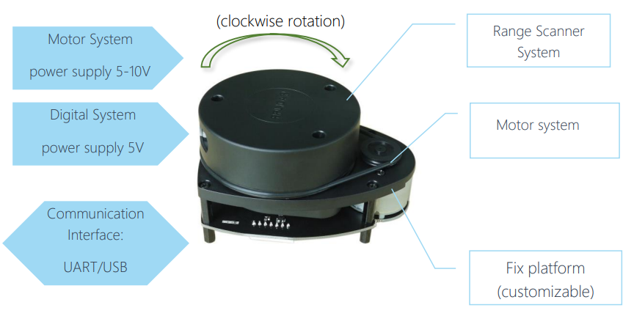

Figure 4.7. LiDAR A1 System composition

(Cited in reference **[24]**)

**+Specification:**

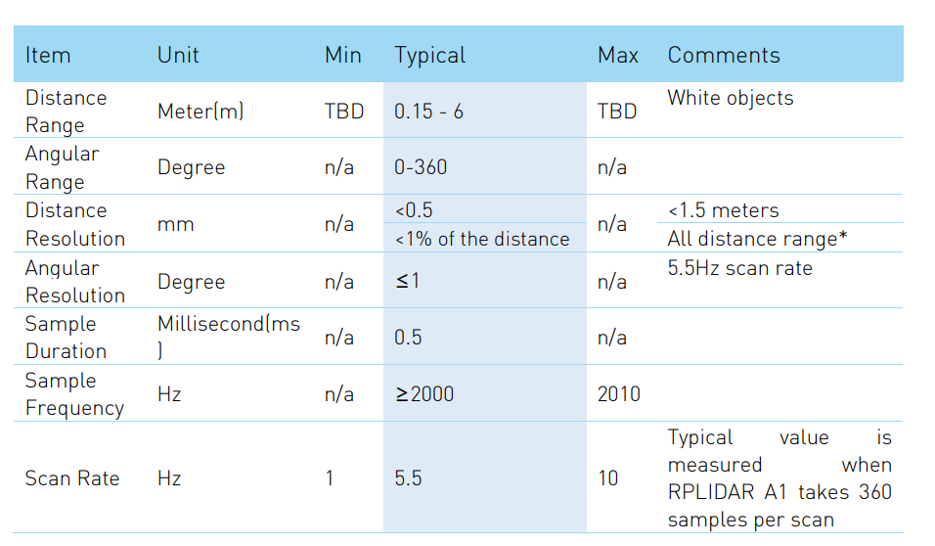

Figure 4.8. Measurement Performance

(Cited in reference **[24]**)

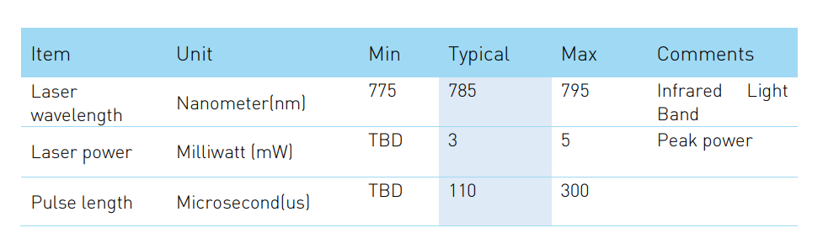

Figure 4.9. Optical specification

(Cited in reference **[24]**)

* **Shape of Robot**

This element also has a big influence on how robot is able to go through or pass the narrow area such as the door or small gaps. Therefore, they are required not too big. Robots with a regular polygon and circular shapes are highly recommended for implementation instead of transformed robots that are long on one axis. Furthermore, bipedal humanoid robots, multi-joint mobile robots, and flying robots are not considered for SLAM.

## **4.2. SLAM process**

To create the map with SLAM, we need to know some required components that relate to the map.

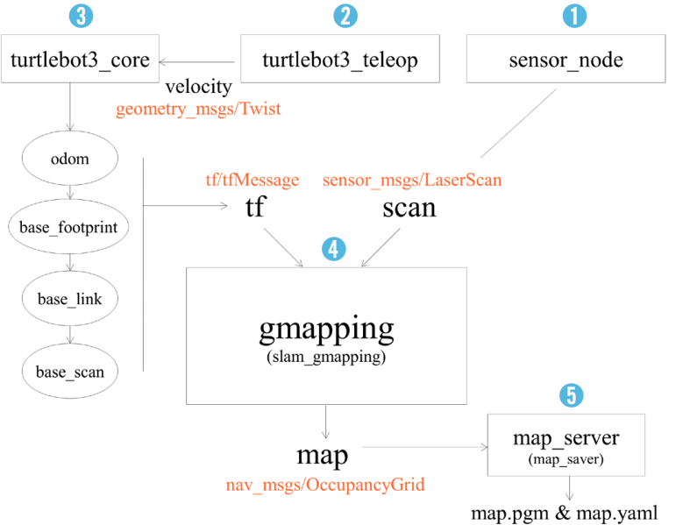

Figure 4.10. Flowchart of SLAM process

(Cited in reference **[4]**)

Table 4.4. Explanation of each component in SLAM process

|  |  |
| --- | --- |
| **Components** | **Function** |
| Sensor_node | This node command the “LaserScan” of Lidar to send the information to the “Slam_gmapping” node. |
| Turtlebot3_teleop | The keyboard signal user command to computer will be taken as an input by this node, after that it will transfer translation and rotation velocity to the node “Turtlebot3_core”. |
| Turtlebot3_core | After having received the two kinds of velocity from “Turtlebot3_teleop” and make the robot move. It will then simultaneously publish the node “odom” parallel to convert relative coordinate of “odom” and “tf” form. |
| Turtlebot3_slam_gmapping | This node creates a map obtained via scan information as soon as finished measuring distance and tf. |
| Map_saver | Both of “map.pgm” and “map.yaml” will be created at the end of process which considered to be a core information file for the map. |

## **4.3. Navigation**

The theory of navigation has already mentioned in chapter 2. It can be described as a simplest term is the ability of a robot to move itself from intial position to goal position without colliding or physically interacting with obstacles.

The autonomous navigation of robot can be explained in the following process below with some required components.

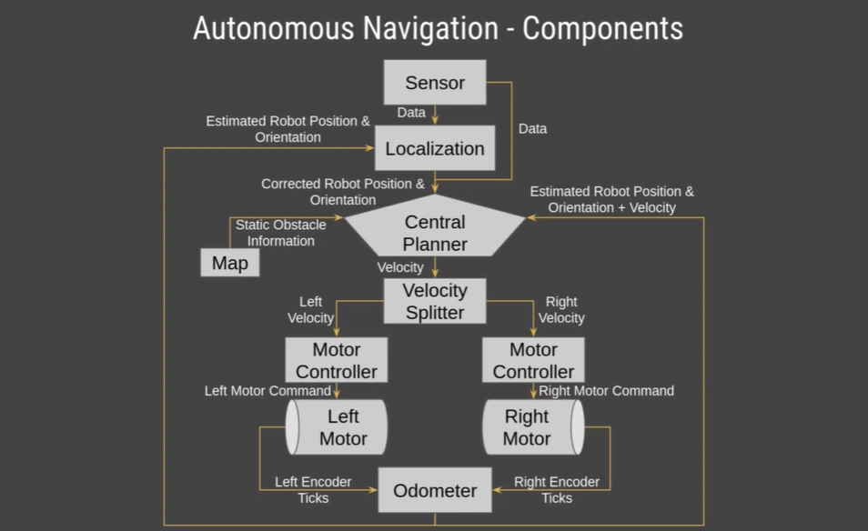

Figure 4.11. Components of autonomous navigation

In addtionall, we also need to focus on the ROS navigation stack, which involves not only ROS components but also differents functionalities such as mapping, map server, planning path, localizing, and so on. All of them unite at once to bring about robot navigation.

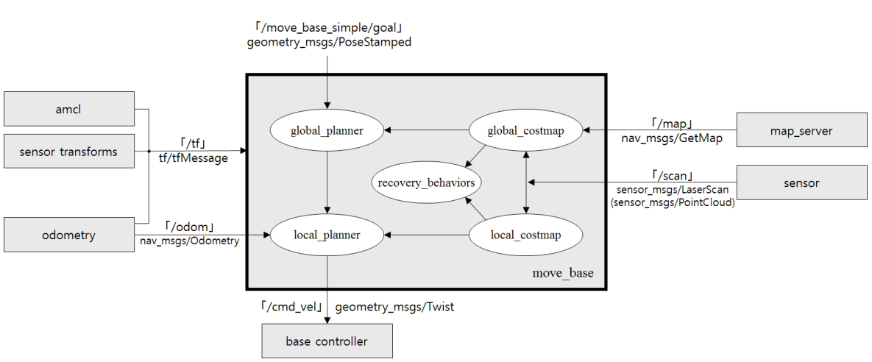

Figure 4.12. Relationship between messages and topics in ROS navigation package

(Cited in reference **[4]**)

The individual components communicate with each other using ROS messages. The relationship between messages and topics to run the ROS navigation package can be illustrated as the below figure.

### **4.3.1. Move_base component**

This package responsible for moving the robot to the specified location. It consists of five components.

* **Global Planner**

This is a specific path planning method takes on a process of generating a static obstacle free-path from current to final position before the robot get ready to move. The expression of start point, and goal point can be represented as x and y coordinates.

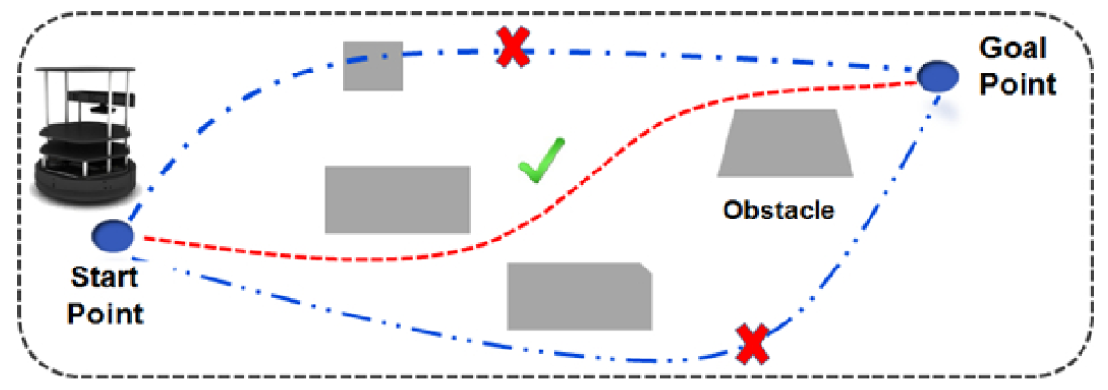

Figure 4.13. Global path planner of mobile robot

This method can be divided into 2 small ways of planning path includes

* **Global_planner**

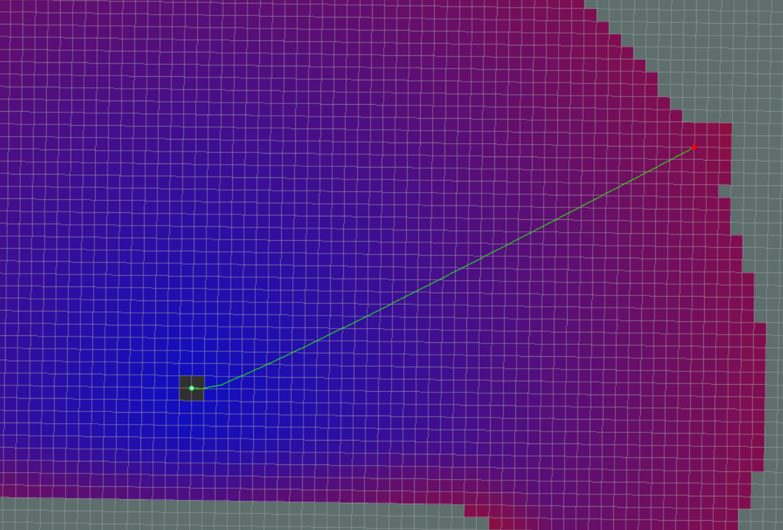

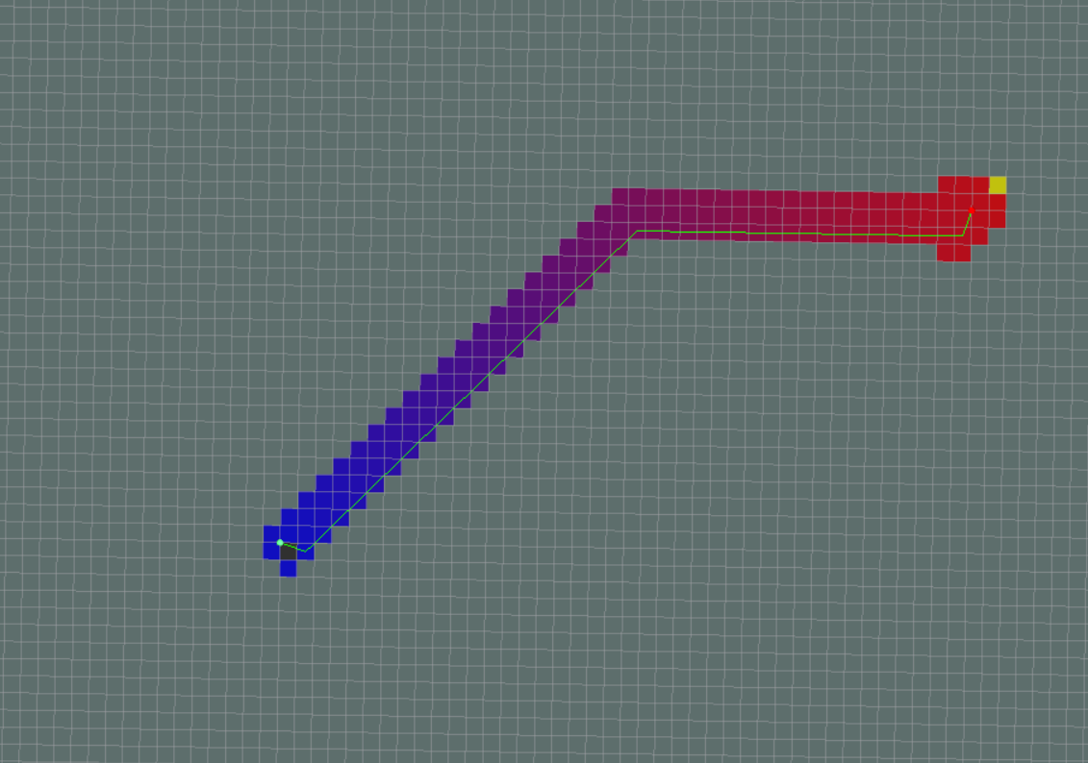

Figure 4.14. Dijkstra’s algorithm(above) and A* algorithm(below)

(Cited in reference **[5]**)

The way of using Dijkstra’s algorithm or A* algorithm to evaluate and plan a shortest free path for a mobile robot to a goal point while avoiding obstacle on its journey.

* **Carrot_planner**

This is said to be simpler than previous method. The given goal on which we command robot to move to will be checked whether it is an obstacle or not. If it true, then robot will choose an alternative goal as close as possible to the goal point by which it is in an obstacle. However in such complicated indoor environment, this planner does not work effectively.

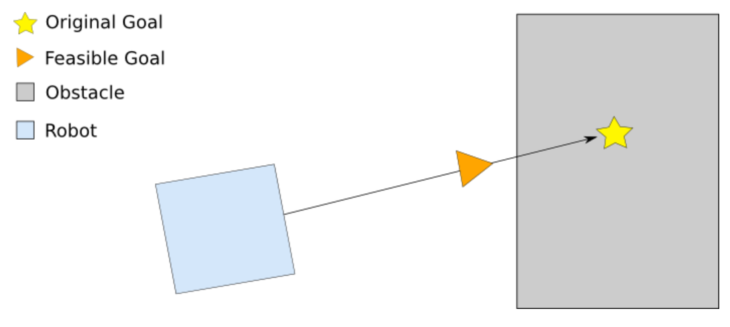

Figure 4.15. Carrot_planner method for robot navigation

* **Local Planner**

The local planner is responsible for plan a real trajectory for a movement of the robot base on the free-path generated by global planner in advance, as it will try to follow that path as close as possible while taking kinematics and dynamics of the robot into account or any moving obstacles.

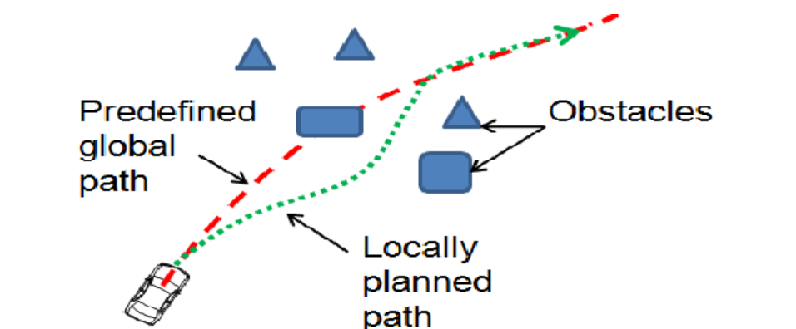

Figure 4.16. Local path planner of mobile robot

This path planning is also able to optimized using an algorithm provided by ROS namely

* **Dynamic Window Approach**

This algorithm will process as the global planner passed to the controller. After that, the controller produces velocity command to send a mobile base.

* Firstly, the controller system will sample the control space of robot discretely.
* Next, at the robot’s current state, the forward simulation will be performed for every sampled velocity in order to anticipate what would happen if that sampled velocity were applied for some short period of time.
* Each trajectory of which resulting from the forward simulation will be evaluated using a metric that integrated some characteristics includes proximity to obstacles, proximity to the goal, proximity to the global path, and speed. Eliminate wrong trajectories (which collide with obstacle)
* Finally, the highest-scoring and reliable trajectory will be chosen and send the associated velocity to the mobile base.
* The process then rinses and repeat as a loop.

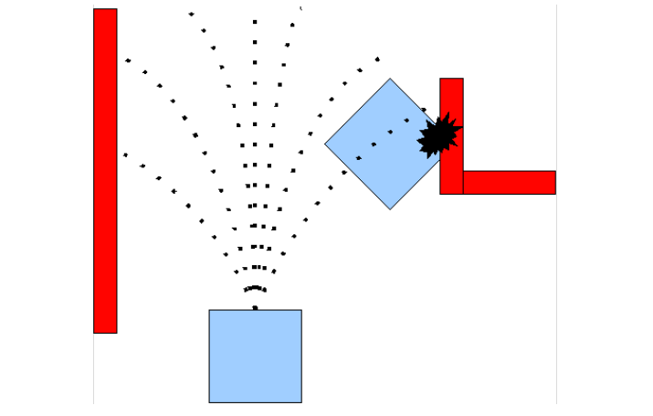

Figure 4.17. Demo of Dynamic Window Approach’s algorithm

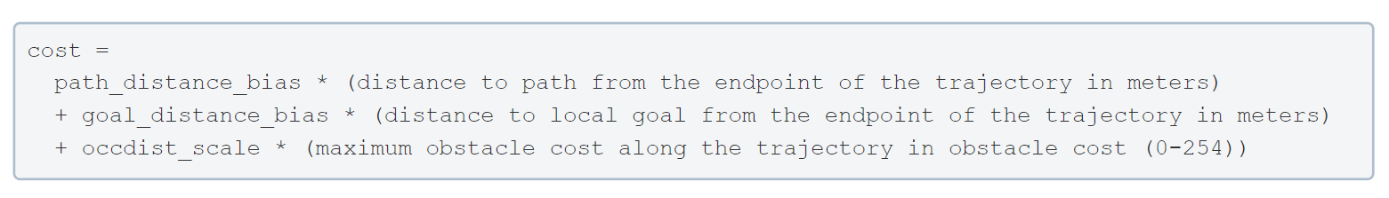(Cited in: <https://www.programmerall.com/article/92751654183/>)

Figure 4.18. The cost function used to score each trajectory

(Cited in: <http://wiki.ros.org/dwa_local_planner>)

* **Costmap**

In navigation, costmap calculates obstacle area as well as possible collision area, and a possible movable area .Depending on the type of navigation, costmap can be classified into two types are:

- Global_costmap: which is used to serve for a path plan while in the navigation in the global area of a fixed map. The represent static obstacle in the robot environment expands the obstacle for proximity safety area (inflated obstacle) so a path plan algorithm does not intersect with this area.

- Local_costmap: which is used to serve for a path plan while in the navigation in the global area of a fixed map. The represent static obstacle in the robot environment expands the obstacle for proximity safety area (inflated obstacle) so a path plan algorithm does not intersect with this area.

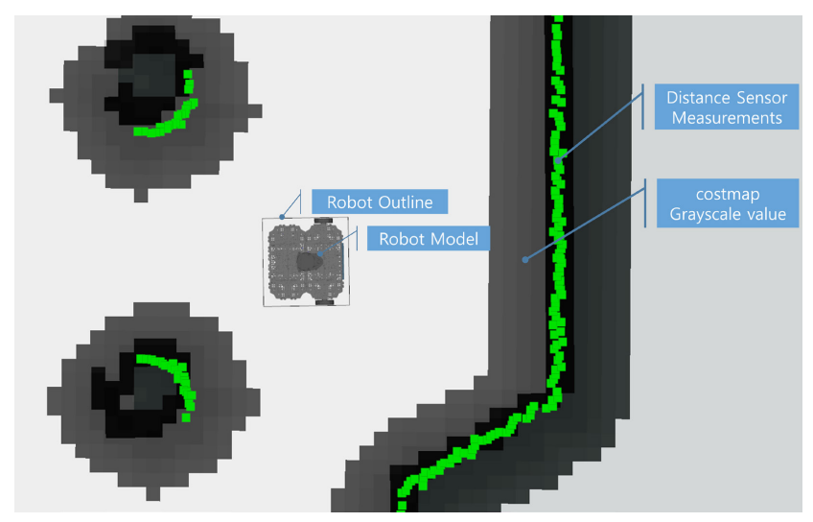

Figure 4.19. Costmap representation (gray scale)

(Cited in reference **[4]**)

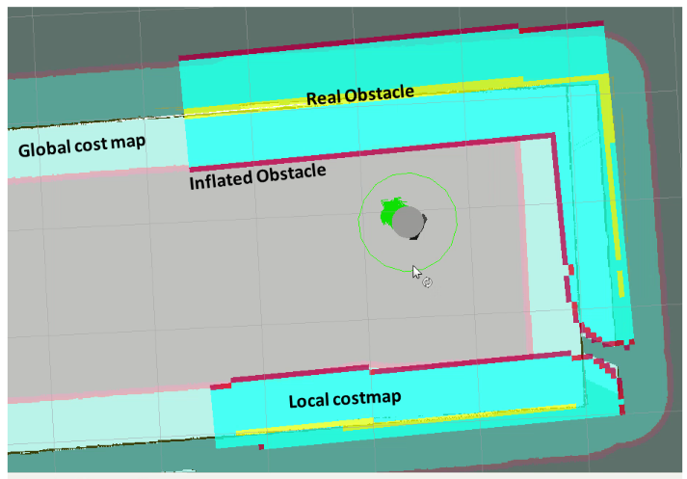

Figure 4.20. Representation of Local and Global costmap

Although both of global and local costmap express different purposes, they still represent in the same way. In general, the costmap is expressed as a value between “0” and “255” which is the limted range for identifying whether the robot is movable or coliding with an obstacle. The calculation of each area depends on the costmap configuration parameters.

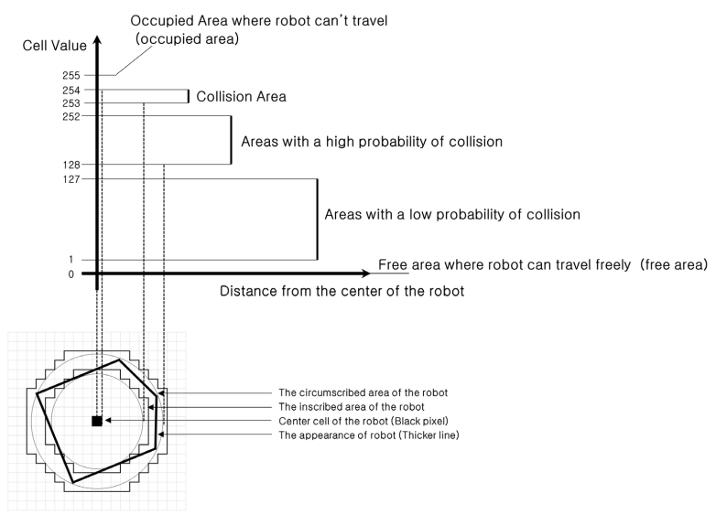

Figure 4.21. Relationship between distance to obstacle and costmap value

(Cited in reference **[4]**)

* **Recovery behaviour**

This term can be explained as the robot suddenly get stuck while moving on its journey and find it difficult to escape from that area, which means the path planning has failed. The recovery behaviour then is implemented to solve the problem.

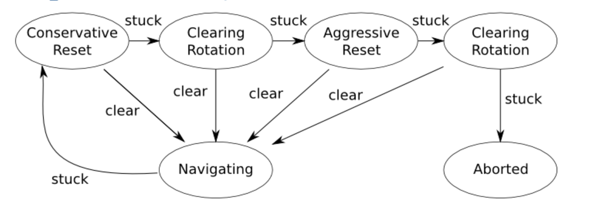

Figure 4.22. Move_base default Recovery Behaviour

(Cited in reference **[19]**)

The principle of this method is that the local costmap will clear the obstacles outside of a user-specified region. Next, if it possible, the robot will launch an in-place rotation to clear out space. If this fails too, the robot will more agressive clear its map, removing all obstacles outside of the rectangular region in which it can rotate in place. This will be followed by another in-place rotation. If all of the stuffs doesn’t work, the robot will consider its goal infeasible and notify the user that it has aborted.

### **4.3.2. Map_server component**

This package responsible for reading the map file and send to planner for path generation.

Firstly, tools in the package store data of maps in a pair of files. The YAML file then describes the map meta-data, and names the image file. The image file encodes the occupancy data.

The more detailed of each component in map format about how they work individually can be shown as below.

* **Image format**

The occupancy state of each individual cell of the world can be presented by the image under a color of the corresponding pixel. In the standard configuration, the area with white pixels is free, whereas the black area coloured by pixels are occupied. Lastly, the area with gray scale is unknown or unexplored.

* **YAML format**

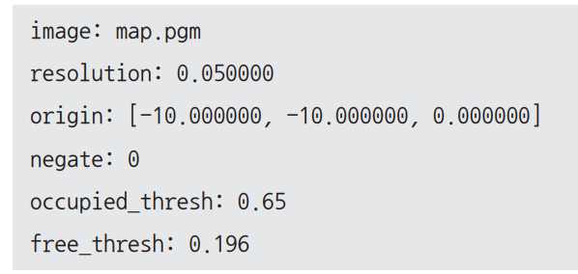In ROS, actual map is stored in “pgm” file format and the “YAML” file contains map information. For example, the map information can be illustrated under an image parameter and resolution in meters/pixels. The more detailed of each parameter can be explained as below.

Figure 4.23. Example of image parameters

(Cited in reference **[4]**)

* **Image:** contains the occupancy data, can be absolute, or relative to the location of the YAML file.
* **Resolution:** meters/pixel
* **Orgin:**The 2-D pose of the lower-left pixel in the map, as (x, y, yaw), with yaw as counterclockwise rotation (yaw=0 means no rotation)
* **Occupied_thresh:** Pixels with occupancy probability greater than this threshold are considered completely occupied.
* **Free_thresh:** Pixels with occupancy probability less than this threshold are considered completely free.
* **Negate:** Whether the white/black free/occupied semantics should be reversed.

### **4.3.3. AMCL component**

This is so called Adaptive Monte Carlo Localization, which is considered to be a high version of predecessor version is Monte Carlo Localization pose estimation, which improves real-time performance by reducing the execution time with less number of samples in the Monte Carlo pose estimation algorithm.

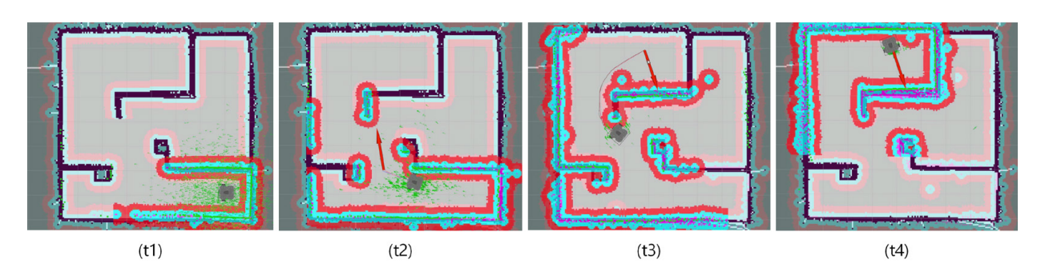The duty of MCL is to determine the location of robot in a given environment. Thus, we must get x,y anh θ of the robot on the map.

Figure 4.24. AMCL process for robot pose estimation

(Cited in reference **[4]**)

### **4.3.4. Base Controller component**

This package reads velocity values from the planner, convert to individual wheel velocities and then to motor commands.

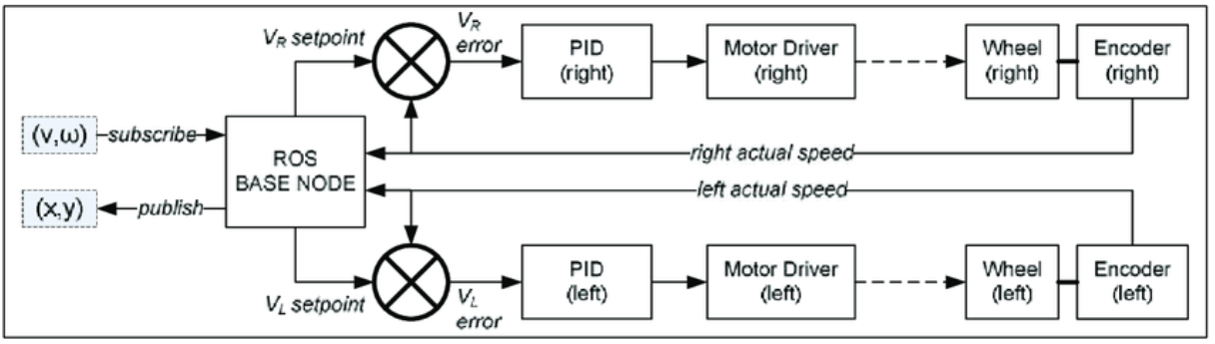

Figure 4.25. Diagram of base controller system

(Cited in: <https://www.researchgate.net/figure/describes-the-diagram-of-base-controller-system-as-ROS-node-The-base-controller-node_fig2_320782369>)

Firstly, the base controller node subscribes v and $ω$ in the form of geometry_msgs/Twist at ROS standard message from the other ROS node as remote operator. Simulaneously, nav_msgs/Odometry is published by the base controller,which consists of x,y,z (=0) obtained from the encoders. ROS geometry_msgs/Twist is translated into $V_{R}$ and $V_{L}$ as a setpoints for two PID controllers. Afterward, PID controllers maintain linear velocity and angular velocity of the mobile robot toward the target position as desired.

### **4.3.5. Odometry component**

This is a method of collecting the data from motion sensors to estimate the change of robot pose over the time. A common type of sensor used for getting this value is encoder that is often integrated with motor.

If a robot has its wheels or legs are equipped a rotary encoder, it is expected to to know exactly how far the robot travelled when we control it to move to any arbitrary location. Moreover, the encoder can measure how far the wheels have rotated. The distance is obtained via the circumference of wheels.

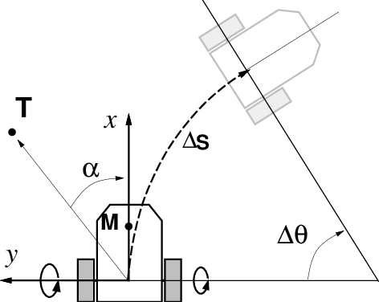

Figure 4.26. Odometry of mobile robot

(Cited in: <https://www.researchgate.net/figure/Mobile-robot-structure-and-odometry-kinematics-One-or-two-front-wheels-not-shown_fig6_3413010>)

### **4.3.6. Sensor transforms component**

* **Tf package**

This component belongs to tf package, which plays an important role in defining the coordinate of each individual’s component of a mobile robot. It allows the user to keep track of multiple coordinate frames over time by which the users are able to transform points, vectors between any two coordinate frames at any desired point of time. Without tf some following tasks of mobile robot such as autonomous driving, transform sensor data to map coordinate are impossible to launch.

* Where was the head frame relative to the world frame at exactly 8 seconds ago ?
* What is the pose of the object in my gripper relative to my base ?
* What is the current pose of the base frame in the map frame ?

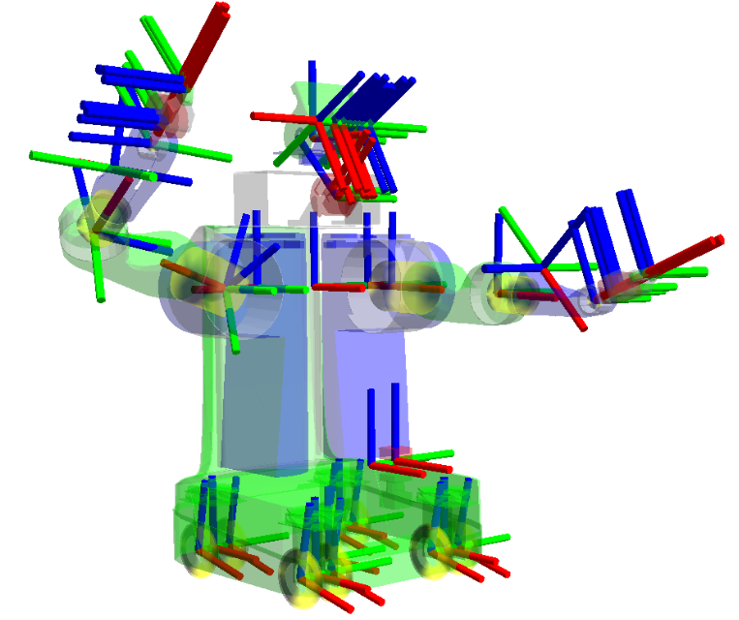

Figure 4.27. The relationship between different coordinates in tf

(Cited in reference **[21]** )

Table 4.5. Summary of tf

|  |  |  |
| --- | --- | --- |
| **SUMMARY OF TF** | | |
| What is TF | Why should we use TF | What problems do TF solve |
| It is a transform library in ROS | Take no effort in performing transformation | Answer where is the head frame relative to the world frame at exactly certain seconds ago |
| The performance of calculating transformation between any frames can be executed by tf |
| It allows to locate the pose of any object in any frame using transformations | Consideration of frames is neglected | Answer what is the pose of the object in a gripper relative to the base |
| A robot is a collection of multiple frames that attached to its different joint | Answer what is the current pose of the base frame in the map frame |

* **URDF package**

This package has the full name as “Unified Robot Description Format”, which can be described as an XML format that represent a robot model, in which includes of links and joints of the robot’s structure.

* Links: rigid parts
* Joints: a connection of two or multiple links that allow robot to do some movement. There are six types of joints supported by ROS include continuous, revolute, prismatic, floating, fixed, and planar. In term of mobile robot, we only use continuous and fixed joints

Some more detailed of link and joints description of mobile robot can be show as the following figures below.

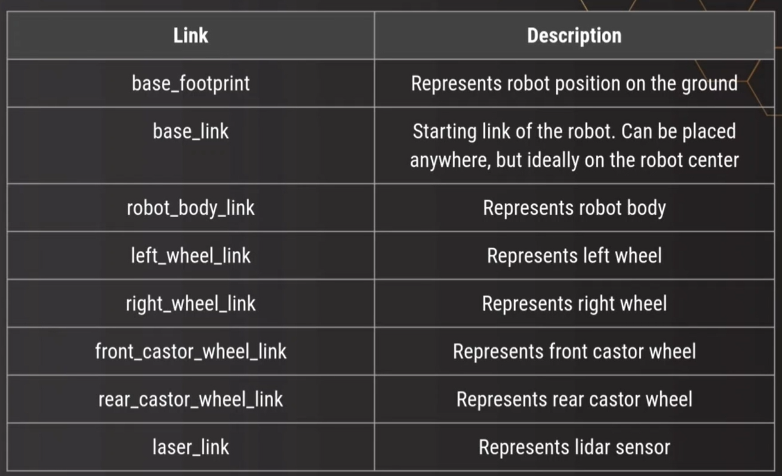

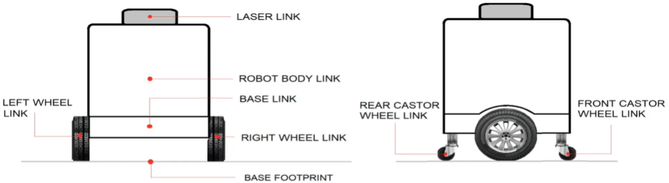

Figure 4.28. Description of links in mobile robot

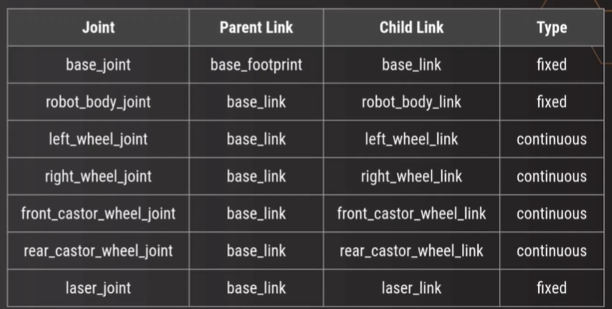

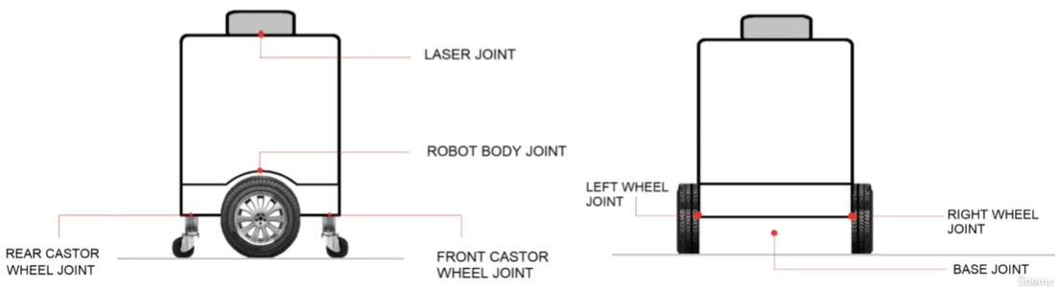

Figure 4.29. Description of joint in mobile robot

Our group’s URDF file of the mobile robot that can be shown below

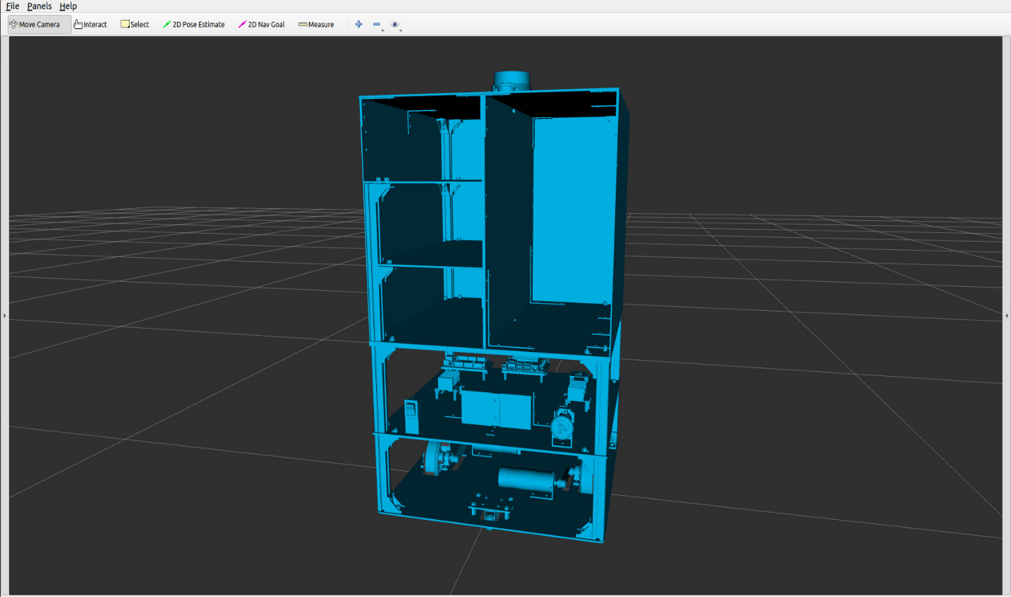

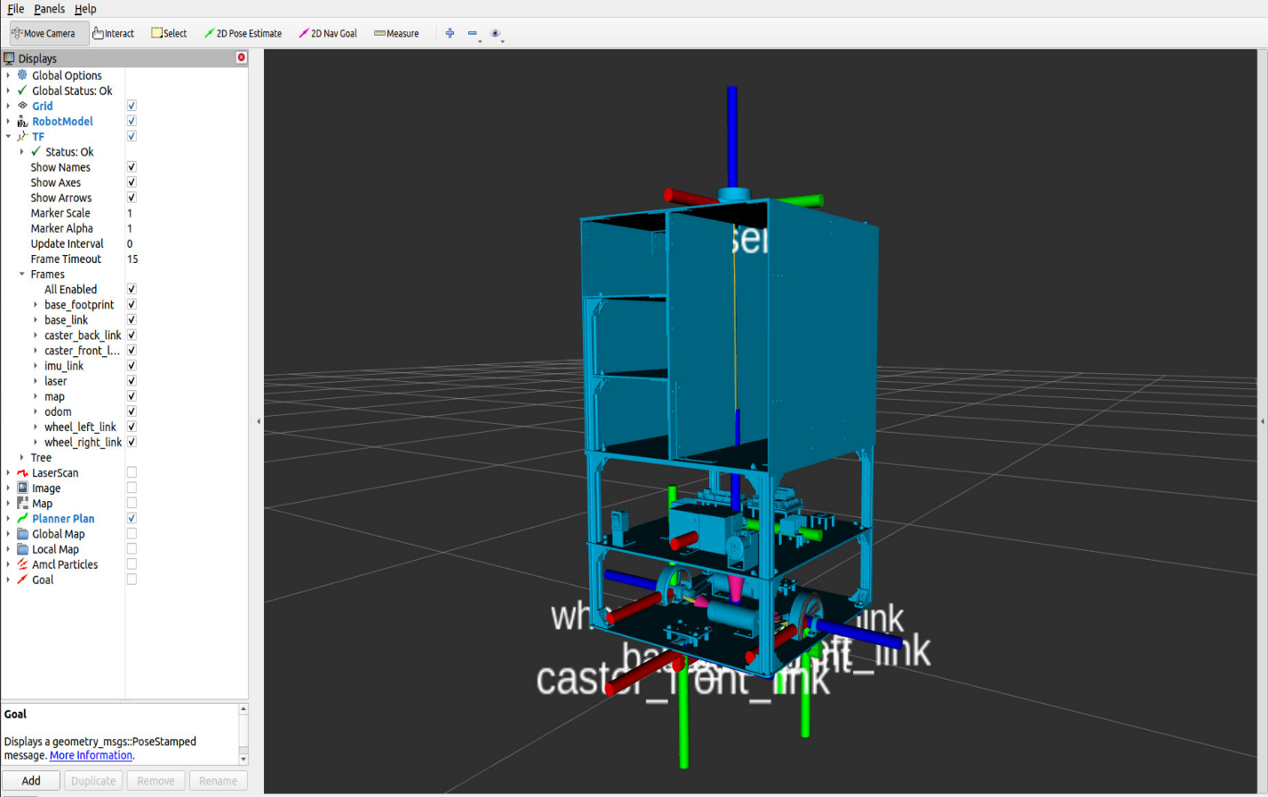Figure 4.30. URDF file of mobile robot

Figure 4.31. Representation of different coordinate frame

## **4.4. ROS-Mobile for manual control**

### **4.4.1. Introduction**

ROS-Mobile is an application designed for dynamic control and visualization of mobile robotic system operated by ROS. The application uses ROS nodes initializing publisher and subscriber with standard ROS messages. In addtional, it is based on the MVVM architecture which comes with simple testing structures and extensibility. The MVVM also stabilizes the application and makes it highly customizable.

* **Step by step how to set up ROS-mobile:**
* An application need to be installed on a mobile device such as smart phone or tablet.
* A wireless ethernet connection between the ROS master and the mobile device has to be established.
* A new configuration can be established after an application being started.
* This configuration is required to set the correct ROS master IP.
* Ros nodes can then be added in the Details section and customized.
* The remote control and visualization can then be accessed in the Viz section.

**4.4.2. Software description**

As we soon get across with the term MVVM in the previous section. In this part, we will go further about the architecture which our Android application is based on. This standard architecture allows the development of robust, efficient applications.

* **Software architecture**

The above diagram can be explained as requires a UI, to enable user interation, as well as ROS nodes, to subscribe or publish to certain ROS topics. The information produced by the user and the data received or sent via the ROS nodes are thereby the concerns of our program which have to handled separately. Despite not having a single entry point like desktop applications do, but Android applications consist of multiple components instead, for instance Activities or Fragments which are controlled by Android OS for intergration into the device workflow. In order to maintain the corret behaviour that our application handle, we use the ViewModel class as a connection between our model and UI. This ViewModel is directly assigned to a UI and let the user interact with them.Thus, The UI controller can be enhanced performance by the OS. The older android version has ROSJava code to be modified to fit the requirements of MVVM architecture.

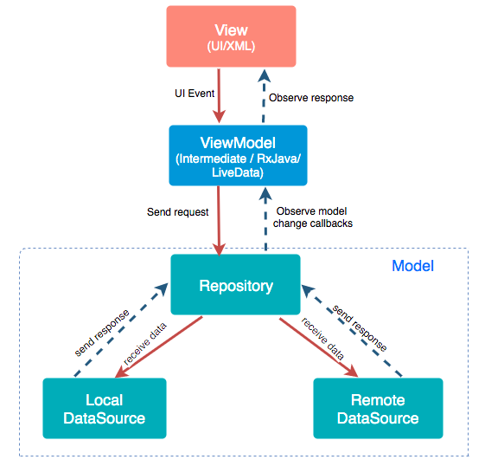

Figure 4.32. The general MVVM designing concept for mobile application

(Cited in reference **[22]**)

* **Software functionalities**

The useful available of ROS-mobile enable our Android devices to control ROS operating system with ease. This can be done via a ROS connection that is established throuhout WLAN by which is able to controle the robot by publishing ROS messages. Moreover, the included SSH client gives the additional control possibility in order to allows direct access to OS. In a nutshell, ROS android application give us a huge assistance in controlling ROS operating system much easier when working with mobile robots outside laboratory environments.

* **Real application for mobile robot**

Our group decided a ROS mobile interface with some necessary information for our mobile robot such as Odometry, velocity

* **Step 1:** Connecting the application with ROS master over WLAN by typing the correct IP address .
* **Step 2:** Adding ROS nodes in the details tab.
* **Step 3:**Enables the controls via joystick method sending geometry msgs/Twist to a cmd_vel topic and the visualization of the generated occupancy grid map by subscribing to the map topic via a grid map method.
* **Step 4:** The recorded occupancy grid map is displayed as well as the joystick. The joystick can be used via touch for sending control inputs over the cmd vel topic to the differential drive robot.

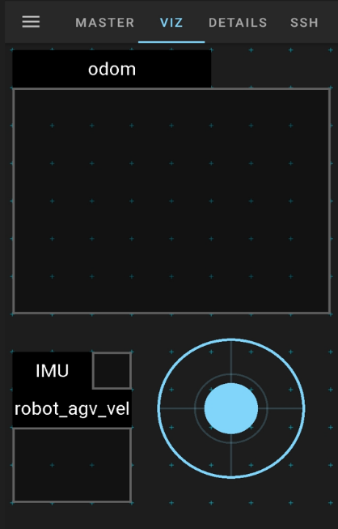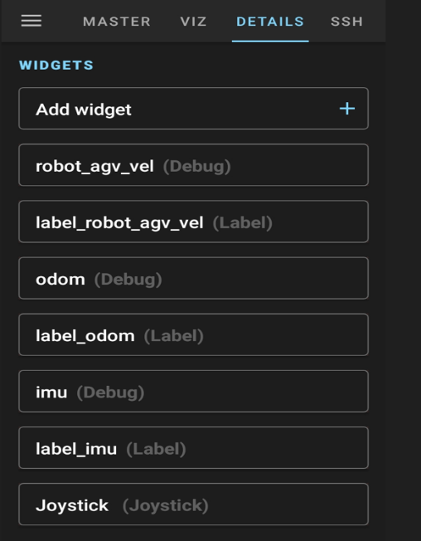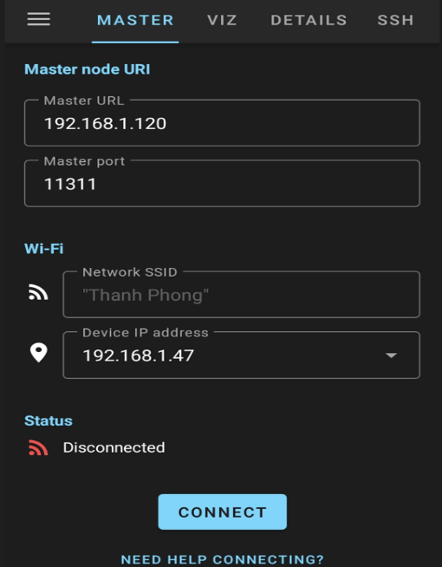

Figure 4.33. Design of controller’s interface with ROS-Mobile

* **Current Application Domains**

The big advantages of ROS mobile can help us to not only easily control and data visualization for mobile robot but also supervise outdoor experiments with robot using smartphones or tablet at ease. Therefore, the researchers has come up a solution to simplify some field experiments and thus expedites the evaluation time for mobile robotic devices. Nowadays, there are some different research projects have already been implemented using ROS mobile.

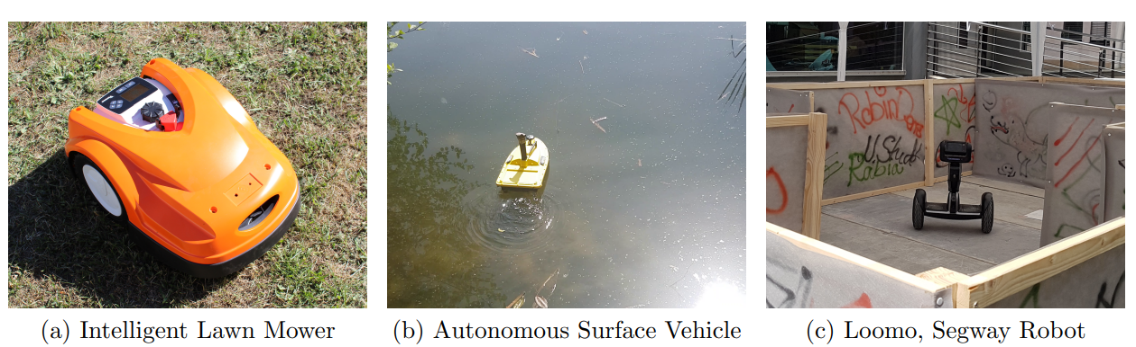

Figure 4.34. Mobile robotic platforms for which ROS-Mobile is currently used for evaluation and control

(Cited in reference **[22]**)

* **Summary of ROS mobile**

After having introduce about ROS mobile and its architecture as well as power full application in real life we can conclude that it is a fast and efficiency control and supervision for realistic experiments with mobile robotic systems in outdoor as well as in indoor environments. The development process for new sensors,algorithms, can then be accelerated. The nowadays version of ROS allows us to implements various nodes for teleoperational control or grid map visualization. The assistance of GitHub repository support user to add any new nodes or visualization methods easily.

# **CHAPTER 5: EXPERIMENTS AND ANALYSES**

## **5.1. Implementation of experiment**

In this first part of chapter 5 we are going to launch an experiment to to test about some basic functionalities of mobile robot, by which can guarantee if it is able to meet some standard requirements to operate properly in hospital environment.

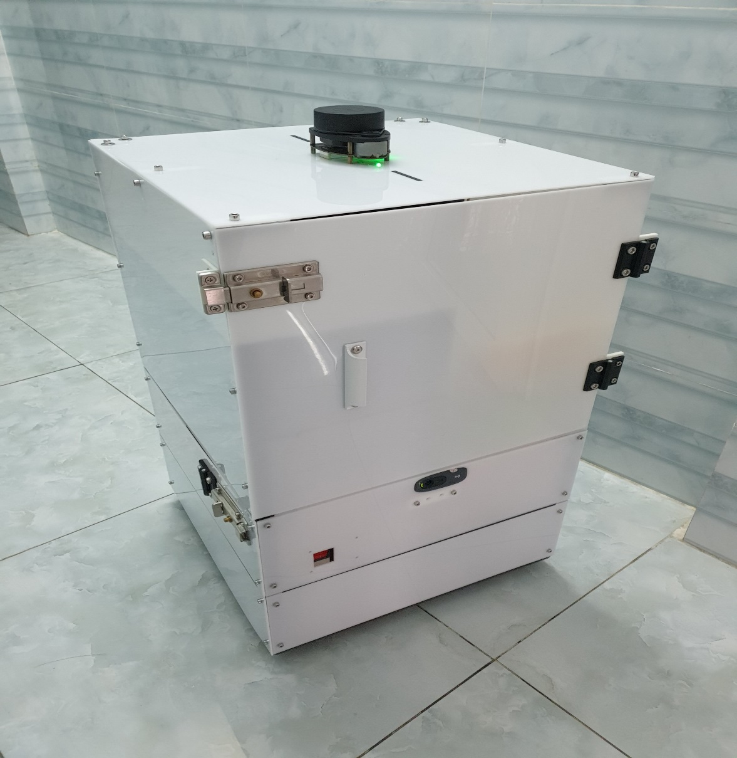

Figure 5.1. Final product result

### **5.1.1. Simulation criteria**

Table 5.1. Simulation criteria

|  |  |
| --- | --- |
| **Number of citeria** | **Objectives of mobile robot** |
| 1 | Able to scan a high quality and accuracy 2D map |
| 2 | Able to precisely recognize static and dynamic obstacles |
| 3 | Able to navigate and go to the exact goal location |
| 4 | Selection of different algorithms for optimizing the navigation task |

### **5.1.2. Result of experiment**

* **2D map Scanned**

The map generated by the map scanning of LiDAR is relative clear and easy to locate the destination compares to the real world

Perform SLAM process:

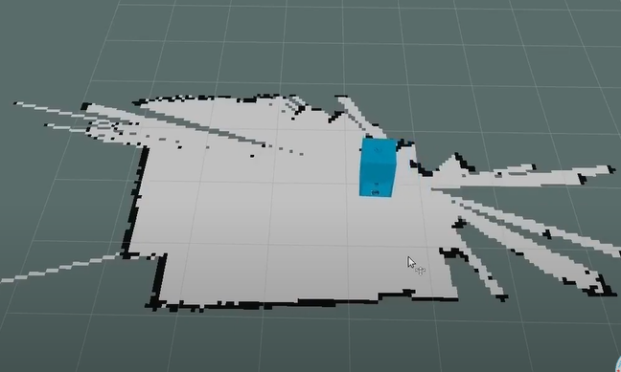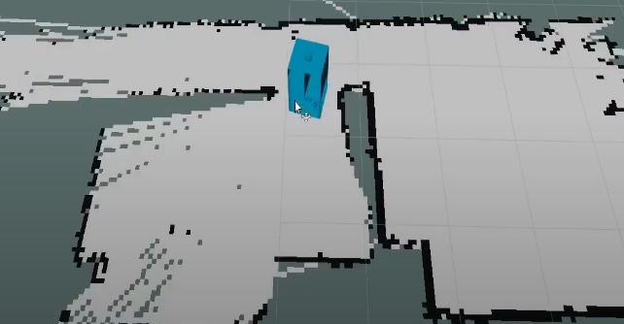

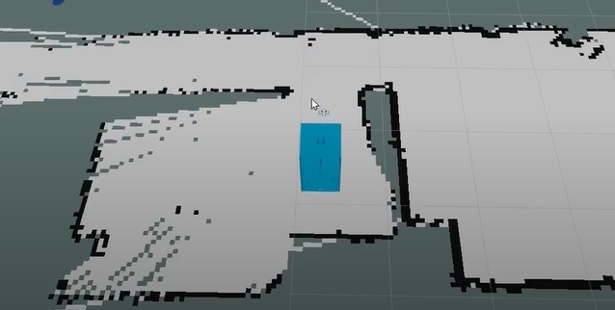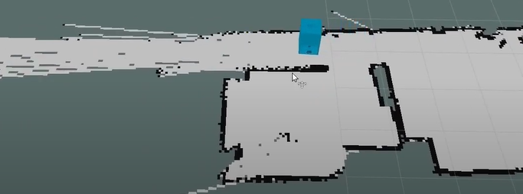

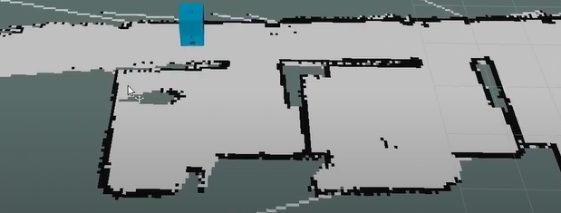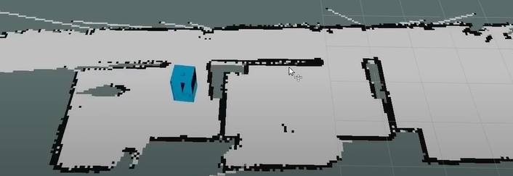

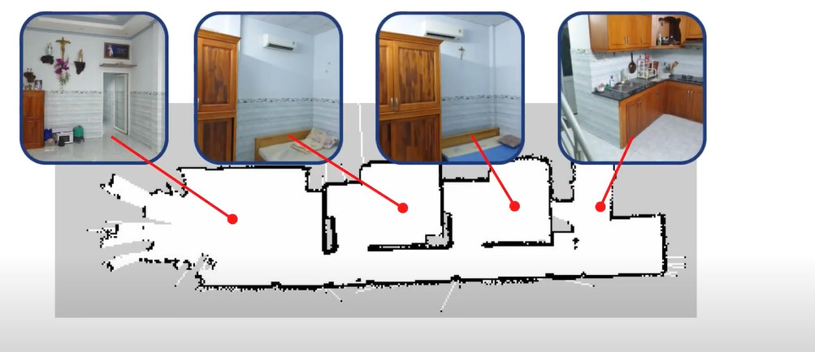

Figure 5.2. Perform Slam process and map scanned result

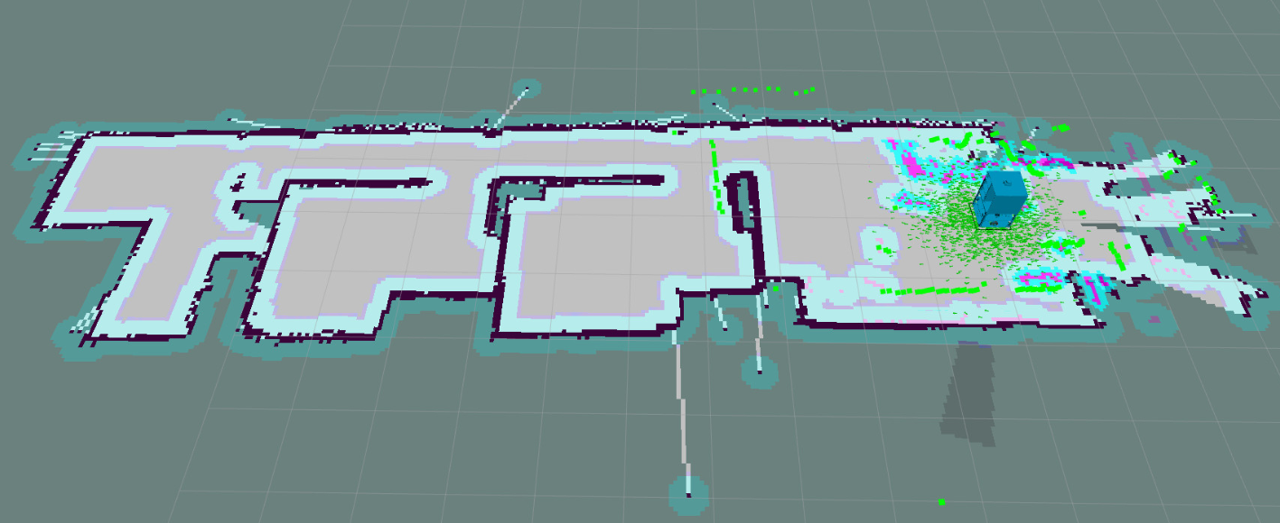

Figure 5.3. Map in simulation environment (Rviz)

* **Navigation**

The Function of navigation can be launch by running Rviz environment and choose the option name as “2D Nav Goal” in the red bracket which shown in the image below, then click on the arbitrary location you wish the robot to move to. After that, there appears a path planning from a present location to destination goal.

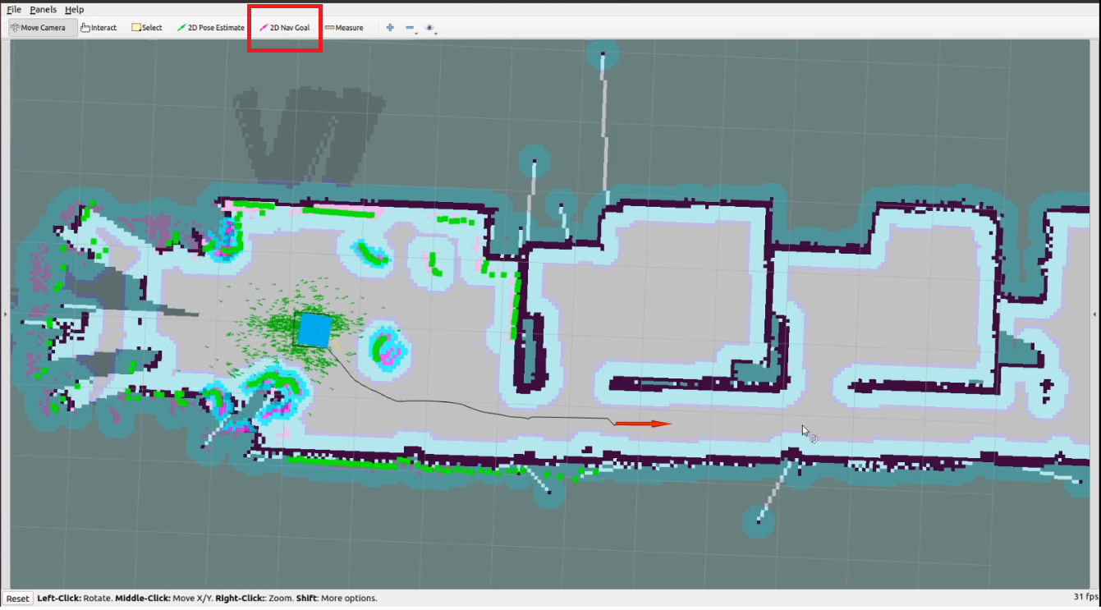

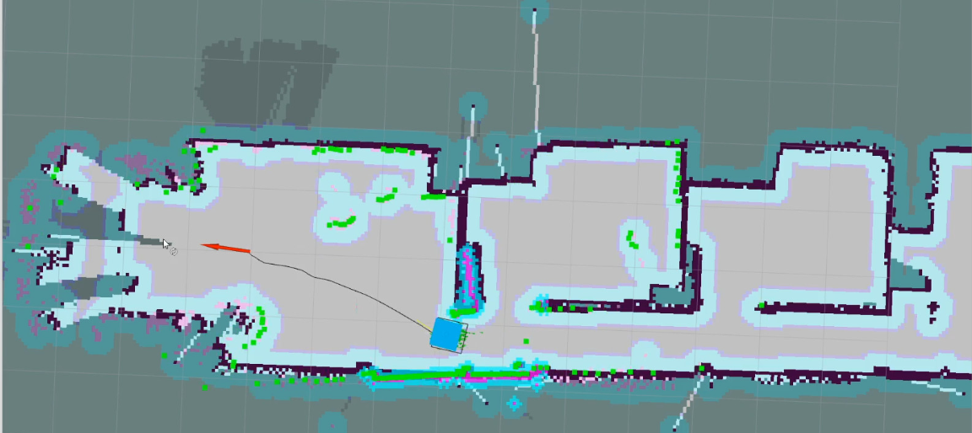

Perform navigation process:

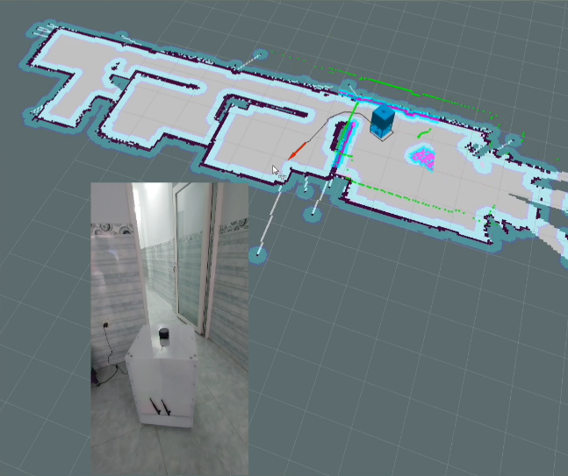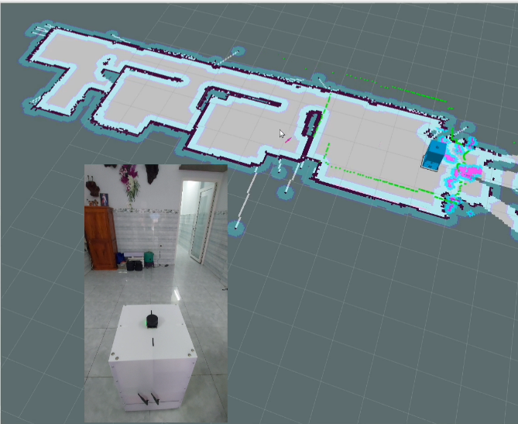

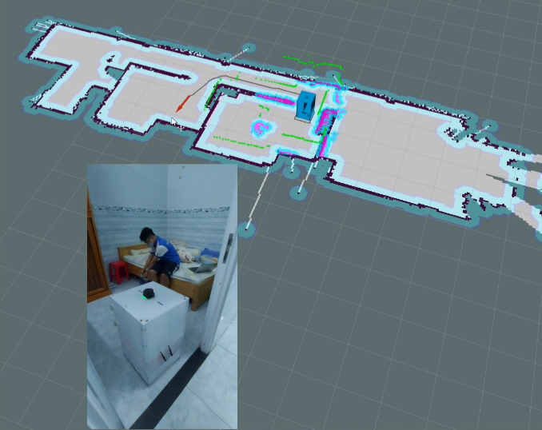

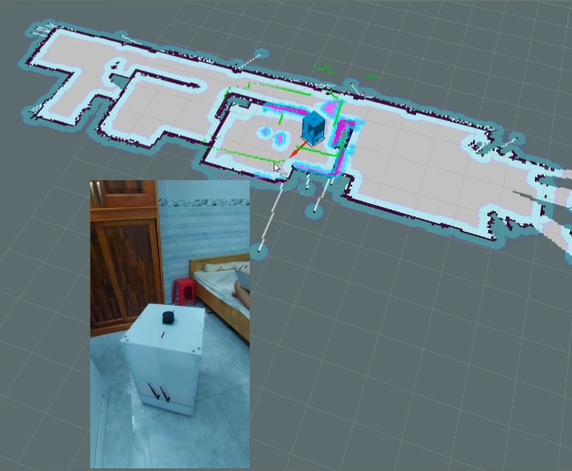

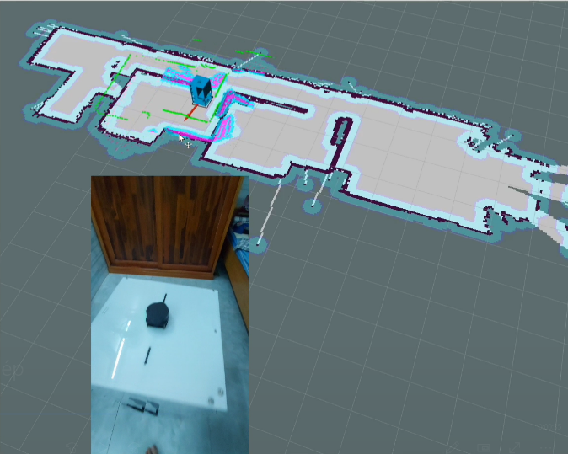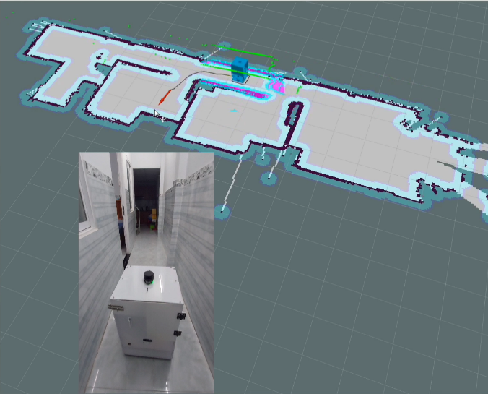

Figure 5.4. Demo of navigation

* **Obstacle recognition and avoidance**

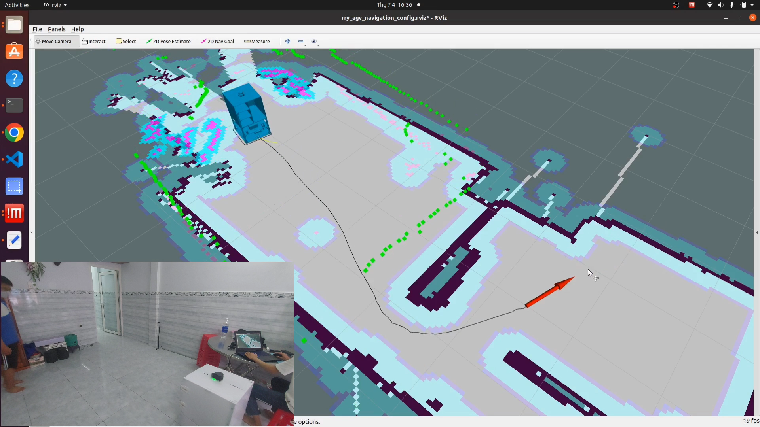

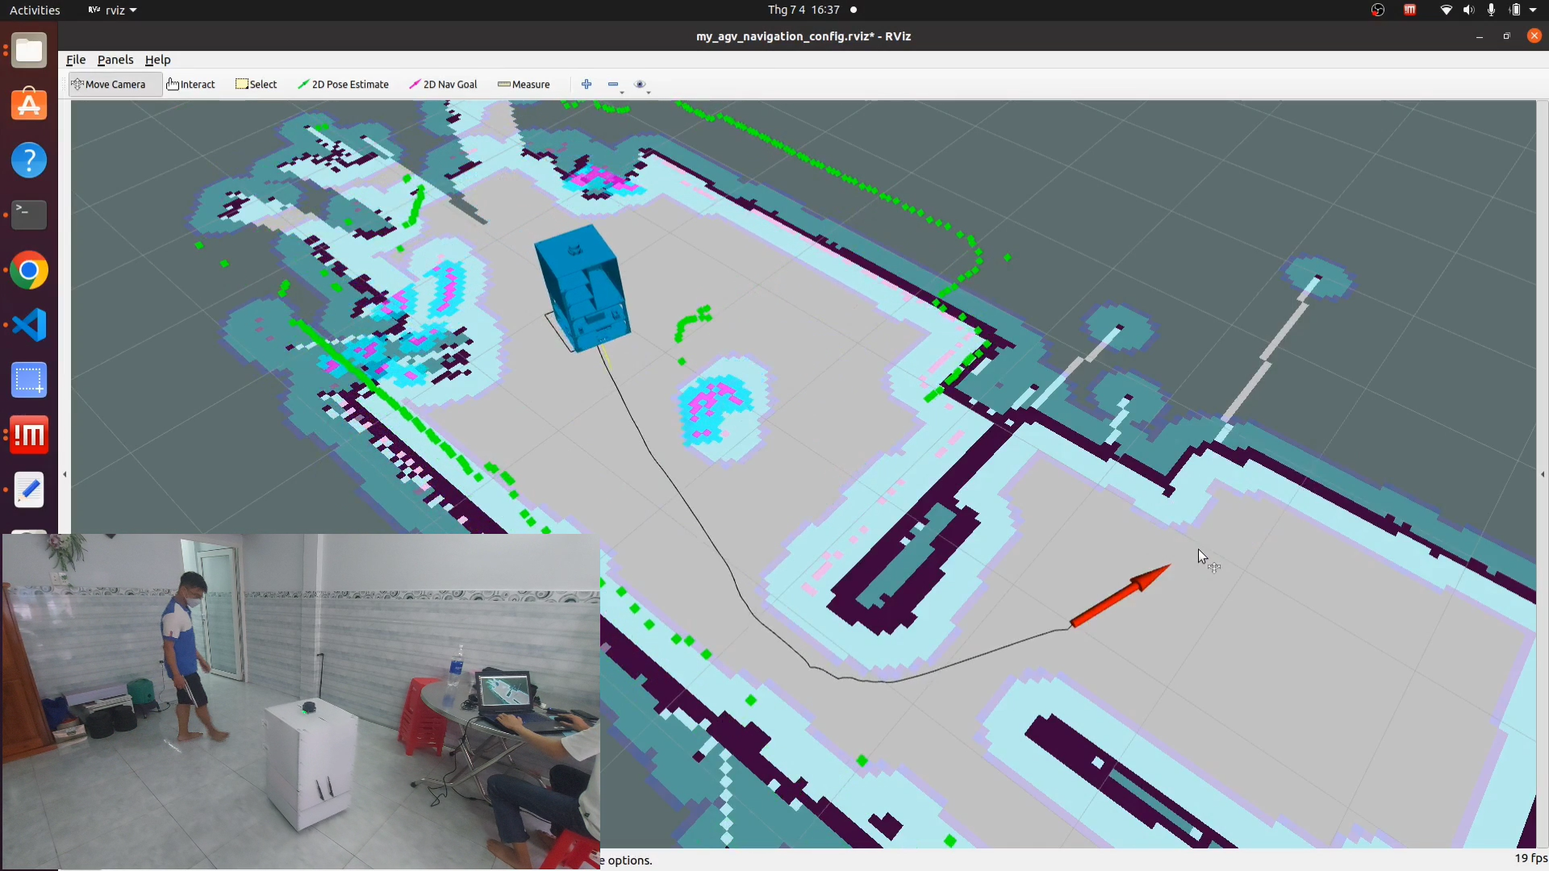

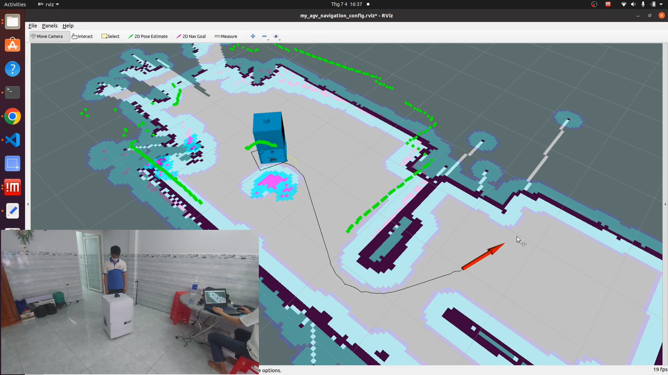

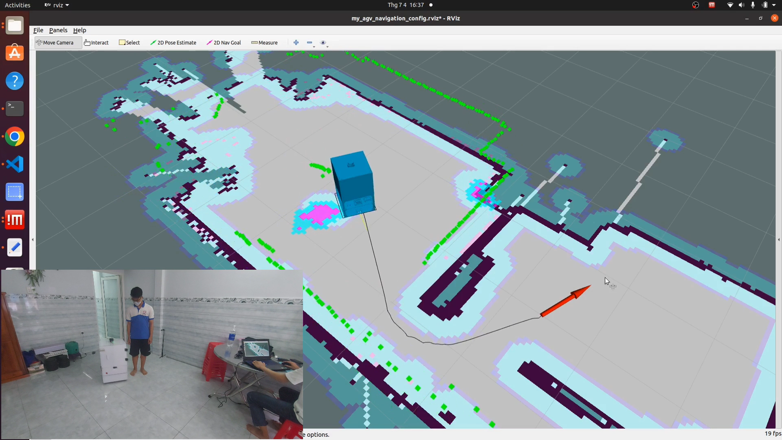

Figure 5.5. Demonstration of obstacle avoidance process

* **Algorithm selection**

- The reason why we have to find the algorithm:

1. The navigation of the robot is the most frequent task we do.
2. It is hard to find the shortest path from one place to the other by ourselves.
3. The algorithm helps us to find the optimum shortest path to reach the goals.

- Why we choose Dijkstra's algorithm?

Dijkstra's algorithm is the algorithm it finds the shortest path from the node called the source node (the node we choose to begin) to another remaining node in the tree graph by adding the weight or cost value on the edges (distance line connection between nodes). While the algorithm executes the added weights to update the distance value of an adjacent node to make a comparison value (get the lowest weight value) to find a new shortest path (source node to adjacent node). There are several reasons our group choose Dijkstra's algorithm for navigation:

1. Dijkstra's algorithm finds the shortest path and goes faster compared to the A* algorithm.
2. Dijkstra's algorithm finds an optimized and smooth path when facing a corner or near an obstacle.
3. Dijkstra's algorithm is the algorithm that makes stabilized the robot and is effective in the computation for the navigation operation and when reaching a goal.

We did a navigation test for three times to get the computation time executes value with the same distance path for Dijkstra’s and A* algorithms.

Table 5.2. The computation time and distance when using Dijkstra’s and A* algorithms.

|  |  |  |  |
| --- | --- | --- | --- |
| First test (1st) | Algorithm | Distance | Computation Time |
| Dijkstra’s | 4.475m | 19.44s |
| A* | 4.511m | 21.93s |
|  | | | |
| Second test (2nd) | Dijkstra’s | 4.436m | 19.92s |
| A* | 4.483m | 21.09s |
|  | | | |
| Third test (3rd) | Dijkstra’s | 4.434m | 20.51s |
| A* | 4.508m | 23.41s |

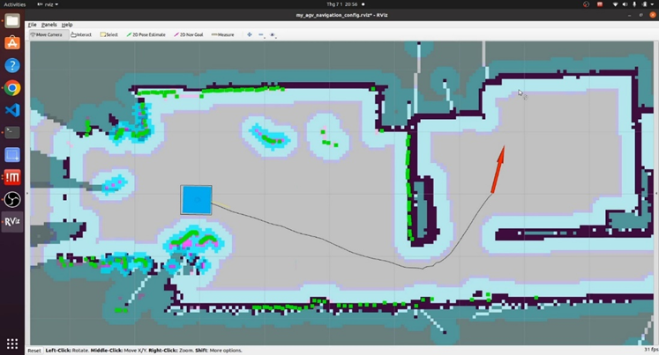

Figure 5.6. Dijkstra's algorithm

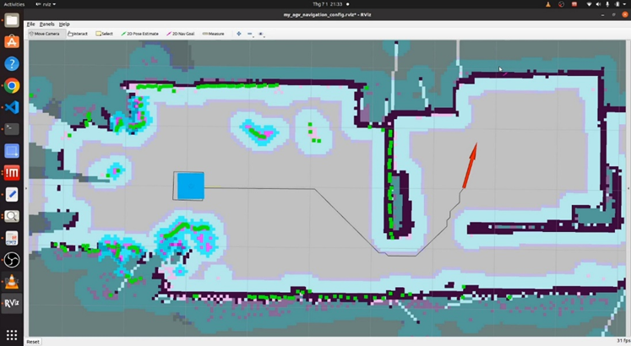

Figure 5.7. A* algorithm

- Dijkstra's algorithm has the following:

* (u,v): the line connection between two nodes u and v (edge).
* w(u,v): indicate the weight between two node.
* dist(): the actual distance from the source node s to all the remaining nodes in the tree graph.
* The distance to the source node: dist(s) = 0.
* The distance to all the remaining nodes: dist(v) = $∞$.
* S: will mark the node that has been visited. After the algorithm executes done. S will have a full node on the tree graph.

Algorithm procedures:

- First start-up, the source node s is chosen due to the dist(s) = 0 must have, and the adjacent node v is chosen next that has the shortest path dist() value.

- The node v will be put to S, to mark v has been visited.

- The distance value of the new adjacent node u of the current node v is only updated when:

If dist(v) + w(u,v) < dist(u) when finding a new shortest path for node u, then

dist(u) = dist(v) +w(u,v).

## **5.2. Establish target specifications**

After having investigate some basic objectives that our mobile robot has been programmed for adapting the right duty in hospital’s appication, we continue to go more further to deeply research in testing working stability of the system via assuming some realistic needs and specifications that fit the market demand. Therefore, it is vital to utilize a database from assigning some target values that can be set for the given needs.

### **5.2.1. Qualitative Research Method**

We are going to collect and analyze non-numerial data based on investigating some essentials needs that can affect the steady rate of mobile robot. After studying and

gathering a lot of information. Our group has finally chosen 6 prominent needs as show in the following table below.

* **Choosing needs for mobile robot**

Table 5.3. List of needs

|  |  |  |
| --- | --- | --- |
| No | **Needs of mobile robot** | **Important rate** |
| 1 | Goal location should be precise | 35% |
| 2 | The map pixel should be accuracy to ensure the correct navigation | 25% |
| 3 | The ability to carry high load capacity as fast as possible | 25% |
| 4 | Long term use of battery | 15% |
| 5 | level of noise should be as low as possible | 5% |
| 6 | The cost for manufacturing should be as low as possible | 5% |

* **Choose suitable metrics respect to needs**

Table 5.4. List of metrics

|  |  |  |  |
| --- | --- | --- | --- |
| **No** | **Metric** | **Needs** | **Unit** |
| 1 | Rate of accuracy | 1,2 | % |
| 2 | Angle rotate | 1 | Degree |
| 3 | Position toletance | 1 | mm |
| 4 | Battery capacity | 4 | Mah |
| 5 | Operation time | 4 | Minutes |
| 6 | Mechanical components | 5,6 | Listing |
| 7 | Total Price of components | 6 | VND |
| 8 | Level of noise | 5 | dB |
| 9 | Power comsumption while moving in realistic | 4 | Watt |
| 10 | Time estimated | 3 | Minute |

* **Link metrics to needs**

Table 5.5. Relationship between metrics and needs

|  |  |  |  |  |  |  |  |  |  |  |  |
| --- | --- | --- | --- | --- | --- | --- | --- | --- | --- | --- | --- |
| NO | **NEEDS** | **METRICS** | | | | | | | | | |
| 1 | 2 | 3 | 4 | 5 | 6 | 7 | 8 | 9 | 10 |
| 1 | Accurate location | X | O | O |  |  |  |  |  |  |  |
| 2 | Accurate map pixel | X |  |  |  |  |  |  |  |  |  |
| 3 | Minimum amount of time |  |  |  |  |  |  |  |  |  | X |
| 4 | Low power consumption over the time |  |  |  | O | O |  |  |  |  |  |
| 5 | Low noise level |  |  |  |  |  | O |  | X |  |  |
| 6 | Low amount of expenditure |  |  |  |  |  | O |  |  |  |  |

Table 5.6. Explanation of direct and indirect measure

|  |  |  |
| --- | --- | --- |
| Measure types | Definition | Symbol |
| Direct | Measures something exactly by using visible tools such as dimension or time can be measured by rulers or calipers and timer respectively | X |
| Indirect | Measures something by having something measured in advance such as area,volume | O |

* **Assign marginal and ideal value for each specification**

Table 5.7. Assign marginal and ideal value for each specification

|  |  |  |  |  |  |
| --- | --- | --- | --- | --- | --- |
| No | **Specification name** | **Unit** | **Ideal value** | **Marginal value** | **Type of specification** |
| 1 | Angle | degree | 360 | ±1o | Basic |
| 2 | Operating time | Minutes | 120 | ±5 | Basic |
| 3 | Noise level | dB | < 70 | ±5 | Basic |
| 4 | Operating power | Watt |  |  | Basic |
| 5 | The percentage of map scanned accuracy in comparison to real world | % | 96 | ±2 | Basic |
| 6 | Maximum scan range of LiDAR | m | 6 | ±1 | Basic |
| 7 | The slowest speed | m/s | depends on experimental result | None | Basic |
| 8 | The fastest speed | m/s | depends on experimental result | None | Basic |
| 9 | The precise distance tolerance | mm | 10 | ±1 | Advanced |
| 10 | The precise rotation tolerance | mm | 10 | ±1 | Advanced |
| 11 | The minimum safety range of distance | cm | 5 | ±1 | Additional |
| 12 | The expenditure of assemble robot | VND | None | None | Basic |

### **5.2.2. Methods of Experiment**

Table 5.8. Experiment methods

|  |  |  |  |  |  |
| --- | --- | --- | --- | --- | --- |
| **Specification name** | **Unit** | **Number of samples** | **Type of test** | | **Description** |
| **Static** | **Dynamic** |
| Angle | Degree | 10 |  | x | Rotate the mobile robot by 360o with bare hands and observe the change of odometry value |
| Noise level | dB | 10 |  | x | Use mobile app |
| The power consumption | Watt | 10 |  | x | Use VOM to measure the voltage |
| Slowest speed | m/s | 10 |  | x | Use navigation’s algorithm to run the mobile robot in curvature road |
| Fastest speed | m/s | 10 |  | x | Use navigation’s algorithm to run the mobile robot in straight road |
| Expenditure of assembling robot | VND | 1 | x |  | Compares to the list of components |
| Maximum of load capacity | kg | 10 |  |  | Fill up a robot with a certain amount of load and run till it can’t handle anymore |
| Safe distance between robot and obstacles | cm | 10 |  | x | Use the ruler |
| The percentage of map scanned accuracy in comparison to real world | % | 1 | x |  | Observes the position value in simulated environment and compares with real world |

### **5.2.3. Experiment Implementation**

* **Static test (1 times)**

Table 5.9. Data collection of static test

|  |  |  |  |  |
| --- | --- | --- | --- | --- |
| **Specification name** | **Number of samples** | **Ideal value** | **Marginal value** | **Measured value** |
| The percentage of map scanned accuracy in comparison to real world | 1 | 96% | ±2 | 99% |
| Expenditure of making robot | 1 | None | None | Depends on **[26]** |

* **Dynamic test (n times)**

**Change of speed compared to variable of load capacity**

Table 5.10. Data collection of speed variable

|  |  |  |  |  |
| --- | --- | --- | --- | --- |
| **Measured value** | | **Result of speed value(m/s)** | **Test n** | **Mass(kg)** |
| **Distance(m)** | **Time(s)** |
| 1.91 | 6.96 | 0.274 | 1 | 1.5 |
| 1.92 | 6.64 | 0.289 | 2 | 3 |
| 1.98 | 7.02 | 0.282 | 3 | 4.5 |
| 1.97 | 7.01 | 0.281 | 4 | 6 |
| 2.07 | 7.54 | 0.274 | 5 | 7.5 |
| 1.97 | 7.34 | 0.268 | 6 | 9 |
| 1.99 | 7.27 | 0.273 | 7 | 10.5 |
| 1.95 | 7.4 | 0.263 | 8 | 12 |
| 1.98 | 7.34 | 0.269 | 9 | 13.5 |
| 2.08 | 8.05 | 0.258 | 10 | 15 |
| 2.05 | 8.79 | 0.233 | 11 | 20 |
| 1.9 | 10.17 | 0.186 | 12 | 25 |

**fastest speed can achieve (without load capacity)**

Table 5.11. Data collection of fastest speed

|  |  |  |  |  |  |
| --- | --- | --- | --- | --- | --- |
| **Ideal value** | **Marginal value** | **Measured value** | | **Result of speed value(m/s)** | **Test n** |
| **Distance(m)** | **Time(s)** |
| Depends on experimental result | None | 1.97 | 7.33 | 0.268 | 1 |
| 2.03 | 7.67 | 0.264 | 2 |
| 1.92 | 7.09 | 0.27 | 3 |
| 1.99 | 7.74 | 0.257 | 4 |
| 2.02 | 7.48 | 0.27 | 5 |
| 1.93 | 7.02 | 0.275 | 6 |
| 1.86 | 6.99 | 0.266 | 7 |
| 1.9 | 6.9 | 0.275 | 8 |
| 1.93 | 7.21 | 0.267 | 9 |
| 1.96 | 7.34 | 0.267 | 10 |

**Slowest speed can achieve (without load capacity)**

A slowest speed can be measured by running the robot in the curve trajectory. We are going to pick an arbitrary point in the map and lets it move to the destination by navigation’s algorithm, while measuring how long it took to finish the journey. The total amount of distance move can be observed on the computer screen.

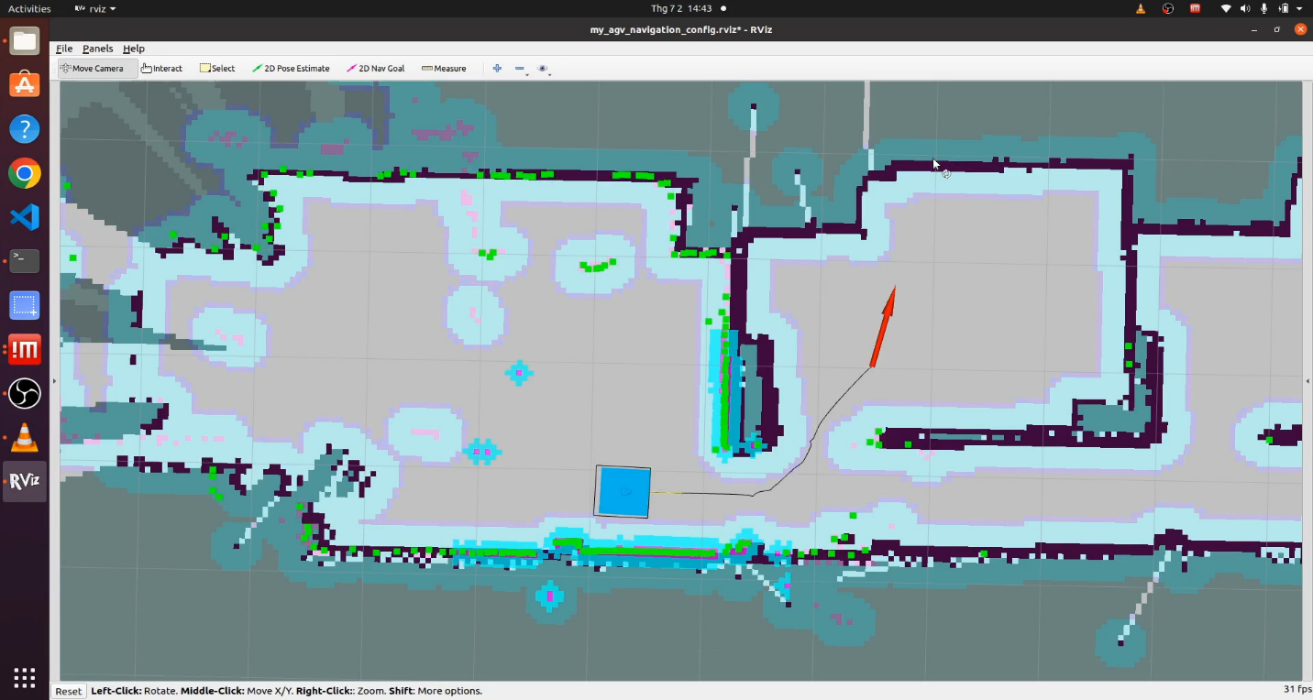

Figure 5.8. Curve trajectory of mobile robot

Table 5.12. Data collection of slowest speed

|  |  |  |  |  |  |
| --- | --- | --- | --- | --- | --- |
| **Ideal value** | **Marginal value** | **Measured value** | | **Result of speed value(m/s)** | **Test n** |
| **Distance(m)** | **Time(s)** |
| Depend on experimental result | None | 2.12 | 9.9 | 0.214 | 1 |
| 2 | 10.26 | 0.195 | 2 |
| 2.04 | 10.92 | 0.187 | 3 |
| 2.12 | 10.22 | 0.207 | 4 |
| 2.11 | 8.98 | 0.235 | 5 |
| 2.09 | 10.8 | 0.193 | 6 |
| 2.07 | 10.09 | 0.205 | 7 |
| 2.08 | 10.05 | 0.207 | 8 |
| 2.09 | 10.83 | 0.193 | 9 |
| 2.03 | 10.79 | 0.188 | 10 |

**Level of noise**

This measurement can be implemented by placing the smartphone with an app “noise measuring” on the journey of mobile robot as it gets as close as to the smart phone, the intensity of sound will be recorded higher over the time.

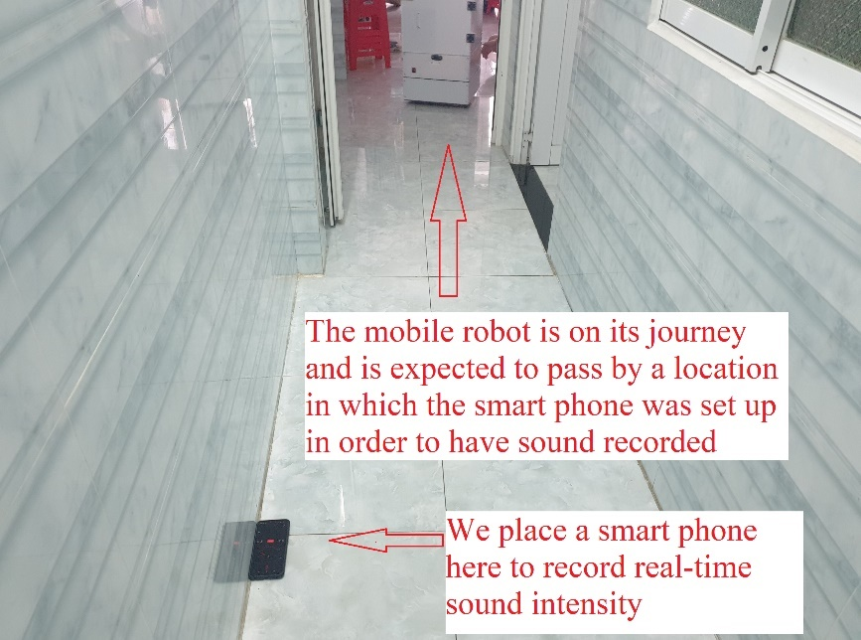

Figure 5.. Demonstration of noise level measuring process

Table 5.13. Data collection of noise level

|  |  |  |  |
| --- | --- | --- | --- |
| **Ideal value(dB)** | **Marginal value** | **Measured noise value(dB)** | **Test n** |
| Lower than 70 | +5 | 58.2 | 1 |
| 61.5 | 2 |
| 60.4 | 3 |
| 62.6 | 4 |
| 63.1 | 5 |
| 67.5 | 6 |
| 64.7 | 7 |
| 61.1 | 8 |
| 62.8 | 9 |
| 60.9 | 10 |

**Compare the accuracy of 360o roration between smart phone’s compass and odometry value**

We are going to place a smartphone opened a compass app on the roof of mobile robot and rotate it using hand and compares the change of degree on the compass with the odometry value read in radian on the computer.

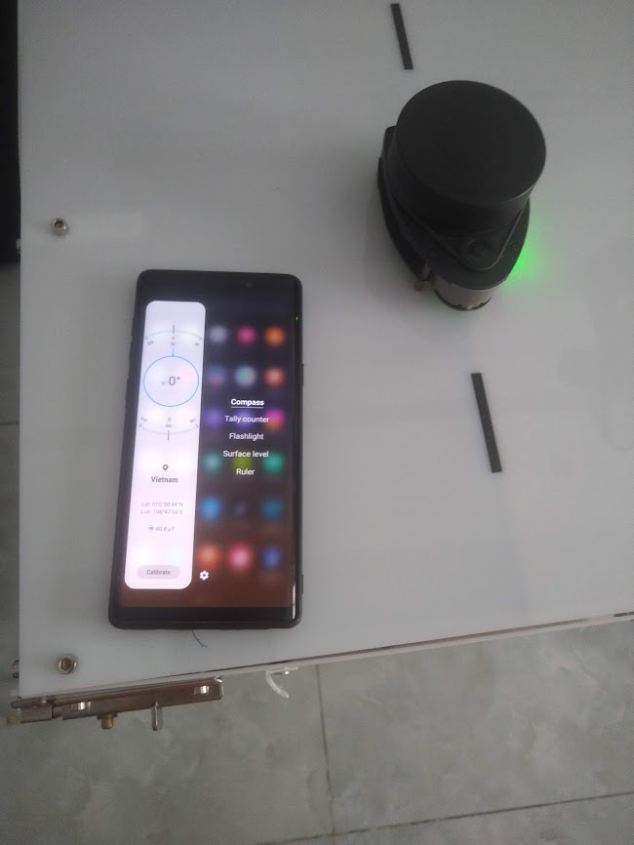

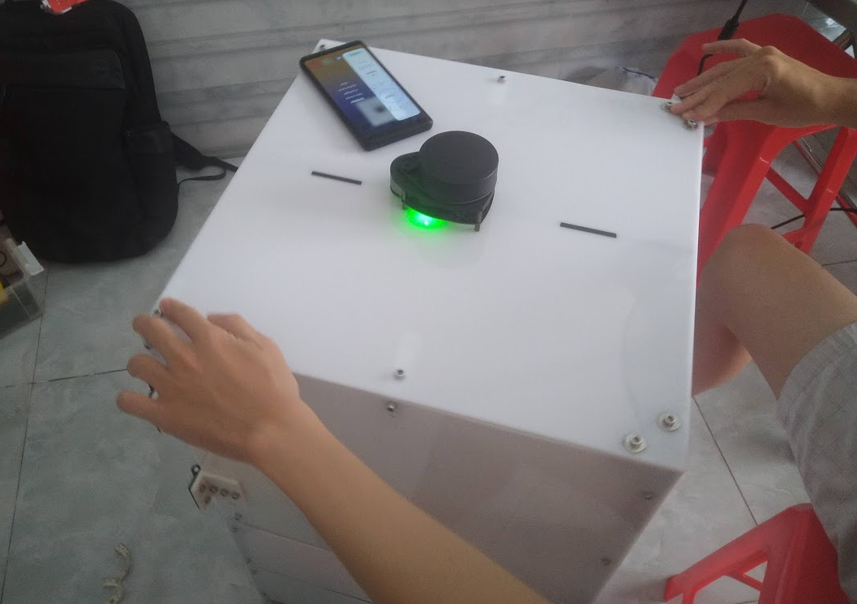Figure 5.10. Set an origin value of compass and place it on robot

Figure 5.11. Rotate the robot with 360o

Table 5.14. Data collection of angle value

|  |  |  |  |  |
| --- | --- | --- | --- | --- |
| **Ideal value(degree)** | **Marginal value** | **Measured tolerance value(degree)** | **Match result (%)** | **Test n** |
| 360 | ±2 | 346 | 96.11 | 1 |
| 347 | 96.38 | 2 |
| 344 | 95.55 | 3 |
| 344 | 95.55 | 4 |
| 354 | 98.33 | 5 |
| 352 | 97.78 | 6 |
| 353 | 98.05 | 7 |
| 339 | 94.16 | 8 |
| 348 | 96.67 | 9 |
| 344 | 95.55 | 10 |
| Average measured value: 347.1 | | | % Average: 96.41 | |

**Safe distance between mobile robot and obstacle**

We are going to command the robot to itself move to the destination as shown in the figure below in which has a narrow distance and observe how it manages to keep distancing from a wall and use the ruler to measure that gap.

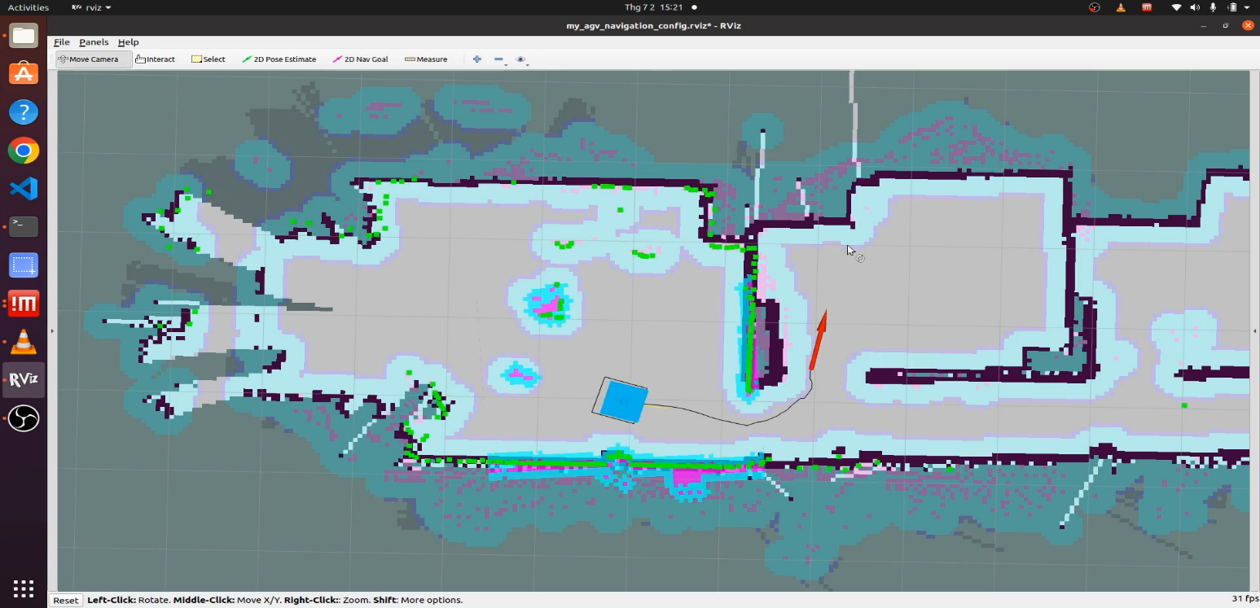

a)

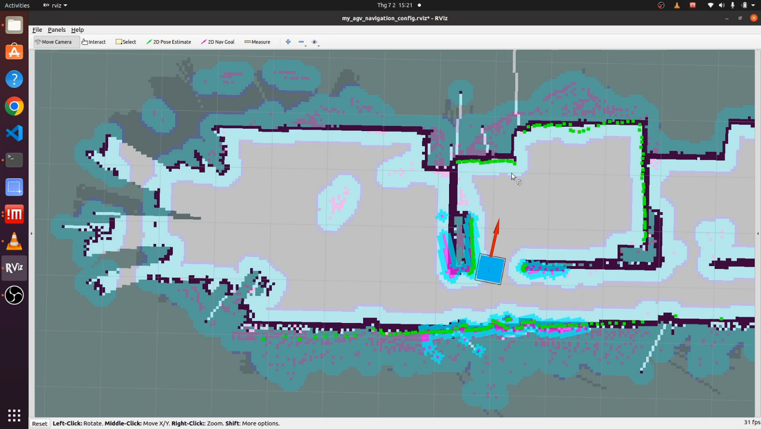

b)

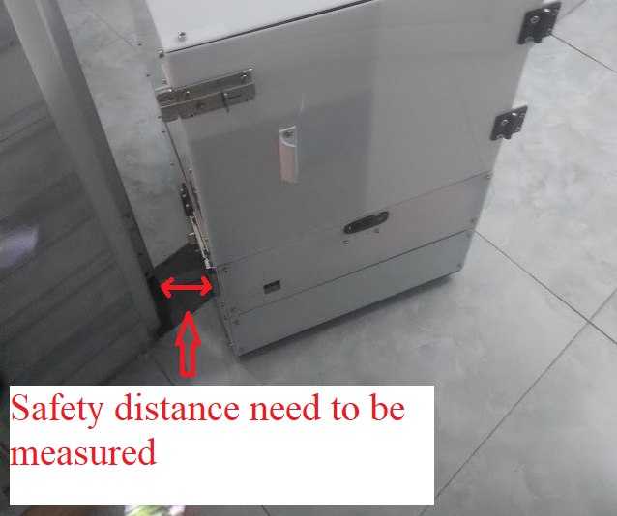

Figure 5.12. Demonstration of safe distance measuring

Table 5.15. Data collection of safe distance

|  |  |  |  |
| --- | --- | --- | --- |
| **Ideal value(cm)** | **Marginal value(cm)** | **Measured distance value (cm)** | **Test n** |
| 6-10 | ±1 | 9.2 | 1 |
| 9.4 | 2 |
| 6.5 | 3 |
| 10.2 | 4 |
| 7.4 | 5 |
| 13.2 | 6 |
| 8.4 | 7 |
| 10.7 | 8 |
| 7.9 | 9 |
| 6.2 | 10 |

**Power consumption with variable of loads capacity**

Table 5.16. Data collection of power consumption

|  |  |  |  |  |
| --- | --- | --- | --- | --- |
| **Without load** | | **With load capacity** | | **Mass(kg)** |
| **Current (A)** | **Power(watt)-**  **Current multiplies by 12** | **Current(A)** | **Power(watt)-current multiplies by 12** |
| 1.7 | 20.4 | 1.86 | 22.32 | 1.5 |
| 1.92 | 23.04 | 3 |
| 2 | 24 | 4.5 |
| 2.3 | 27.6 | 6 |
| 2.3 | 27.6 | 7.5 |
| 2.6 | 31.2 | 9 |
| 2.8 | 33.6 | 10.5 |
| 2.7 | 32.4 | 12 |
| 2.9 | 34.8 | 13.5 |
| 3 | 36 | 15 |

## **5.3. Analysis of data**

### **5.3.1. Static test analysis**

Table 5.17. Static test analysis

|  |  |  |
| --- | --- | --- |
| Specifications | Result | Evaluate |
| The percentage of map scanned accuracy in comparison to real world | 100% | According to the measured value, we can conclde this criteria satisfy the inital requirement |
| Expenditure of making robot | 100% |  |

### **5.3.2. Dynamic test analysis**

* **Change of speed compared to variable of load capacity**

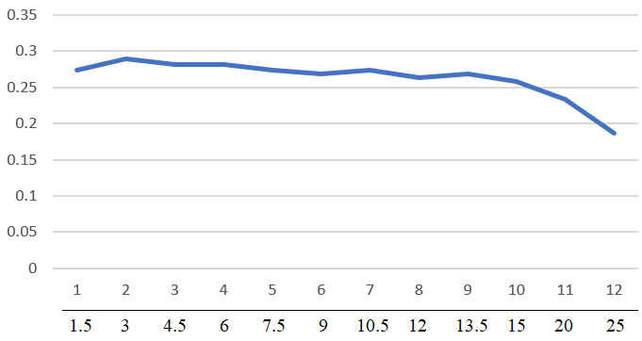

Speed(m/s)

Mass(kg)

Test times(n)

Figure 5.13. relationship between speed and mass

**Comment:**

Looking at the graph, it can be noticeable that there is a downward trend of speed value as the weight gains.

At initially, there is a light increase of speed from just over 0.25 to approximately 0.3 m/s despite of the double weight gain from 1.5 to 3 kg. However, we can witness the gradual decrease of speed as we put more weight on the robot from 3 to 15 kg. The speed of robot started to drop quickly as we put more weight and the value reaches the lowest point at just under 0.2 m/s.

To conclude, we can see that the robot is able to work effectively and stable at a certain range of speed in which it doesn’t change too much as it can handle from 1.5 to just over 15kg. On the other hand, the robot is likely to loss its stability if the weight capacity is larger than threshold value at 20kg.

* 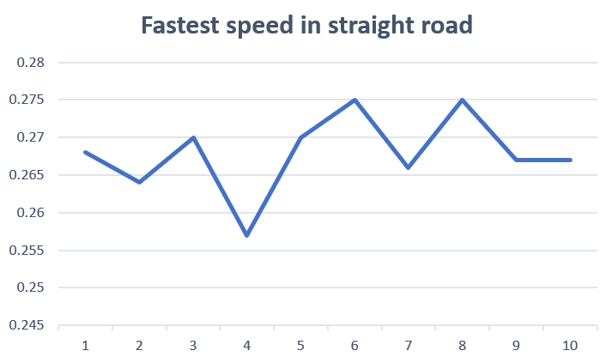**fastest speed can achieve (without load capacity)**

Speed (m/s)

Test times (n)

Figure 5.14. A variable of fastest speed achieved over ten times tested

**Comment:**

It is clearly that, the fluctuation of speed is quite aggressive, the lowest value can be measured is just under 0.26 m/s while peak value is approximately 0.275 m/s.

* **Slowest speed can achieve (without load capacity)**

**Comment:**

Looking at the graph it is obvious that, the fluctuation of speed value is between 0.18 to approximately 0.23 m/s. When compared to the range of fastest speed value from 0.26 to 0.275 launch in straight road. The deviant is quite trivial.

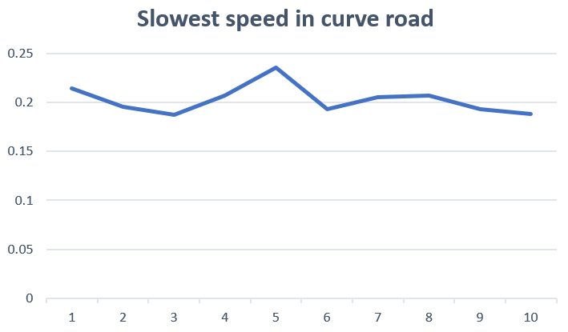

Speed (m/s)

Test times (n)

Figure 5.15. A variable of slowest speed achieved over ten times tested

* **Compare the accuracy of 360o roration between smart phone’s compass and odometry value**

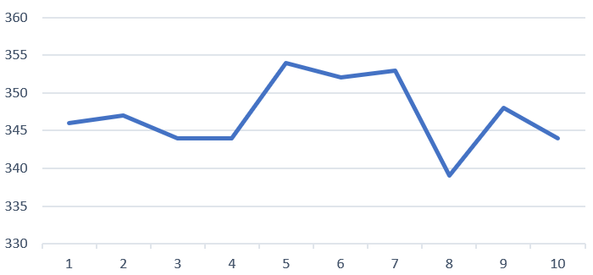

Angle (degree)

Test times (n)

Figure 5.16. A variable of angle’s accuracy over ten times tested

**Comment:**

It is clear that, the change of angle value fluctuates in the range of just under 340 to approximately 355 degrees but still not meet the desire value at 360. However, the percentage accuracy of odometry often ten times test is about 96.41 % (already computed in the experiment result) as compared to value in real world.

We can conclude that, the Accuracy percentage of IMU does not meet the requirements. However, it still works properly in real world.

* 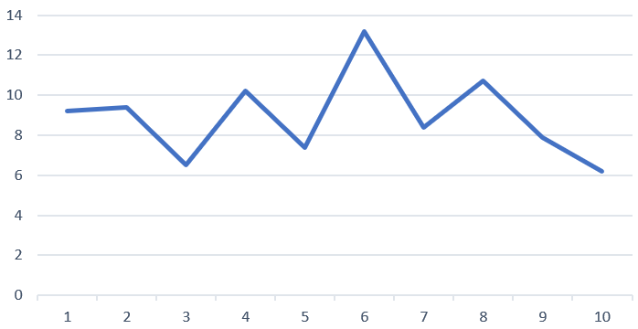**Safe distance between mobile robot and obstacle**

Speed (m/s)

Test times (n)

Figure 5.17. The change of safe distance over ten times test

**Comment:**

Looking at the line graph, it is clear that the safe distance of robot shows the aggressive fluctuation, the range of value varies from 6 to approximately 13 cm offset from the wall.

We can conclude that the range of safe distance performed by mobile robot completely meet the requirement of safety standard.

* 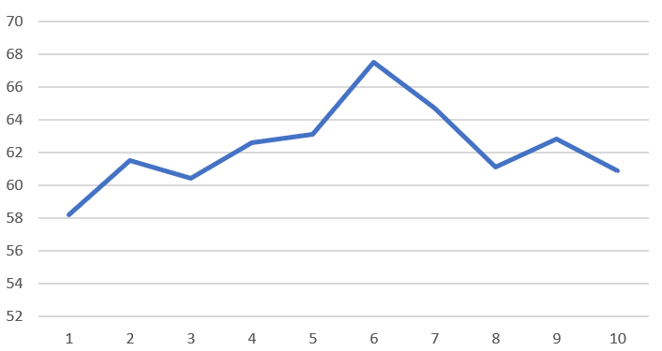**Level of noise**

Noise level (dB)

Test times (n)

Figure 5.18. The variable of noise level over ten times test

**Comment:**

Looking at the graph, the amount of noise level ranges from approximately 58 to the peak at just over 68 dB.

We can conclude that, the noise level of mobile robot meets the requirement since the value fluctuates below the maximum allowable value at 70 dB.

**Power consumption with variable of loads capacity**

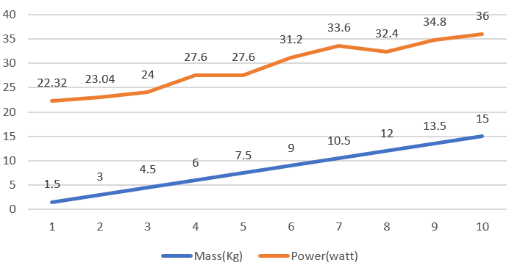

Test times (n)

Figure 5.19. Power consumption with variable of loads capacity

**Comment:**

Looking at the line graph, it is obvious that the increase of loads capacity is directly proportional to the power consumption.

### **5.3.3. Conclusion**

After having been through many technical experiments for evaluating the steady state of our mobile robot. There are still somes criteria do not meet the requirements . However, the error of the value is quite acceptable due to a long time used of some electrical components that might affect the accuracy of the whole system. In general, our mobile robot works as expected.

# **CHAPTER 6: CONCLUSION AND FUTURE IMPROVEMENT**

## **6.1. Lesson learnt**

After four months have been researching and implementing the graduation project, our group has gained a lot of useful knowledge. we now have a deeper insight into aspect of mobile robot and the process of how to implement and program it. In term of theoretical of controller method, we has broaden more knowledge about how the PID works and the application of it into control the speed of motor to maintain the steady state of the system. Moreover, we have also learnt how the process of navigation works by taking a lot of effort deeply researched into SLAM algorithm. Beside the theoretical knowlege, we are able to know how to design the electrical system and wiring connection for a real mobile robot. Furthermore, we can also improve a lot of practical skill in mechanical design and assemble the robot that contains a variety of components. Last but not least, the most critical things that we have managed to learnt throughout this graduation thesis is the aiblity to work as team work which leads us to the success of this final project of 4 years duration at university.

## **6.2. Achievement**

Our group has managed to design and implement the mobile robot for hospital’s application with some basic but essentials for the patient. As we were able to develop a robot with ability of scan a map of surrounded environment, and it can autonomously drive to the destination goal that is given by the users and does not require any manual control by human-being. Moreover, our robot is also smart enough to not only detect and avoid obstacle simultaneously, but it can also generate the new path and keep moving until finish its journey. Our robot is also equipped with a camera that streams the real-time image, enable the user to know where the robot is moving to. Furthermore, we also developed the pid controller that enable the robot to run at a constant speed range when carrying a certain amount of load capacity that without causing too much noise due to high load acts on the frame.

## **6.3. Limitation**

Beside of obtaining many good lessons and knowledge as finished this huge project, our group still has had some issues not yet solved out. The weakest point of our mobile robot is the limitation of obstacle recognition performed by LiDAR sensor as it is only able to scan tall obstacles such as human, or any object with large height because of the location of placing sensor is on the top of robot so it can only recognize any obstacles at the same height of it. The second issue is the noise produced by the mobile robot whenever it performs a curve movement as we use the navigation’s algorithm, and this problem should come from the mechanical design. These are the two huge problem that our group need to improve to expect the best version of mobile robot in the future.

## **6.4. Suggestion for future improvement**

* Integrate and program the LCD interface and button for easy choosing the ceratin goal navigation location.
* Upgrade the robot so it can carry more weight.
* Change the design of the robot that can put the RPLIDAR A1 as low as possible so it can avoid the lower obstacle.
* Tunning more parameters in the global planner algorithm or trying another algorithm to make the robot more stable and accurate in the navigation task.

# **REFERENCES**

**Books**

**[1]** PGS.TS. Trinh Chat – Le Van Uyen, “Tính Toán Thiết Kế Hệ Dẫn Động Cơ Khí”, NHA XUAT BAN GIAO DUC, (february 2006).

**[2]** Anis Kouba, “Robot Operating System (ROS)” , 2016 in Switzerland.

**[3]** Lentin Joseph, “Robot Operating System for Absolute Beginners”, copyright.

**[4]** YoonSeok Pyo, HanCheol Cho, RyuWoon Jung, TaeHoon Lim, “ROS Robot Programming”, (December 22nd 2017).

**[5]** Kaiyu Zheng, “ROS Navigation Tuning Guide” , (September 2nd 2016).

**[6]** Farbod Fahimi, “Autonomous Robots Modeling, Path Planning, and Control”, 2009.

**Websites**

**[7]** Damond Goodwin, “The Evolution of Autonomous Mobile Robot”, (September 9th 2020). Available:

<https://control.com/technical-articles/the-evolution-of-autonomous-mobile-robots/>

**[8]** Mike Oitzman, “What’s the difference between an AMR and an AGV?”, (August 6th 2021). Available:

<https://mobilerobotguide.com/2021/08/06/whats-the-difference-between-an-amr-and-an-agv/#:~:text=AMRs%20are%20capable%20of%20free,a%20variety%20of%20locomotion%20configurations.>

**[9]** “AMRs vs. AGVs: The Difference Between a Robot and a Guided Vehicle”, (September 10th 2020). Available:

<https://fetchrobotics.com/fetch-robotics-blog/amrs-vs-agvs-the-difference-between-a-robot-and-a-guided-vehicle/>

**[10]** “Trend of using AMR Robots in Vietnam”, IDMEA. Available:

<https://idmea.com/xu-huong-su-dung-robot-amr-o-viet-nam/>

**[11]** Tri thuc Viet – Toan cau, “Tiến sĩ Việt nghiên cứu robot tự hành thông minh AMR”, (March 4th 2021). Available:

<https://kienthuc.net.vn/tri-thuc-viet-toan-cau/tien-si-viet-nghien-cuu-robot-tu-hanh-thong-minh-amr-1506463.html>

**[12]** Jason Walker, “What Are Autonomous Robots? 8 Applications for Today’s AMRs”. Available:

<https://waypointrobotics.com/blog/what-autonomous-robots/#:~:text=AMRs%20for%20Logistics,a%20day%2C%20in%20unbroken%20cycles.>

**[13]** Chinhphu.vn, Bao Dien Tu Chinh Phu, “Vận hành robot thông minh thay nhân viên y tế trong khu cách ly”, (May 18th 2021). Available:

<https://baochinhphu.vn/van-hanh-robot-thong-minh-thay-nhan-vien-y-te-trong-khu-cach-ly-102292457.htm>

**[14]** The MathWorks, “SLAM (Simultaneous Localization and Mapping)”. Available:

<https://www.mathworks.com/discovery/slam.html>

**[15]** Wikipedia, “Bộ điều khiển PID”, Available:

<https://vi.wikipedia.org/wiki/B%E1%BB%99_%C4%91i%E1%BB%81u_khi%E1%BB%83n_PID>

**[16]** Eric Peňa and Mary Grace Legaspi, “UART: A Hardware Communication Protocol Understanding Universal Asynchronous Receiver/Transmitter”, AnalogDialogue. Availalbe:

<https://www.analog.com/en/analog-dialogue/articles/uart-a-hardware-communication-protocol.html#:~:text=By%20definition%2C%20UART%20is%20a,going%20to%20the%20receiving%20end.>

**[17]** Nour Taweel, Maisa jazba, “Introduction to rosserial_arduino”, (December 11th 2018). Available

<https://atadiat.com/en/e-rosserial-arduino-introduction/>

**[18]** ResearchGate, “the diagram of base controller system as ROS node”. Available

<https://www.researchgate.net/figure/describes-the-diagram-of-base-controller-system-as-ROS-node-The-base-controller-node_fig2_320782369>

**[19]** ROS.org, “move_base”. Available:

<http://wiki.ros.org/move_base>

**[20]** ROS.org, “map_server”. Available:

<http://wiki.ros.org/map_server>

**[21]** ROS.org, “tf”. Available:

<http://wiki.ros.org/tf>

**[22]** Nils Rottmann, Nico Studt, Elmar Rueckert, “ROS-Mobile: An Android application for the Robot Operating System”, (November 5th 2020). Available:

<https://arxiv.org/pdf/2011.02781.pdf>

**[23]** Dude, Jenkin, “Computational Principles of Mobile Robotics”. Available:

<http://www.cs.columbia.edu/~allen/F17/NOTES/icckinematics.pdf>

**[24]** Tuan Tran, “Công thức tính thời gian sử dụng ắc quy”, (February 19th 2015). Available:

<https://acquy.info/faq/cong-thuc-tinh-thoi-gian-su-dung-ac-quy.html>

**Datasheet**

**[25]** <https://www.generationrobots.com/media/rplidar-a1m8-360-degree-laser-scanner-development-kit-datasheet-1.pdf>

**Total consumption spent for project**

**[26]**  <https://docs.google.com/spreadsheets/d/1dPRdbV1x-lflgL6BlZV_9cRprqsgaQYX0sQeoEq2fIw/edit#gid=1340653627>